Writing Sample 1 Forum Post:
In Fallon’s case his genetics or his nature say he has a predisposition to certain actions while his life experiences show he has never succumb to them because of how he was raised or nurture. From personal life experiences this seems to hold true. In my personal experience I believe things like intelligence are not predestined by good genetics. While I was young I believed I was dumb, that is I felt like I did not understand the materials that were being taught and was behind academically to my peers. I became obsessed with this and began to study independently with vigor, I read many math books, history books, physics books, philosophy. I was so driven by this obsession that I taught myself Calculus, limits, differentiation and integrals by the age of 15 and taught myself to read German so that I could read my favorite philosopher Immanuel Kant in his native language, as already knowing two languages I realized that a lot gets lost in translation. I realized one thing about education and intelligence, no one is just born with it, even if you have a predisposition that makes it easier for you, it takes time and effort to acquire knowledge. Based on this realization I instilled this in my children, but not as an obsession of guilt or inferiority but as curiosity. From early in their lives I taught them to read, to write, to do basic arithmetic before they entered the school system. I gave them some tools, but tools alone are not what create curiosity. I took them camping, taught them how to fish and how we must consume some form of life in order to exist (yes plants are alive), how to build a fire and its importance how it is so important to us as a species but also so dangerous. At night we would look at the stars and I would explain what they are made of, of the galaxies, of black holes. We would watch things like Carl Sagan’s the Cosmos and its later iteration by Neil DeGrasse Tyson. There were many more things that I did with them and it seems to have worked. They have all in their ways expounded on their curiosities, my oldest daughter (14) entrenches herself in history and art, my second oldest (12) loves the sciences and mathematics, my son (10) builds robots, my two youngest (6 &5) are still developing their curiosities. Of course, there are many other behaviors that adhere to nature and nurture but categorically they are not mutually exclusive. In the case of my children my two oldest are not biologically mine and it is interesting to see how the oldest father is a gifted artist which she has seemed to inherit from him. While she continues to pursue her artistic talents, I found it interesting that helping her develop other subject areas has seemed to help her creativity. Yet take the case of my biological son, he has great capacity for learning yet had trouble academically because of his inability to keep still. He was diagnosed with ADHD and through therapy, because I did not like the idea of loading my child up with medicines that only seem to dumb the problem not actually help him learn to cope with it, he has shown great improvements in his academic life and has moved to a gifted and talented program their school system has. The program has actually been a blessing to him because it keeps him intellectually challenged and in turn helps him stay calmer. I’ve also been blessed to help my girlfriend who teaches at SER of Puerto Rico, where she works with children with disabilities, not all learning disabilities. It is interesting how this school helps so many children and how given the opportunity many of them are able to reach milestones that would otherwise not be possible due to their condition. This is truly the most fascinating aspect of being able to on occasion help at SER. You can actually see the effects of Nature AND Nurture. Why capitalize and? The reality is because these are two things that work hand in hand, there are the physical and natural aspects of human behavior and development, but there are also outside influences that impact us as we grow up. This leads to what can be done to have the greatest positive impact on our children. The reality is that as a study this subject is at its infancy and there is no clear cut one answer that solves it. Each person, each child is a dynamic being and we are still at the trial an error phase of our understanding of this subject. That being said, it is always good to be as dynamic as the subject and be able to adapt to change. As with my children just when I thought I had a handle on my oldest daughter, her hormones kicked in and I was dealing with an entirely new beast full of at times it seems illogical emotions. The techniques and challenges of raising her have changed, but my love for her remains the same.
Writing Sample 2 Forum Post:
1. Based on our study of nature vs nurture, our human development is an intricate one. Yet there is one fundamental aspect which is most often overlooked. Each social worker, parent or educator is fundamentally guided by the philosophies they have developed in life. These philosophies of what a good person is and should be will guide their pursuit in raising children. For example, if a person philosophically believes in religion, for example Christianity, their core belief system tells them that humans are a species of shame and of guilt. These basic concepts drive how we see not just ourselves but how we pursue the development of our children. As a counter example, Friedrich Nietzsche would postulate that we live a life of pain, yet what marks us as good people is our ability to overcome this pain and turn it into something good. While things like Erikson’s theory of development stages gives some insight into human development it fails to recognize what is good, what is bad, what is moral what is not moral, what makes a good person, what makes a bad person. Questions that at their most fundamental level are philosophical in nature and personal to each person. Let’s take Beth’s case for example, in this case her biological parents, specifically her biological father, neglected her and abused her, sickeningly sexually abused her. Her biological father obviously had an amoral view of life which let him justify the horrible things that he did to his daughter. When the child left her home, and moved in with the Tennant’s they were not made aware of the abuse that they had been subject to, especially Beth. Using Erikson’s stages of development as a springboard we can quickly summarize that Beth’s development of trust and morality were thrown way out of normalcy into negative extremes. Yet the real problem with society is that Erikson for example can’t raise every child and even if he could what would make his system better than others. These questions obviously do not attest to the need of correcting the behaviors of deeply affected children. It is easy to look back in retrospect and say using the best models for child development that we posses that there was something wrong with Beth. Yet it is through learning about these processes, the differing philosophies of psychology and sociology that we can help differentiate and see when children and people in general need help. The earlier these issues can be seen and treated the easier a path to recovery and self-betterment.
2. Parents need to be especially mindful of these three things, their physical, their moral and educational or intellectual development. While these don’t specifically adhere to the diction used by the readings they are immensely the most influential in the development of children into positive productive and good adults. First comes the physical because there are always challenges that arise, for example autism, ADHD, and any physical impediment that could disrupt the development. In this case you cannot take the same approach to developing a child with no impediments as to how you pursue rising a child that does. Their moral development is also another very important aspect of raising a child. This is where you can catch a serial killer as they say, although usually nothing as extreme as this, but this is the point were professionals, parents and educators can have a profound impact into what kind of a person the children grown up to be. Encouragement which is covered as positive reinforcement is not exactly what I am getting at here. The educational or intellectual development can never be over stated in its importance to the development of a child. Realistically the more a person can understand about the world about them the better they are able to adjust to their needs and the needs of those around them.
3. There is one very specific point that I would like to make on this subject as a whole. While we study the micro in analyzing human beings we tend to lose objectivity of the big picture. The reality is that any development structure you take up there should always be just one pursuit. Raising a good person that is ready to be independent and morally well adjusted. Based on this premise as everyone takes up the challenges of raising children they must ask themselves basic questions. How will this action help them achieve that goal? Will this help build a foundation on which they can develop better skills? The reality is that even if you have a child with severe autism it would be a good testament of a great parent how well their prepared their child to live as independently as possible. There is a floating theory that the instant gratification of these coming generations and of never allowing them to face failure is making it harder for them to adjust to life as adults, specifically in being able to adjust to job goals, they expect to be instantly rewarded both by their job and their sense of worth at their job. They also are less adjusted to and have less ability to handle situations where they fail and do not have the tools necessary to bounce back from such failures. These are just a few of the challenges facing the new world and the reason why we need to keep pursuing betterment in this dynamic world. New technologies and changes in our society bring new challenges, our pursuit, the pursuit of anyone involved in the development of our children is to make sure they are ready to face those changes and challenges.
Writing Sample 3 Forum Post:
1. I believe Vygotsky presents the best model out of all the models represented in the text. It most realistically describes the role of societies impact on the development of an individual and the intrinsic importance of an individual to build upon what natural talents they may have. Through mentoring of each medium or adult they build upon their natural state to their next level. In some cases, they can take what they have learned and surpass their teacher. This can also be true in the opposite direction because negative things can be taught as well, and neglect of teaching through any medium can actually lead to a stunt in growth of that individual. I particularly like the concept of apprenticeship in learning.

2. Parenting as an approach takes on many different phases and holds a complexity beyond what we are able to understand at the moment. My kids are always complaining to me that I treat them all differently and they are right. The reality is that the best parenting approach depends on the child. Having five kids, two that I have raised since babies and three biological I can say through the years I have learned that the approach for each is different. Some kids need a more authoritarian parent, some kids need a more permissive parent, and some need a more authoritative parent. This dynamic also changes depending on the child’s needs, for example a child that needed an authoritarian parent at some point may need a change to an authoritative parent as they grow and as they are nearly ready to leave the home change again to a permissive parent. Honestly I am oversimplifying here, the nature of the complexities of these concepts you could possibly write volumes. The basic premise is that the reality is that you need to learn all parenting styles and types and always stay attuned to the needs of your child as not are they complex but also change over time.

3. In an extreme case like Genie I would definitely mold some kind of variation of Vygotsky’s approach to learning. I think beginning with cultural mediation to reintroduce Genie to society would have the most impact and would lead to better results. Surrounding her with many skilled mentors would help achieve Genie’s maximum potential considering the stunt in developmental growth she had early in life.
Writing Sample 4 Short Paper:
Hannibal
Hannibal was from Carthage and was born into a military, his father was involved in the first Punic War. After his father’s defeat, he moved with Hannibal to Spain where he was raised. At the age of 26 Hannibal was given command of an army to help take back control of Iberia where he succeeded. This also brought about the negation of the treaty between Rome and Carthage. This is where Hannibal’s true genius as a military commander truly shine. He quickly set on the move toward Rome itself! Now as these are historical facts we do not think of it much, but within the context of the times there were very few times that Rome was challenged and this was one of the few times were Rome itself was attacked. Before these events took place Rome had amassed a large army that was to fight into two fronts, one in Africa and the other in Iberia, what they did not know at the time was that Hannibal was already on his way to Rome. Hannibal’s first challenge was crossing Rhone River where there were Celtic tribes awaiting them, he prepared for a full assault but managed to get the bulk of his troops across without much conflict. The problem at this point was that Scipio who was the roman in charge of the invasion that was supposed to head to Iberia was close by and had realized that Hannibal was on his way to Rome. At this point Hannibal was forced to make a genius decision, he either had to fight them head on or take a different route. Hannibal chose to avoid the fighting at that point and head to the alps. This was considered suicide for any army because of the inclement weather and the hostile small tribes that lived in the area. He successfully pushed through the alps again with some losses but mostly still intact. This point is extremely important because he not only brought the war to Rome through his moves but also showed the resolve of his army towards the war itself. After crossing he had many victories and eventually came at a stalemate in Rome before being called away to help support the troops in Africa (Second Punic War: Hannibal's War in Italy. 2016). Eventually the war was lost by Carthage but Hannibal did a lot of damage.
References
Second Punic War: Hannibal's War in Italy. (2016, August 04). Retrieved from http://www.historynet.com/second-punic-war-hannibals-war-in-italy.htm
Writing Sample 5 Short Paper:
Hannibal
Greece was by all senses of both imagination and reality a spectacular place. There were incredible things going on during even the times before Alexander the Great. The was a rich culture with beautiful art, the foundations of philosophical contemplation of the metaphysical, of our human nature (justice as it pertains to what makes a person good) and the contemplation of what is truth (can also be thought of as knowledge). Incredible things were done in math and in the sciences, people were pondering the nature of nature. There were problems as well, Greece was divided and in constant war with its own city states and with foreign powers. This is where Alexander the great came in, right before he came into power his father had begun the preparations for unification through treaties. After his father’s death Alexander continued his work and his ambition of beating the Persian empire. Through some hard-fought battles at home he then took sites on Persia where he began his move toward defeating the Persians. Upon successfully defeating them he then sought out to conquer the world. Now it may seem that he was all about fighting and wonder how does this lead to the Hellenistic age but these are the events that lead to this era. The simple reason for this is because during this period Greek culture and learning was spread through all lands that became part of the empire. The term Hellenistic comes from the ancient Greek word for Greece. The Hellenistic age was a time when Greece was unaffected by other cultures, in fact they were the influencers of other cultures. Through the spread of the Greek empire through the works of Alexander the Great you could say that the world became Greece and was influenced by it (Alexander the Great and the Hellenistic Age. 2017). This brings up the fact that Alexander did not have a long reign and did not have heirs of appropriate age to take over his life goals. After his death, the empire was divided among his generals and you would think that would be the end of the Hellenistic age, that would have made it too short to become considered an era. The reality is that the spread of Greek culture and blending of cultures continued long after his death. Greek influence continued long after his death through sometime in during the roman rule when Romans finally conquered the last of the territories that were part of the Macedonian Empire (History.com Staff. 2010).
References
Alexander the Great and the Hellenistic Age. (2017). Retrieved from http://www.penfield.edu/webpages/jgiotto/onlinetextbook.cfm?subpage=1653418
History.com Staff. (2010). Hellenistic Greece. Retrieved from http://www.history.com/topics/ancient-history/hellenistic-greece

Writing Sample 6 Essay:

Task 1 Essay
Juan Maldonado Franco
Western Governors University

My grandfather was an inspiration to me in many ways. He owned his own coffee farm in Puerto Rico and was a leader his workers looked up to. He has under his employment dozens of workers that would help pick the coffee beans. He wanted to teach my brothers and me the virtues of hard work, so he would take us to the fields to pick coffee and help with other tasks. He had many virtues that made him such an exemplary man, some of the ethical traits that have always stuck with me were his honesty and his sense of justice.
His honesty was unparalleled; there is a saying in Spanish that goes “un hombre sin su palabra no vale nada,” which translates to “a man without his word isn’t worth anything.” We would later get into discussions about the meaning of this. The saying seems simple, and many take its words at face value, he would explain that while it is true that when a person keeps making promises that they don’t keep, people tend to not trust the person because they have come to recognize that they have a habit of not doing what they say they are going to do. This, of course, would be the takeaway that most people would derive from this saying. Then he asked me a question that gives a new perspective to this saying, what happens when you keep making promises to yourself that you don’t keep. At that moment he blew my mind, the implications of what this means still affect me to this day.
My grandfather had a sense of justice that encapsulated knowledge, wisdom, and compassion. His sense of justice was not self-fulfilling nor cruel. There was just something so intrinsic that flowed so naturally from his being; he understood what was right and what was wrong. He had eight grandchildren, and there is no possible way to determine which was his favorite because we were all treated so well. He had the ability to stop us from doing wrong and to impart his sense of justice to us, which I believe has made us better people than we would have been.
My father is a great man in so many ways, but he had a problem with being unfaithful which, naturally, lead to my parent’s divorce. My grandfather who is my dad’s father did something that I still see as a prime example embodying both honesty and fairness. He helped my mom transition to a life without my dad and was open about what he thought about my dad’s actions. My grandfather loved both of my parents with all his heart, but he knew that what my dad did was wrong. He never stopped loving either of them; he let them live out of their lives and only helped when he was needed. So, when it happened, he let my mom understand that my dad’s actions were wrong and that she had his full support because she wanted to stay with him. I am sure it was a horrible situation for my grandfather to be, but he approached the situation by doing what he believed was right.
We will be looking at a scenario of a company and an ethical dilemma an employee is faced with. A company that has a product that helps most people but could cause severe infections to a few patients is out on the market, and the employee must decide what to do about this information. We will focus on two perspectives that determine how we rationalize such a situation. The first is consequentialism; this is a body of thought that perceives that ethical decisions be based on the end results (MacIntosh. 2017). Through the consequentialism theory, we look at what the effects or consequences are for this scenario. In this scenario, one benefit is that many people’s lives are improved by the product. There is also a plethora of consequences, people might go into chaos because of fear of the product, and fewer lives would be improved. You could get fired from your job for divulging confidential information, how the company would be perceived. Yet there are other ways of looking at it, it could force the company to figure out what improvements can be made so that no one is harmed by their product, you could also save lives by letting people know some of the possible side effects, and it could also allow for doctors to find potential issues faster possibly reducing the incidents caused by the product. Using a consequentialist perspective depends on the sum of rational questions and how to get the best results that impact the most people in a positive way. I believe that by looking at it from a consequentialist perspective, the employee in the scenario would not divulge the information because in the end there are more people being helped by the product than are being harmed. The second is deontologist, this body of thought that decisions be based on duties, obligations, and principles (MacIntosh. 2017). Through the deontologist perspective, we consider our ethical values such as; is it right to let anyone get hurt by the product knowing that it could be harmful to them, shouldn’t we let people know the consequences make the decision for themselves. We must ask ourselves if our decision could be universally used in similar cases. Might the patients whose lives have been transformed by the product be forced to abandon the product. The reality is that based on natural laws it is not morally right for someone to knowingly let others die. Based on this perspective it would determine that the employee would choose to divulge the information.
1. Discuss which level of cognitive moral development (i.e., preconventional, conventional, or postconventional) is represented in the scenario for each of the following questions:
• What action would be best for society in the long term?
I believe this question fits into the postconventional cognitive moral development stage 5. This question looks at the implication for society as a whole and what is best for the greater good.
• If I reveal this information, will my company find out and fire me?
I believe this question fits into the preconventional cognitive moral development stage 1. The question relates to a person’s interest in avoiding being punished.
• Which course of action would best serve justice?
I believe this question fits into the postconventional cognitive moral development stage 6. The question relates to a person equating the answer to the following ethical perspectives of what is right and justice.
• Are there any laws that indicate whether I should disclose this information?
I believe this question fits into conventional cognitive moral development stage 4. The question looks at what legal justification can be used to form a decision; if the law prescribes one action then they will act toward that action if it specifies another then they will follow the other.
• If I keep quiet, will my company reward me for that?
I believe this question fits into the preconventional cognitive moral development stage 2. The question relates to the personal interest of the individual, even if the morality is wrong if the reward is good enough they will choose to act for their own gain.
Copy of ELI has been attached.
According to my ELI, I view ethics through a Responsibilities Lens. My preferred lens values rationality and autonomy. This means that I am driven by using logic to determine the best values possible with the knowledge available and value people’s right to follow their principles even if I don’t agree with them. This responsibilities lens is part of the family of deontology which seeks to make moral judgments, guided by personal values and how they weigh on others to determine what is ethical. I realize that I am an ever-evolving person and the more knowledge and understanding I again the better my principles will be and as such am always studying and learning and taking new perspectives into account. As with the example of my grandfather, I stated that he said, “a man without his word is worth nothing,” and described there was a more significant meaning to this. I realized that it is true that if you can’t keep your word, people will begin mistrusting you, yet have we ever considered what it means when you keep breaking promises to yourself.
My ethical values are based on a rational process to determine the most fundamental perspectives that guide our principles. Since my ethical lens is something that I have thought about at great lengths, those guiding principles become used in every facet of my life. It is comparable to universal truths; a person would not treat their coworkers a different way from their kids, you need to be a good person both at home and at work. It is essential to recognize the individuality of each situation and act accordingly yet for the most fundamental issues the concept is to approach from a fairness point of view which can be universally applied.
Of the challenges to my lens, the one that terrifies me the most is my blind spot. The basic concept of the issue is being unaware of an issue and therefore make ethical mistakes. This can take several forms, for example being that my lens is so logical it can often be a problem because it fails to take into consideration how a person may feel, which could cause them to be upset or feel pain.
The three steps I can take to work on this challenge can help me be better well rounded and make better decisions. The first is listening to those around me and trying to understand how they feel, by understating how they feel one can incorporate this information into their ethical decision making. The second is to ask for advice, sometimes having different opinions can help put a situation and their consequences into perspective. The third possibility is to take the time to make an informed decision by researching the subject, this isn’t always possible, but sometimes even a small google search and be helpful, the idea is to be more empathic and learn from others.
My primary values are rationality and autonomy; this means that I value the following rationality in my thought process and the autonomy to be a free thinker. My classical virtue is prudence; this means I seek to make wise decisions, it is important to make the correct decisions given the context it pertains to, developing empathy for others to make sure to stay humble.
My five core values from “Clarifying Your Values” are Honesty/Integrity, Promise-Keeping, Fairness/Justice, Humility, and Diversity. I place a lot of value in honesty and keeping promises which could be argued form a part of my primary values and classical virtue. This is because my personal reasoning leads me to believe the wisest action is to make sure to always be honest and keep my promises. Fairness is also exceedingly important to me although this is one of my potential risks. I believe that although it is not in my primary values or classical virtues, it is something that I try my hardest to achieve, I will be particularly careful to follow the suggestions I made so that I can be fair when the time requires it. Diversity lines up with my classical virtue because years of experience have taught me that the thing that makes people great is their individuality, again I must remain vigilant in balancing diversity when attempting to be fair. I believe a person must be humble; it is an attribute that is hard to achieve but helps us learn more about ourselves and others. This lines up with my classical virtue because the more that you can understand others, or have empathy, the better the decisions a person makes.
The ethical lens and clarifying values exercises have helped internalize how far I have come and how far I must go to achieve a better ethical milestone. I believe just as in our physical lives our ethical lives grow as well and by taking the time to analyze the ethical lens and clarifying values, I noticed that there are values that I hold dear to myself that are part of my potential risks. By becoming aware of these potential risks, I can pursue avenues that will allow me to view fairness from a different perspective to avoid making unfair decisions because of not considering everyone and focusing on just the individual. This will help my professional life because I am in a position that can affect individuals but can affect whole groups of people as well. I believe that continuing to be humble, honest and keeping my promises I will foster a better ethical environment for people in my professional life.
References
MacIntosh, E. (2017, April 23). Ethical Theories Summarized & Explained: Consequentialism, Deontology, Virtue Ethics, and Objectivist Ethical Egoism. Retrieved from https://objectivismindepth.com/2017/04/23/ethical-theories-summarized-explained-consequentialism-deontology-virtue-ethics-and-objectivist-ethical-egoism/
Writing Sample 7 Essay:

Task 3 Essay
Juan Maldonado Franco
Western Governors University

A. Code of Ethics Analysis
For this task, I have chosen ONEOK who is a primary provider of natural gas in the state of Oklahoma. Oklahoma has large deposits of natural gas, and ONEOK handles the from extraction to providing natural gas to the homes in Oklahoma and other states.
A1. Corporate Social Responsibility (CSR)
To better understand how well ONEOK conforms to the practices of CSR I have chosen to break it down into four parts. Environmental Efforts, Philanthropy, Ethical Labor Practices, Volunteering:
1. Environmental Efforts: While it is discussed in the Code of Business Conduct and Ethics (CBCE) that the company is committed to environmental responsibility, it briefly mentions sustainable use natural resources such as water, waste, and energy conservation. It also states some, again, broad guidelines for employees to follow applicable laws. The CBCE fails to mention any steps the company seeks to make regarding any of the proposed
2. Philanthropy: No efforts neither in stated commitment nor steps to how they can help their local community (note this does not constitute that they do not engage in philanthropy).
3. Ethical Labor Practices: Their goals are clearly stated, and guidelines to achieve these goals are thorough.
4. Volunteering: No efforts are stated in the CBCE. There is no mention of any initiatives for volunteering the company takes (note: this does not constitute that they do not engage in any volunteering programs).
A2. Compliance and Legal Mandates
1. For ONEOK to be noncompliant with legal mandates carries significant implications. The company provides a utility service that is regulated by the government and as such the company follows strict guidelines. Their CBCE clearly states what the company its employees can legally do. They also are very clear about what things the company and its employees can’t do as well. It is aligned with federal and state laws. There are hefty fines that are associated with noncompliance with legal mandates, some areas include, environmental violations, employee rights, merger reporting, and other issues.
2. ONEOK has clearly stated policies on issues and a hotline for any concerns and questions. Within the CBCE they also have a well-written questions and answers section that helps clarify some gray areas. There is a department dedicated to the ethical issues within the company and to assist employees in better decision making. The employee hotline includes assistance for whistleblowing, legal matters, and personal matters. The CBCE is an excellent place for an employee to refer to for questions concerning the code of conduct and ethical issues within the constructs of their jobs.
A3. In many aspects, ONEOK helps facilitate an ethical culture. There are clear definitions as to what constitutes sexual harassment, a safe work environment, non-violence, anti-bullying and other issues. I believe there is a correlation between clearly defined standards and compliance. When it is clear to understand what is expected of the employee, they are more likely to follow the prescribed values. Although the company does not state them as values, they are values nonetheless. I think the most helpful aspect for employees is their access to assistance with issues through many channels which include the hotlines. The only concern is that some of the issues are just strictly aligned with the law and do not go above and beyond to set themselves apart from other companies.
A4. Employee Resources
1. The company has five resources for asking questions and reporting concerns. The first is by going to your immediate supervisor. This, of course, is standard for many companies and is usually the best resource. The employee can also go to the code of conduct and ethics administrator. They have a dedicated department to conduct and ethics within the company and can be an excellent resource for employees. They can also go to a member of the legal department, this an incredible resource to assess the legality of a situation. The employee can also go to the human resource department with concerns, and this is an excellent resource for questions that may not be legal in nature but more aligned to educating oneself on the values of the company and similar matters. Lastly, there is the ONEOK hotline which is confidential and can be a great resource when issues concern higher ranking members of the company or matters an employee wants to get information in a private manner.
2. I believe that the company has many great resources for employees to deal with ethical concerns. The first resource I would use is the hotline which is probably the most significant resource for an employee because it can be done anonymously. It provides a clear path that allows the company to become aware of issues without the employee having to give their personal information. I also believe having access to the company lawyers can be a great resource I would also use. There are times an employee might want to know the legality of an action they take an employee and having lawyers be able to answer those questions is excellent.
A5. ONEOK Code of Business Conduct and Ethics has been attached.
B. Whistleblowing
B1. Things for a whistleblower to consider:
1. A potential whistleblower needs to consider if there is a valid case for whistleblowing, there are laws that concern blowing the whistle on a company. The process is not intended for an employee to air their grievances, they are to report illegal activities, health and safety, breaking federal regulations, and coverups (Callister. 2018). Things outside of this scope are not protected by whistleblowing laws. This means that personal issues within the company need to be handled internally.
2. An employee should check if a company has channels for whistleblowing, a first attempt should be made to handle the issue within the company first, and an employee should consider this as their first option. Usually, an employee can report to managers, HR and to upper management. If the employee has exhausted these channels, then should they consider going to government agencies to resolve the issue.
3. The law is created to protect the employee so that issues can come to light. There is a caveat to being legally protected by retaliation. There are social implications to whistleblowing, and the employee needs to be aware that there may be personal implications in their lives that comes with whistleblowing.
B2. The steps an employee should take to reporting should include:
1. The employee should first document what they can on the issue of concern. While the employee is not the police, they should still record what is possible. This could help if an investigation is warranted or if they are called as a witness.
2. The employee should raise their concerns to their immediate supervisor unless the supervisor is part of the issue. If this avenue has been exhausted the employee should go to the company’s human resources or legal department if one is available.
3. If the HR or a legal department is not able to resolve the issue, the employee should check to see if the company has a hotline for reporting such matters, if they do, they should contact the hotline to file their reporting.
4. If there is no hotline available, they should then consider contacting the appropriate government agency to let them know if any activities that are of concern.
5. Through every step the employee takes they should document the actions taken and their outcome, this could help in situations where there is a possible coverup.
C. There are advantages and disadvantages to paying whistleblowers when speaking in general terms and within the scope of the laws that are applicable. There are four applicable laws that give incentives to whistleblowers. The False Claims Act is the first such law which provides incentives to whistleblowers. The IRS also has a program to help incentivize whistleblowing, The IRS Whistleblower Rewards program which pays between 15 to 30 percent of unpaid taxes in cases where the settlement exceeds $2 million. The Dodd-Frank Act divides into two other incentive programs, the first is The Securities Whistleblower Reward Program, and then there is the Commodity Exchange Act Whistleblowers Rewards. The Securities Whistleblower Reward Program is for providing information to the Securities Exchange Commission. The Commodity Exchange Act Whistleblowers Reward is for providing information to the Commodity Futures Trading Commission (Whistleblowers International. 2018). The other laws concern other issues which are not a financial reward in their nature. Of all the laws that provide an incentive to individuals reporting unlawful behavior, they can get between 10 to 35 percent of awards received in the prosecution of a company.
1. Advantages: By providing a monetary incentive these laws seek to give whistleblowers that extra push to report unlawful behavior. This is so that people who are on the fence about reporting illegal behavior have an incentive. That means that between protection from retaliation and incentives people will come forward.
2. Disadvantages: There is the issue of the motivation behind such claims, some may be provided falsely in the hopes of monetary gains. The incentive may create an overload of allegations from people looking to get a reward. The reward is only given when there is money awarded from a case that has been successfully prosecuted, and there are cases where the issue is resolved without any monetary exchange. Even if there is money involved the whistleblower may still suffer from negative public opinion.
D. The US Sentencing Guidelines can impact companies in substantial ways. This can be financial, from $8,500 up to $150,000,000 in fines. Fines could bring a company to ruin, yet there are things that a company can do to lower their liability in such cases. There are some things the guidelines take into consideration that a company can’t change but there are others that a company can establish that can greatly affect how much in fines must be paid. A company that has a robust ethics policy in place will score lower on the Sentencing Guidelines and will reduce how much they pay in fines. This influences companies to create an ethics policy system within their corporations. There are also incentives for not having prior incidents and showing moral integrity but not trying to cover up issues related to the case. The real incentives here are that even if sentencing is unavoidable, it pays to have an ethical system and show good moral values within an organization.
D1. The scoring system is based from 1 to 45 points and starts with a culpability score of 5; this determines how much the company pays in fines, the three main factors that are taken into considerations are:
1. The organization's size and the code of ethics of the company: this means that a company’s size is evaluated and converted to points in determining fines. The code of ethics can also lower the company’s liability, companies with a robust code of ethics, hotlines, and systems in place can reduce their liability making the code of ethics an essential part of any company.
2. History of conduct: Companies with a prior history of violating ethical laws can find themselves paying more in fines. Companies that exhibit good ethical values and have shown it through philanthropy, volunteering, and other kind acts can lower their liabilities when it comes time to determine fines.
3. Obstruction of the investigation: A company that tries to hide information or directly lies about subjects in the investigation find themselves paying more in fines. On the other end, a company that cooperates with an investigation can lower their liabilities when it comes time to determine penalties (United States Sentencing Commission. 2016).
The real takeaway here is the better a company’s code of ethics, and ethical values the lower their liability in case they have to pay fines.

References
Callister, L. (2018, August 26). 6 things to consider before you blow the whistle. Retrieved from https://www.skillcast.com/blog/6-things-to-consider-before-you-blow-the-whistle
United States Sentencing Commission. (2016, April 26). 2015 Chapter 8. Retrieved from https://www.ussc.gov/guidelines/2015-guidelines-manual/2015-chapter-8
Whistleblowers International. (2018). Whistleblower Rewards and Compensation. Retrieved from https://www.whistleblowersinternational.com/what-is-whistleblowing/rewards/
Writing Sample 8 Essay:

Task 1 Essay
Juan Maldonado Franco
Western Governors University

Table of Contents
Organization Description 3
Organization and Objectives 3
Primary Leader 3
Leadership Role in the Organization 5
SWOT Analysis 8
Two Strengths of the Organization 9
Two Weaknesses of the Organization 10
Two Opportunities of the Organization 11
Two Threats of the Organization 11
Leadership Evaluation 12
Three Strengths of the Leader 12
Three Weaknesses of the Leader 13
Three Practices to Maximize Leader Effectiveness 14

Organization Description

Organization and Objectives

Red’s is a supermarket based in Oklahoma that founded in the 60’s. The company started with one store in a small town in Oklahoma and expanding to include 18 stores although at its peak it had 24 stores. Founded on the underlying philosophy of becoming the best place to work and shop, true to their motto in 2007 Red’s became employee-owned. The company has become a standard model for outstanding customer service since its inception. Fresh product is also another cornerstone of the company that is ardently adhered to, and product that is not going to be sold is donated to food banks. Red’s was the first independent food grocer to introduce pharmacies into their locations. At the helm is Jeff Reasor the son of the founder of the company as CEO, it has a CFO and COO, below them are the different department directors and then each store has its own hierarchy. Where the store director oversees each store, then there is the co-fresh manager and below them are the department managers and assistant department managers. The company has an involved culture; the company is employee-owned, so there is much emphasis on employee growth and wellbeing. Twice a year the company has events for all employees and their families to foster a family environment in the company. This has garnered remarkable results for the company, this commitment for their employees is translated to their customers where employees provide value to every customer's visit.
Primary Leader

There are some guidelines that are standard throughout the company, but the store director has the autonomy to run their store. Justin Briggs is one of those store directors who is very passionate about the company and carrying out the company mission. As a transformational leader, he helps inspire his workers by making them feel like they belong, giving them purpose and motivating them. Justin also guides the way by showing his involvement in the process and being an example of what can be accomplished. Justin allows his employees to act and have a hand in the development and deployment of changes all the while offering them guidance and the willingness to input on the ideas, allowing for the final decision to be made by the employee, he fosters the feeling of his and other stores being a family that works together to accomplish their goals (Kauppi et al. 2018).
Justin dedicates time to getting to know his employees. He fosters a personal relationship with each employee getting to know them, their goals, their concerns, their passions and about their families. By cultivating this relationship with employees, they feel they can speak to Justin to raise their concerns and ideas; this also gives him the ability to understand how to drive each employee to excellence or if they would develop better as a person and employee in a different department based on their personal goals and their passions. He dedicates time for willing employees to give them guidance with their professional goals and how to accomplish them and with concerns they may have. As he walks the store, he makes sure to stop and speak to employees and customers. He has an uncanny ability to make these new employees feel welcome and a part of the family, he usually does this by helping the employee with their task and talking to them while helping them. By becoming involved in the employee's project, he fosters the feeling of speaking to a friend, someone with whom you work side by side every day.
Feeling purpose in the goals of the company and the store is one of the most significant goals of Justin. He does not shy away from stressing the importance of our customers and how working and making our customers feel like family. He understands that aside from the products we offer, how we make customers feel is an integral part of the equation. As he does in getting to know his employees, Justin is very involved with getting to know the customers. Employees can see him engaging the customer and providing them excellent customer service. Part of the company mission is to provide the best product to the customers. Justin goes through each department looking at visual cues of the product being displayed to customers, if the product does not hold up to his standards employees are instructed to package the product for donation or disposal depending on its condition.
Every week he gathers the managers of all departments and discusses how the store is performing, then he goes on to explain how the company is performing, Justin then goes on to talk with each department about how their department is performing and asks the employees if they have noticed any trends and if they have any ideas for changes or how products are received. Justin fosters a relationship with individual employees they feel they can speak and let their opinions be heard. He then gives the department manager the ability to discuss ideas with him about changes they believe can help. Each department is continually trying new things, diverse ways of organizing the merchandise and product, of how to move product differently in the quest of finding new ways of making the experience for customers as incredible as possible. For this reason, it is essential for Justin to keep his department managers and employees motivated and engaged in the process.
Leadership Role in the Organization

The company lives by its mission, the focus of every day is fostering the relationship between employees and customers. The quality of the product is also vital for the company, and they have set guidelines for what is acceptable and unacceptable. The store director has a responsibility to be the last safeguard for maintaining quality. Each store seems to run in a hierarchal scheme, but the reality is that it runs more like a matrix. There is a reason for this, while the store director has near total control over their store the company has department directors which each department manager also answers to. If there is a conflict between a department director and a store director, the store director’s decision overrules the department director. This seems to be rarely necessary since department directors are usually there to assist in new product implementation, coaching and discussing ideas on how to better the department which generally goes along with helping the store director with such tasks. The staff is well trained to perform their functions without direction, and when issues arise, there is a more collaborative style of dealing with issues within the store. Employees from different departments are encouraged to help each other. Managers also go a long way toward helping one another when problems arise. Final decisions on issues are made by the store director; this is rarely necessary. Usually, the decisions pertaining to a department are made by the department manager. Employees are reviewed each year, and the focus on what is most valued in an employee is clear. The employee is evaluated on their ability to perform their task of course, but more emphasis is put on the interactions between them and customers and how well they work together with other employees. The company does not shy away from holding every employee responsible for keeping in step with the company mission.
Within the culture of the company, there are ways of communicating that include language understood by employees. The company also focuses significantly on family, making employees feel like family and including the employee’s family as part of the company. The company holds picknicks and events for families to attend as a company, for example, they will rent out a restaurant for the day and encourage employees to participate with their families so that they can get to know other people within the company. There are times when individual stores will cook out and invite customers, during these events the employee’s families are also encouraged to stop by and participate. The working hours and schedules are flexible; they can accommodate employees needs within reason. Many employees find that this helps them find work-life balance giving them time with their families. There are two types of stories that are passed to employees and serve different purposes; one is of the success stories of employees that have reached significant milestones and have made significant accomplishments, both personal and for the company. The second type of story is used for educational purposes and is usually in the form of cautionary tales so as not to repeat the same mistakes again. An excellent example of the first case is of an employee that went back to school got their degree and was now the head of a new department and making great strides in their new position. Another excellent example of the second case would be serving customer product that was picked up very late and was not as fresh as it should have been. The second tale serves as a more cautionary tale because although the customer was ok with the product, the other people the product was served to may get the wrong impression about the quality of the product served at the company. As an employee-owned company, each member of the staff has a stake in the company and its wellbeing. Employees stay because they can tell that their efforts pay off, they are treated like family and management is attentive to their needs.
Although what has been described until this point has been the leadership style of the store director there are some changes and milestones that have been reached at a higher level of the company. The first owner was very charismatic, the foundation for the current mission was laid by him, his focus was taking care of employees, customers and serving the best product possible. When his son took over the company, he took these concepts a step further, which dramatically changed the culture within the company. When his son decided to make the company employee-owned, he radically changed the dynamic of the company and the culture that is what is now being practiced. Employees felt they had a stake in the company and how it performed, this has transferred to the company’s growth. While his father held the company, the company opened fifteen stores within fifty years and was able to expand the company substantially. when his son took over and changed the company to employee-owned, the stores saw its greatest instore growth. His focus shifted from that of his father, he is more employee and customer driven and believes that if you take good care of your employees and customers profits will follow. He has said that he never changed the company from its family-owned status, that his family just grew, and this can be seen in his interaction between himself and employees. At the store director level, Justin has adopted this point of view and demonstrated it through his interactions with employees and customers. He takes the time to build individual relationships, gives guidance and shows empathy which allows both employees and customers to open up to him and discuss their needs which he, in turn, uses to assist them better.
SWOT Analysis

The company has the ability to grow and become a national leader in the supermarket industry as a study of how to move the company forward a SWOT analysis is the most appropriate form of determining what the company does right and how it works for them and the things that are keeping the company from reaching greater heights, as such the following is a SWOT analysis table that gives an overview of the strengths, weaknesses, opportunities, and threats the company faces:

Using the table above it has been determined that the strengths of the company are their product and customer service. Their weaknesses are their outdated processes and communicating changes. They have a fantastic opportunity within the growing Hispanic market and have the opportunity to expand in underserved markets. Their threats are the new national companies that are coming in to compete and the stagnation in not using their position at the moment to expand.
Two Strengths of the Organization

After an in-depth market analysis performed by the company, they have found that their greatest strength of all is their superior customer service. The company has developed a four-step customer service plain which they used to train their employees. The first part is for the employee to introduce themselves, the second part is to inquire how the customer is doing and if they have any questions or concerns, the third part involves adding value to the customer's visit and the fourth part is thanking them for visiting us. This system has become one of the cornerstones of their excellent customer service. They also work with manufacturers and distributors to provide the best product possible, fish is flown in fresh, they have agreements with local farms to offer the great option of organic and regular vegetables and meats. This is also some top reason customers visit the company instead of their competitors. They have the most extensive cheese selection in the state and have cheeses from many countries which they do not shy away from allowing customers to sample and have integrated cheese professionals to help customers navigate the diversity in flavors.
Two Weaknesses of the Organization

Where they have excellent customer service and products, the company is lacking in having processes that are not very efficient and have had a challenging time communicating to customers the innovative technologies they have implemented that could greatly assist them in making their shopping experience better. The company still holds an inefficient system for providing information for managers to make better ordering decisions. The system that is supposed to keep track of customer shopping behavior, inventory and alert managers when the stock is getting low is nearly nonexistent. Managers enter an invoice total without any way to track the individual products. This makes it hard for the company to really see which products actually sell and which products don’t, it also puts some guesswork into when inventory levels are getting low and new product needs to be purchased. The company has also implemented online shopping with free delivery and the ability to scan their items as they shop through their phones, these are some incredible advancements and innovations in the industry which would make shopping for customers feel easier, yet the company has made no efforts to promote these new concepts. This could be integrated through one of their strengths which is customer service during the third step of customer service of adding value to the customers experience those working the cash register could use the time to let customers know about the new shopping options they have.
Two Opportunities of the Organization

There is a terrific opportunity for growth the company can take advantage of; there is a growing Hispanic community in the area that has not been fully exploited, the company can use their leverage to start offering more products that include this community. The company is in a great position at the moment because the supermarkets that provide only for Hispanic customers are small and do not have the negotiating power that Red’s has at the moment because of its much larger size. This means that the company can offer them products at a lower price than the current competitors. The company also has an opportunity to serve communities that are underserved. The state has been growing at a rapid pace and what used to be small towns are now turning into small cities, and these locations are ripe with opportunity for the company to keep their expansion going. The company started in a small town that eventually reached the larger city and has the chance to continue serving small towns and sustain their growth.
Two Threats of the Organization

There are some areas that could be a threat to the company, the first being stagnation, the second being competition. The stagnation we are referring to has to do with the growth of the company and is also one of its opportunities the company could use to its advantage but the reality is that the company has done a great job in growing the individual store sales and earnings but the company is being choked by the competition in the area, stores such as Sprouts and Trader Joes are now entering the market and will squeeze out the earnings from the stores in the city, and in order for the company to continue to prosper it needs to look to expanding outside the area. Sprouts being the most prominent competitor has had an effect on sales at Red’s and if the company does not look towards growing the stagnation will eventually dwindle the company down.
Leadership Evaluation

Three Strengths of the Leader

A transformational leader is first measured on their influence of their followers; they do this by developing a vision, then they come up with a strategy to achieve and implement their vision (Kauppi et al. 2018). In the case of Justin, he follows the company vision of making the company a fantastic place for employees and customers. The strengths that allow him to accomplish this mission is his connection to them, his ability to foster creativity and develop them to help them reach their goals and the goals of the company. By creating a relationship with the employees, he is able to gauge the kind of employee they are and how he is best able to guide them by giving them teachable moments. For example, an employee working for the deli department has communicated to Justin that he wishes to become a manager. Justin will then have the employee take on more responsibility and give him advice on the areas where he can grow. This employee, in turn, puts forward their best effort to bring the best customer service they have. Justin also goes to his managers from time to time to ask them how their department is performing, almost always getting the ball rolling by throwing in a few suggestions such as if maybe moving a product to a different location might be better, this, in turn, gets the manager thinking of if that might work or if perhaps the product might be better placed in an area that has not been discussed. This helps the organization by allowing products that may not be performing as well the chance to be seen and get them moving. Employee development is a massive goal for Justin; he takes pride in creating the future managers of the company. From the previous example of the employee that wanted to become a manager, Justin worked together with the department manager in giving them more responsibilities and coaching. This employee eventually became a department manager themselves.
Three Weaknesses of the Leader

There are drawbacks to the transformational leader, it is tough to keep track of every employee, sometimes their efforts to help employees can be viewed as favoritism, not all problems in a company can be resolved by focusing solely on employees and customers, other issues that impact the company financially creep up and sometimes orders from above can bring confusion to the whole scheme of running the store. Employees come and go, and it is difficult to develop a personal relationship with all of them. When Justin focuses on helping specific employees, other employees have misconstrued this as playing favorites, as in the example of the deli employee that wanted to become a manager since Justin dedicated time to growing the employee other employees began to feel that they were being ignored and assumed that the deli employee was a favorite and was being given special treatment (Faris. 2018). The intentions of helping the employee were noble in nature and gave the company a great new manager it created some tensions. There are times when managers make bad decisions that need to be overruled, but because of wanting to give autonomy to the managers these bad decisions go through without the proper intervention. One such case was when a meat manager wished to introduce a new product that would not sell in the store, Justin knew since it had been attempted before, yet he never intervened, and a lot of product was lost in the process. There are also sometimes issues when the company decides to go in a direction with a product or policy, and a department manager doesn’t want to follow.
Three Practices to Maximize Leader Effectiveness

Justin does a fantastic job of being an inspiration and connecting with his employees. There are some areas that he could make some changes and become an even better transformational leader. Instead of giving managers too much autonomy, he should place some rules to hold them accountable for changes in the company and make sure they are staying in tune with the goals of the company. By holding managers accountable for making sure policies and products are introduced and appropriately enforced the department managers would make sure to stay in tune with the company. This would mean that everyone in the company would stay in tune and would work together to accomplish the same goals and keep in touch with the direction the company takes. While the practice of getting to know employees and developing them is a great one he could help bring in department managers into the fold and give more of the development of employees to them. This would be a better practice because it would keep other employees from having the perception that he has favoritism towards individual employees. The take away here would be that there would be less frustration between employees and it would give him the ability to focus on other tasks. Justin also needs to be willing to intervene when he believes an employee is making a wrong decision (Inam. 2016). This would keep the store from making mistakes that could easily be avoided. By avoiding these mistakes, the company can save money in loss of product and could curtail other problems that could arise with the proper intervention.

References
Faris, S. (2018, June 28). The Disadvantages of Transformational Leadership. Retrieved from https://bizfluent.com/info-7749368-disadvantages-transformational-leadership.html
Inam, H. (2016, June 27). Five Practices of Transformational Leaders. Retrieved from https://www.forbes.com/sites/hennainam/2016/06/25/five-practices-of-transformational-leaders/#3cc75160d0f7
Kauppi et al. (2018). Transformational leadership. Retrieved from https://www.langston.edu/sites/default/files/basic-content-files/TransformationalLeadership.pdf
Writing Sample 9 Essay:

Task 2 Essay
Juan Maldonado Franco
Western Governors University

Seven Habits Profile Reflection

I often wonder what makes a person great and wonder what kind of person I am. I ask myself questions such as what it takes to be a great person. There are good examples in my life of people that have gone above and beyond. In this course, I was introduced to some new concepts of what makes a person great and the distinct types of leadership. One of the best tools introduced was the 7 Habits of Highly Effective People. Using the 7 Habits Profile I was able to gain further understanding of what I am doing well and what things I still need to work on, here is a copy of my results for the 7 Habits Profile that we will be using to gain a better understanding of what kind of person I am and what areas I can become better:

Using the 7 Habits Profile, we can gauge that there is room for improvement in all categories, especially in sharpening the saw. I noticed that in all categories except for one I range from 14 to 16 out of 18 with the exception of sharpening the saw which I got an 8. In order to gain a better understanding of what this all means each category will be interpreted.
In the Emotional Bank Account, I fare ok with a 15 out of 18; this means that I can draw a pretty good about from my emotional bank account, one area of concern is that I need to be more empathetic towards others and show more kindness and consideration towards them. My greatest strength is keeping my word when I say I will do something which helps significantly in gaining the trust of others. There are times that employees come to speak about their coworkers in which I take the time to listen to their concerns, sometimes those concerns turn toward negative issues they have with their coworkers, so I try to be the neutral party and mediate between the two employees.
I have balance in my life as well, having a 15 out of 18, I seek to maintain a balance between the different aspects of my life, I am also mindful of others when I do things, and I am a hard worker. I’ve had a very few instances of working so hard as to burn out, one case was when I opened up a store I was working from open to close 7 days a week which amounted to 105 hours a week, I ended up hiring some extra help and went back to working regular hours but felt the effects of working too many hours for too long for a while. I am very family oriented and make time for my family and friends; they are always on my mind when I make impactful decisions outside of work, while at work I believe that in order to succeed everyone needs to do well and as such rarely make decisions that can negatively impact others.
I am also proactive in my life; I am in control, focus on the things I can change and take responsibility for my actions. I figured out when I was young that one of the biggest time wasters was focusing on things I had no ability to control and focus on the things I did. This has had a profound impact because it helps when you set goals to accomplish. When I was younger, I thought I was dumb and thought that you had to be born smart. Yet I realized that you can control what you learn and that while it was harder for me at first but once I started the process I found that I became a better learner and had a more rounded knowledge base. One subject that was especially hard for me when I was younger was math. I dedicated time to learning, including the summers I spent with my grandparents and now my bachelors is in math.
To begin with the end in mind, you have to set goals and set yourself up for success. I set realistic and attainable short and long-term goals, an example is that I wish to live closer to my kids, currently, I live in Puerto Rico and my kids live in Oklahoma, so I have decided to move to Dallas. I recently finished my bachelor’s in mathematics and decided that I would like to wait until I am better prepared and do my masters at WGU. I have given myself a year to complete the masters, which I hope will not take that long.
While having goals is great, it becomes harder achieving them if you don’t take steps to reach them. That is why putting first things first is vital in accomplishing goals. This means diminishing time wasters, not letting busy work interfere with meaningful work and doing useful things to help achieve your goals. I have a joke that I tell everyone to make my point on my philosophy about procrastination. I tell them that I am the laziest person they will ever meet, but that to feed my laziness I try to accomplish my tasks as soon as possible. The reasoning behind this is that if you get your tasks done as quickly as possible you will have time for the entertaining things that you wish to engage in, and if you are able to finish your work quickly you will have even more time.
To think win-win is to have a winner’s attitude and while there are some areas I could work on such as my end results, I genuinely want to see other people succeed, and I am willing to cooperate with others. One such catastrophe was a project I was working on with a group that was in conjunction with another group, and while our group worked really well together I kept the pace of my group much faster than the other group and in the end both of our groups suffered because of it since if we had taken the time to share information with the other group it would have significantly helped them out and would have given us new ideas to try.
One of the best qualities that I have is that I love to listen and learn from others. While my purpose has always been the same, to learn and understand the person, my approach had an evolution through the years. When I was younger I would approach the situation in a confrontational manner, I would play the devil's advocate, yet as I got older, I realized that robbed my emotional bank account and changed my approach to be more engaging with questions to understand the concerns of others. I try to keep questions to those that can help me better understand the other person.
One of my passions in life is finding new or better ways of doing things; this applies to both my personal and professional life. I have come to realize that there are limits to what we can accomplish on our own and have learned that working with others we can achieve much more. By letting others express their opinions, we can sometimes gain ideas that help us grow and gain more insights. I have found that the most creative way of seeing new or better ideas is to become a well-rounded person. The more you learn about as many subjects using as many resources as possible, the easier it is to make the connection between things that have never been thought of before.
One of the areas where I need the most work is in sharpening the saw, I don’t take care of my health. While I do take time to find enjoyment in life, I lack in taking care of my health, as a diabetic I have struggled for many years to make the lifestyle changes necessary to lead a healthy life. While I do a decent job building relationships at work, I lack in this area when it comes to my personal life.
Leadership Practices Evaluation

Based on the analysis of the 7 Habits and personal experience I have concluded that I take on a situational leadership style. I can adapt my leadership approach depending on the circumstances. One of the reasons I can be flexible is because I am very analytical in nature and can assess the situation that is presented to me and can adapt to what can work best (Cherry. 2018). The situational leadership style developed because I worked in the restaurant business for so many years. When I started as a manager, I used a single approach and began to realize that there was no one specific way of being a leader within the industry. As I changed from one restaurant to another, I also realized that even within the same company different situations called for assorted styles. This depended on the level of competency and commitment of an employee and the organization’s culture; they also can place more emphasis on the task or the people they lead depending on what is needed at the time (EBA. 2017). Situational leaders have distinct characteristics that help them flow between leadership styles. They usually have the insight to understand the needs of their followers and adjust accordingly. The situational leader must be flexible so that they can move from style to style; they must garner the trust of their followers otherwise changing styles would seem like chaos. They must be problem solvers so that they can figure out what the best leadership style to get the job done. The leader must keep a coaching mentality so as to evaluate the followers of their competence and maturity which allows them to formulate the best plan to enhance the follower and themselves (St. Thomas University. 2018). This style has some strengths which help set them apart from the others, but it also has some weaknesses that a leader needs to be aware of so as not to fall prey to them.
Three Strengths as a Leader

When I enter a work environment in a leadership role, I begin by assessing the employee’s readiness, short-term and long-term goals of the company and the company’s culture. After taking all factors in I can figure out how to best approach the situation. When I started working as a general manager at a new restaurant, I realized that some employees lacked the confidence to perform their jobs but were motivated to perform well while others were highly skilled at their jobs but had grown frustrated with the company and had low morale. This meant I had to take two approaches with the two types of employees. The employees that lacked in confidence but were motivated needed coaching to help them along to perform their best. The skilled employees needed a leader that could build trust with them and give them some attainable goals that would make them feel like they were a more significant part of the company. After using the different approaches with the employees, I was able to get both types of employees more excited about their job and their ability to perform it. I have also realized that by being able to adapt as a leader solving some of the more complex problems faced by a company becomes more accessible to do. I once introduced a new product to a supermarket that I worked for, and I was given the opportunity to create a new job that would be integrated into the department I worked for. I was found in a position where I had to set up the new product, incorporate it into my department and keep all previous responsibilities. I delegated more of my duties while the project took off to my assistant manager and was able to coach the new employees that would handle the production of the new product. By delegating my responsibilities, I was able to introduce a successful product that has now been integrated into all their stores. One factor that helps me transition between roles is my problem-solving abilities. When I studied physics and math, there was one thing that I learned very quickly, that problems have solutions and the solutions can take many forms even if they are not the ones you would like. I opened up a store of my own some time ago that I realized that I was going to have to close and because I keep track of and am always assessing the situations I was able to catch it early on. With this information I was able to keep employees working and help them find other jobs without hurting me financially. While this is not a business achievement, it is a personal one that I was able to accomplish without hurting employees or myself.
Three Weaknesses as a Leader

There are some weaknesses that I have as a leader that could hurt my ability to lead. There are times when I distance myself from others, I am by nature very introverted which has some advantages, but sometimes I tend to seclude myself longer than I should. There was a time when I needed some time alone and secluded myself in my office and nearly spent the whole day there. While I was still productive, employees later told me that they felt like I didn’t care about what was going on. This is something I have been working for years to try to find balance in. There are also times where I can seem hypocritical especially when advising followers about health issues. As I have stated before I do very little to take care of my own health, yet I care about others wellbeing and find myself giving them advice on such matters and while I do have some knowledge that can help them in this regard they are left feeling confused at best. There are times when there are tasks that should be delegated to others, but because I want to perform the work myself, I end up increasing my workload. This also can have an adverse effect of making workers feel like I don’t trust them to complete the work. I love to cook, and in the restaurant, it is very tempting to want to enter the kitchen and cook all day. There was a time when I got in trouble with my boss because I was spending too much time in the kitchen and not out with customers. The reality is that they were right, by spending too much time cooking I was letting other tasks go by the wayside.
One of the bonuses of identifying one’s weaknesses is that you can formulate a plan to address the issues and become a better leader. In order not to distance myself too much I should try to have scheduled times for alone time, by scheduling alone time I could keep the time periods to a specified amount of time. Creating scheduled times can give employees the perception of a personal routine, this, in turn, would make them feel like it is nothing personal against them. To not appear hypocritical when advising employees, I can formulate a plan to eat better and live a healthier life. This would take away the perception that I am giving random advice and create a more trusting environment. When it comes to delegating tasks better, I believe that I need to keep to the things that need to be done but when there is free time instead of trying the job on my own work together with the employee. This can serve two purposes one of them is to build on the relationship with employees and the second is to keep myself focused on the bigger picture.
Smart Goals

There are two practices in my life that I would like to work on which I believe can make me a better leader. The first task is to live a healthier life, after all, one of the seven habits is to sharpen the saw, and the reality is that I need to better this issue, mainly because what good is a leader if they are not around for very long. To accomplish this goal, I will begin by making my portion sizes smaller; currently I eat two and a half times more than what the recommended amount should be. I will start by cutting my portions by half which would put my portions to one and a quarter of what I should be eating. Although the goal seems significant, I have reason to believe I can achieve this as some years back I was able to accomplish this first goal and ultimately was able to get back to the recommended portions. Part of being a leader is setting the example for your employees and by accomplishing this goal, I hope to prove to them that I am not just concerned about their well-being but my own as well. I wish to achieve this goal within four months and then setting up another health goal. I would like to be more sensitive towards the feelings of others, I believe I can accomplish this by taking the time to listen more to their concerns and ambitions. I wish to set time twice a week to get to know an employee better. I believe if I spend thirty minutes twice a week with an employee I can gain a deeper understanding and be able to understand their feelings better. I think this will help me create a stronger bond with each employee. There are 5 employees working under me, I think this should take me about five weeks to accomplish.
To accomplish these goals, I have some ideas on things that can be done to achieve them. To lower portion sizes I will use measurement instruments to keep track of how much of each item goes on the plate. While the types of food I eat won’t change for the moment, the amounts will. Another thing that I can do is add small snacks so that it won’t feel like such a heavy burden. To better understand the feeling of the employees I will direct questions that can help them be more open about talking about how they feel, I have found some resources that can help me accomplish that. I will also take some time to reflect on the things that have been spoken about and how I would feel. This can hopefully help me gain a better understanding of their feelings.
References
Cherry, K. (2018, February 11). How Does the Situation Influence Leadership? Retrieved from https://www.verywellmind.com/what-is-the-situational-theory-of-leadership-2795321
EBA. (2017, August 30). Situational Leadership Theory: Understanding how to be an Effective and Flexible Leader. Retrieved from http://www.educational-business-articles.com/situational-leadership-theory/
St. Thomas University. (2018, May 08). What is Situational Leadership? How Flexibility Leads to Success. Retrieved from https://online.stu.edu/articles/education/what-is-situational-leadership.aspx
Writing Sample 10 Essay:

Task 1 Essay
Juan Maldonado Franco
Western Governors University

Table of Contents

Proposal 3
CRM 5
Distribution 6
Pricing 8
Promotional Strategy 9

Proposal

The houses in Puerto Rico are solid, they are built out of cement and have proven that they can withstand category 5 hurricane winds. Our company has been in the forefront of concrete building technology. We have identified two products that can help us penetrate a global market and a specific market where to introduce the product. The first product housing built using printing technology. We have been able to produce an 800 sqft house in less than 24 hours at an incredibly low price. This product will help the market produce low cost housing for a low-income population. The second of our products is an insulated concrete wall. This product has proved to be more flexible and stronger than the current concrete walls most houses have been built with. One of the most significant benefits of this product is that because it is insulated there is less heat transfer. In warmer climates this is a breakthrough since it significantly lowers house cooling costs and makes it viable to install central air conditioning units without having astronomical electric bills. This product is intended for the upper middle and high class and the commercial sector such as retail and hospitality. To begin the introduction of our products into a global market, we would like to first introduce it to India.
Three methods used to determine the feasibility of expanding into a global market:
1. Environment Analysis
India and its governing states have developed initiatives to encourage development in the country with initiatives such as Small City Project and the construction of 150,000 houses under the Pradhan Mantri Awas Yojana otherwise known as PMAY (India Brand Equity Foundation. 2017). This means that there are excellent initiatives that our concrete housing printing technology is perfect for the initiatives set by the Indian government. It can be used to create low-income housing at an affordable price; this could help us secure those contracts. Because of technological changes happening in India, the upper-middle and high class are looking to modernize their living styles. There is also a change occurring in the retail and hospitality industries where they are trying to attract more outside tourism. The insulated wall construction will allow for the upper-middle and high class to modernize and allow commercial businesses to be friendlier to tourists.
2. Industry Analysis
The construction industry is seeing steady growth in India. With a Compounded Annual Rate of Growth or CARG of 11.7% from 2013-2017 to a projected CARG of 15.7% by 2022, this means the construction industry will be valued at $738.5 Billion (Business Wire. 2018). This means this is a great market to penetrate in the construction of housing and commercial real estate. As discussed in the Environment Analysis the Indian government is investing in the infrastructure of their country, and we have a potential to do well in this market.
3. Complementary Product Analysis
We build concrete houses and as such concrete prices determine what we can provide and at which rate we can offer them at. At home, concrete costs about $200 per meter cubed, in India, the concrete would cost us around $45 per meter cubed. We determined that to build a concrete house here, it would cost $11,000 per home, because of the price difference in concrete we have learned that the same house in India would cost us $3800 to produce.
There is a competitive advantage we can offer in this market. We can offer a total price to build a home with our home printing at a price that cannot be matched by any of our competitors. The reality is that India has a sizeable low-income community, this is one of the reasons that the government has enacted ways to build housing for this group. We can provide fast, low-cost housing; this helps the market by producing housing that is affordable to the low-income bracket. Our competition can at best offer low income housing for $16,000, our cost to build each house is $3800. Using industry averages for profit margin of 20% this means that competitor’s cost would be around $12,800 per house. This means we can sustain a better profit margin and still sell the homes substantially cheaper than the competition.
There are also some disadvantages to introducing these products to India. The biggest of them being that there is no central governing system for making decisions, this means that decisions making is left to individual states. To first penetrate the market, we will need to work closely with states that are more business friendly. We have identified that Gujrat is friendly to foreign companies and has a good climate for investing (Export.gov. 2017). By securing contracts with Gujrat or similar states, we can prove that our product is the best option thus giving us access to other states. We have also identified that getting product and brand recognition for our higher-end products could be difficult. We will align our marketing and advertising strategies so that we can optimize our penetration in the market.
CRM

We will be using Global Shop Solutions ERP Software to keep track our customers and relationships with businesses. It is able to track sales and leads in real time which are helpful to keep up production costs. It tracks customers and prospects, orders, shipment, it can report job status, keeps track of customer information, and allows for building customer profiles. The resellers we plan to work with use different CRM software, this product allows us to gain access to their customer information. As part of the contract to become a certified reseller of our product, they must be willing to share their data. This integration allows us to identify which areas have better customer response and what type of demographic is purchasing our product. The software automatically organizes the data for ease of use, this will help direct our advertising and customer outreach programs to target those demographics.
Distribution

Concrete solutions should use a two-distribution channel approach. A direct sales channel for the printed houses. The massive contracts and necessity to keep the highest quality to secure more contracts, this demands that we make the homes ourselves. There is a lot of money involved in getting the contract to build homes and keeping price down is essential to securing these contracts. There will also be a Value-Added Reseller distribution approach. We will work with leading construction supply companies to resell the insulated wall. Since they already sell other building supplies, it will lead to more exposure and give contractors more options to materials used in their projects. We will initially provide installation training at stores to provide a smoother transition and will advertise the insulated wall accordingly for product and brand awareness.
There are some key considerations for entering the Indian market:
1. Decentralized Power
Decentralized power is one of the key concerns for entering the Indian market. This means that to do business, we need to consider the differences in each state when considering a national strategy. Some potential states have been identified as being friendly to foreign investment, and those will be the focus of initial considerations.
2. High Tariffs and Protectionist Policies
India also has high tariffs and protectionist policies that could hinder our ability to gain access to the market. We have determined that the best approach for market penetration involves an initial investment in creating a manufacturing and distribution option for the insulated wall and build the equipment necessary for house printing there. To stay competitive in the market, shipping products to India would be too costly. Therefore we have determined that using local materials would significantly lower costs giving us the ability to stay competitive.
1. Infrastructure
Infrastructure is also another concern that must be considered. India does not have a great infrastructure system which means shipping product to resellers and getting materials to the site may be challenging. India is investing heavily in their infrastructure at the moment, but the states chosen for initial introduction have been chosen because they have already been making strides in their investment.
Our global supply chain model has a different model for each of the products being offered. The printed wall will be direct sales oriented, working closely with government officials we hope to secure the contracts necessary to accomplish this. This means that we will produce the equipment needed for printing and purchase materials needed for projects. This reduces the necessity for storage space which would incur a significant investment for the company. The insulated wall will be manufactured in the country and sold through Value-Added Resellers. This will require investment in production plants and storage. One of the benefits of working with resellers is that it lowers storage needs since resellers will purchase the product to sell in their stores.
Pricing

The pricing model for both products will be markup pricing. We will be using a predetermined markup percentage to keep profits stable. The markup for each product will be different because of the differences in who the product is intended for. House printing will be evaluated at a markup that keeps profits high while keeping the total price below market averages. The insulated wall will be marked up at an inflated percentage; this is due to the exclusivity of the product. We will also work closely with our reseller to create a suggested retail price to keep better control of the product image as a premium product.
Our production costs associated with our products are cement and metals. These costs are market dependent and will need to be sourced locally. Lower prices in both cement and metal in India will help keep our product cost low. We will need to build relationships with manufacturers of materials we use to see if there are possibilities to lower materials cost. We plan to produce the product in India and will need to find a building to retrofit a to suit our needs, in case this is not possible then we will need to build plant to produce the insulated wall. The printed home will need specialized equipment that will need to be sent to India. Since we designed the printer used for our printed homes there is a possibility that we can find a business that can build them for us. If we are unable to build the printer in India then they will need to be built by our current partners and shipped to India, this will increase initial costs substantially.
The house printing has been met with initial enthusiasm for the product. House printing allows for governments to spend less of the budget on each individual house being built. This allows for the allocation of the same funds to reach higher housing numbers using the same numbers. Because the houses are made out of cement customers appreciate that there are long-term savings, this is due to fewer maintenance costs for each home and their long durability. Insulated walls have had a good reception with customers; potential resellers are a little more reserved. Customers that fit the market segmentation for the product give it high praises and seem excited at the prospect of a sturdier house and better insulation. Resellers, on the other hand, are more reserved in their opinions while they love the product they have concerns on how the customers will react and if that will translate into sales. In our marketing and advertising discussion, we will outline different approaches that will be used to get product and brand recognition while promoting our reseller partners.
After doing an analysis of the total cost to customers of our competition we have been able to determine that a low-end house will have a total cost to the government of $16,000 per home. Since the cost to produce a home for us is $3800 we can set a reasonable profit margin and still sell homes well below the price of the competition. The total costs to customers for a 2000 sqft house at the upper end using data compiled averaging competitor prices would cost around $80,000. Considering that the insulated wall is a material used in the construction of a house we have determined that the total cost for customers using the markup percentage pricing strategy the house would cost the customer $90,000. This sets the product as a premium product without creating an unrealistic artificially inflated price.
Promotional Strategy

We will begin our promotional strategy by going on a public relations campaign. This means our company will use mass media and public forums to not just introduce the product but to create a consensus for the need of the product. The primary goal here is to influence the public to ask their representatives for house printing in their communities so that they can have affordable housing. The insulated wall will get mass media coverage as well as advertising to create product and brand recognition. Even though we will be selling the insulated wall materials to resellers, we need to get product and brand recognition to the public, by making customers aware of the product and its benefits we can create more need form resellers for the insulated wall.
Our mass media strategy includes using television to make commercials and joining radio shows to promote the printed house and insulated walls. The purpose of the ads and radio shows in the printed homes is to influence public opinion. On television this will be done by using ads to introduce the project idea and encourage the public to contact their representatives, we will also join daytime shows having a representative discuss the advantages of our product. A similar approach to joining daytime shows on tv will be conducted on the radio by having representatives join radio hosts in discussing the government programs and how our company can benefit the state and country. We will also be using social media to attract public opinion and create enthusiasm around both products. Facebook and Twitter will be used to keep direct contact with potential customers and answer questions. We hope to retain customers and decision makers engaged through both forums.
Our products are intended for different demographics, for example, our insulated wall is designed for customers with higher income while house printing is designed for lower income. Since house printing is designed for lower income and the decision makers are government officials we determined that public relations are the best way to influence the decision makers since the decision makers must respond to their constituents. Insulated housing is also defined by demographic since the product requires more purchasing power and long-term commitment. For insulated walls the psychographic demographic allows us to understand the needs and behaviors of those who would like new lifestyles more closely related to those of eastern countries. There are many in this group that has traveled to western countries to receive their education and have grown a taste for certain aspects of that lifestyle. Our mass media and social media approaches will reflect this.
There are two approaches we would like to take for sales promotional activities for the insulated wall. The first approach will be offering the construction of a new house through a raffle that promotes a good cause. This promotion will provide two benefits, it will help introduce the product to gain market penetration and the second is part of the public relations campaign to align the business with good causes. The second approach is to have a joint promotion with a general contractor for discounted house construction. This helps our company in two ways; it builds a relationship with a contractor that can promote the use of our product to his client and the second is to offer customers savings for a limited time. The sales promotion for the printed house is more difficult since they are contracts with governments. To offset we have determined that the margin profit of sales price be slightly inflated to give room for negotiations so that decision-making bodies can feel like they are getting a discount.
References
India Brand Equity Foundation. (2017, November 01). About Indian Real Estate Industry, Market Size, Export & Investment Opportunity. Retrieved from https://www.ibef.org/industry/real-estate-india.aspx
Business Wire. (2018, April 10). Indian $738.5 Billion Construction Market Report 2018-2022 - Opportunity, Trends and Drivers - ResearchAndMarkets.com. Retrieved from https://www.businesswire.com/news/home/20180410006134/en/Indian-738.5-Billion-Construction-Market-Report-2018-2022
Export.gov. (2017, July 25). India - Market Challenges. Retrieved from https://www.export.gov/article?id=India-Market-Challenges
Writing Sample 11 Essay:

Osage Nation Tag Agency

Juan Maldonado Franco

Table of Contents
Executive Summary 3
Client Organization 5
Functional Areas 8
Organizational Obstacles 12
Recommendations 13
Implementation 16
Timeline 17
Financial Impact 18
Organizational Impact 20
References 21
Appendix A 22

Executive Summary
Business Challenge
The Tax Commission which oversees the Tag Agency for the Osage Nation has been tasked with cutting costs. In researching the task, it was found that issuing tags for cars is taking 22 minutes per customer compared to other organizations that average 15. It was also noticed that revenue has stagnated in the past few years.
Functional Areas
During the investigation phase three functional areas affected or affecting the business problem were identified:
Finance: This functional area affects not just the ability to bring the project to life but is also affected by the project itself since new revenue created would increase financial capacity for the agency.
Customer Service: This functional area is affected by the problem statement since one of the most important tasks for the agency is to provide the best service for all tribal members.
Information Technology: This functional area was found to be the root cause of the problem. The software that is being used to assist members is antiquated and is in need of an update.
Recommendations
New Software: New software that is created for specific use by the Native American Nation would provide agents the ability to serve tribal members much faster.
Online Services: By providing online services to account information and the ability to purchase tags and license plates online would take some of the strain from the agents. The agency will also provide tribal members the option to either pick up at the agency or have it mailed to them.
Software Licensing: Through licensing of software to other Nations the agency will be able to pay for ongoing software updates and increase revenue.
Implementation and Timeline
The total cost for the project is $266,000 and have a recurring cost per year of $206,000. These costs are associated with salaries and computers necessary to complete the work. It is projected to take 286 days or about 9 and a half months.
Financial and Organizational Impact
The first years Return on Investment (ROI) after constructing the software would be 38% of the total revenue increase of $367,500 and total costs of $266,000. The project is expected to break even within 3 years of starting the project. The two main financial benefits are increasing revenue from the tag agency and creating a new source of revenue from licensing the software.
The Osage Nation is focused on providing assistance to all tribal members. By creating a program that facilitates members purchases of their tags and license plates they create an environment where their members can take advantage of the programs. Most programs operated and taxes collected by the Tax Commission are utilized to create social programs to assist their tribal members. The project can also assist other Nations in providing the same services for their tribal members.

Native American Nation Tag Agency

Native American Nation provides services to its tribal members through many programs. One of the programs the Nation has is through their Tax Commission where they issue tags and license plates. This program has become stale over the years with little attention paid to how members can be best assisted. The Native American Nation is now looking into how to improve the program and cut costs.
Client Organization

A.1. The Native American Nation has a long and tumultuous history. As a semi-nomadic tribe, they settled their lands and lived off the land. In the 1800’s they were forced to relocate several times from Missouri to Kansas, eventually to settle permanently in northeastern Oklahoma. They initially existed by farming what they needed, they would eventually lease their lands to cattle ranchers for grazing. They would eventually find that their lands were rich with oil and gas which would be leased to companies for a percentage royalty.
The US constitution gives Native American Nations the right to self-govern, this allows them to tax, pass their own laws and have their own courts. The Native American Nation as a self-governing body has an executive branch led by a chief, a legislative branch with its own elected officials. They also have an attorney general and a judicial branch for legal purposes. The Nation has its own treasury which led to the creation of the Native American Nation Tax Commission which serves as a tax collection agency.
The Native American Nation Tax Commission offers services for collecting taxes, photo identification, vehicle registration, car title changes, personalized tags, trademark license, business license, and business tax forms. Their target is Native Americans who are part of the Native American Nation. They compete with other Nations since Native Americans can be registered with more than one tribe, so the idea is to offer the best service so that customers will use their service. There are an estimated 20,000 tribal members registered with the Native American Nation (Osage Nation. 2019). They collect about 650,000 in vehicle registration, car title changes and personalized tags. The more people that use their service the more revenue is collected for Native American Nation which gives them more money for projects that can benefit people. Native American Nation is taking longer to assist customers and could potentially be losing many customers that are registered to other nations.

Business Challenge

A.1.a.
Native American Nation has operated their tag agency for many years using the same approach. When a new tribal council was voted in last year they inquired if there were any ways that the tag agency could cut costs. Upon closer inspection, we found that issuing tags for cars is taking 22 minutes per customer compared to other organizations that average 15. This led to an analysis of how tags were issued to see if there were ways to not just cut down on costs but improve how long it took to issue tags or license plates. The goal became to lower how long it took to issue tags and how to increase revenue at the same time.

Functional Areas

A.2.

Finance
Native American Nation as an independent government agency is responsible for all aspects of its finances. This affects not just the tax commission but affects many of the other programs the Indian Nation runs, for example, they have programs in that assist its members such as health services and scholarships. The time it takes for Indian Nation members to be assisted to get their tags, their license plates, etc. not just affects the process while they are being assisted but can also create long lines and wait times which further frustrate its members.
Currently, the agency brings in $650,000 in revenue each year. They average about 7500 transactions per year bringing the average to $87 per transaction. There are 20,000 registered members of which it is estimated that 14,000 members still live in Oklahoma. There is also the fact that the current software being used costs nearly $6,000 per month between leasing and servicing. Total costs for running the program are estimated at around $250,000 per year. While those are some healthy profit margins for the program, there is room for improvement.
The Native American Nation Counsel has been looking for ways to reduce costs. They have determined they would like some changes made to this program yet have no clear or concise way of approaching the problem. Although this does not solve the problem, it does ask us to reflect on what ways the program can change, this has led to the realization that how long it takes to assist a member affects finance as well. In taking this task on we may come to not just find a way to lower wait times but perhaps cut costs and or increase revenue at the same time.
Customer Service
We have become a society that is fast moving and having to wait is one of the things that can often frustrate us the most. As I walked into the office where the services are rendered, I realized that the staff was very friendly and provided excellent customer service. So, it is natural to ask if the staff is friendly, and provide good service why are people getting so frustrated, what things could be holding the agency from serving more people, why do so many people walk out? This question got me thinking, what can be going on here? As I spent more time at the agency, I saw long lines form and they seemed to stay long. I put myself in the customer's position and realized I would be frustrated too. While the data that was provided to me told me that on average each person was assisted within 22 minutes, it seemed like the time it took was much longer.
Native American Nation also only has one location where they can render their services from. The fact that they are considered almost like their own country means that their services and facilities must be within their lands, there is also an issue that the population of members within their lands is less than 6000 which means that they cannot reach as many of their members who still live within the state and are eligible for the program to participate. This means that adding more locations to a relatively small land area with a population of just 6000 members will only raise costs without any added revenue or benefit to its members.
When you add the frustrations of the members and the inability to reach out to more members, we have come to realize that customer service ends up being pivotal in the growth of the agency. Therefore, changes in how the agency operates are pivotal to creating a way to better interact with customers and serve them better. The goal of the Native American Nation is to serve their members to the best of their ability. Organizations that can more effectively assist their members or customers will always stand out from all others and the tag agency has a mission to make their tribal members feel like they get world-class service (Hyken. 2017). The care and love they show for each other are inspiring and it shows through the type of customer service they provide, everyone is important to them and they show it through their approach. All that is needed is to give the agents the tools they need to reach a better level of customer service, one that goes beyond what they provide now.
Information Technology
The elephant in the room is in information technology. While analyzing how customer service affected the company one thing became clear. The cause of members having to wait so long was not just how complex the computer system was to navigate but how slow and inefficient it was. There was one screen to verify the member's information, there was another screen to input changes to members information, there was another screen to deal with new registration, to put it simply there was a new screen the agent had to open to perform each task.
The equipment the agents use is new and up to date, so there are not many issues with the equipment itself, it works as it should. Since the software is third party there was also issues about getting proper support for the application and ease of use for the purposes the agency needs. Their system is adequate in keeping member information private and secure. The issue lies mostly with how the application integrates with their other systems and with itself.
The system costs nearly $6000 a month to operate yet has no internet support for members to attain information needed for their transactions. The system only operates within their intranet which means members have no access to their information. We live in an age when you can log in and retrieve your social security information, your driving records in some states, and pretty much any information you need. This could be an area for improvement as well since it can attract more members to use their service. If an agent had to spend less time switching between screens there could be huge improvements in how long it takes to assist a member. If a member could long online to retrieve their tag information or even do the process online, it could help the agency have more members use their service.

Organizational Obstacles

A.2.a.

Native Americans are traditional by nature and one of the biggest challenges is getting a project approved to make big changes in the system. The reality is that it was hard to find where to cut costs within the agency, most of them involved making changes that would affect all three functional areas. Their culture of the Native American Natures as a government agency is mirrored by their traditions.
There was fear that introducing a project that involves government changes would be challenging because of possible legal issues. The biggest issue in question was whether allowing members to purchase their tags, renewals, etc. online would conflict with state or federal laws. Fortunately, the Native American Nation has the autonomy to make its own laws and operate as it sees fit.
Funding could also become an issue, the inquiry that started this project was the council wanting to cut costs. There are benefits to investing for the future of the agency but projects such as this still need to be approved by the council. If the benefits can outweigh the costs there is a good chance the project can be approved and move forward.

Recommendations
A.3.
To address wait times for Native American Nation, the following recommendations have been made:
New Software
The new software will allow the agency to service members much faster. There are two approaches that could be taken for the new software, the first is to hire a third-party company to handle software development. This approach has been quoted by several third-party solutions, the least expensive has been quoted at $450,000 one-time cost and $8000 recurring monthly cost once the software has been created. The second approach and the approach recommended is to build the software in-house and maintain it in-house. The total project cost is estimated to be $266,000 one-time cost and $6800 recurring monthly cost.
The main reason for the agency to do the project itself is because it functions as a government agency and would benefit from having a support team that is located in-house. Since the agency operates out of one location the support team can be located directly in the building allowing for further assistance and future software updates. This gives the agency the ability to constantly make improvements to the system and do troubleshooting on site.
By building new software customer service assistance times can dramatically decrease. The system can be optimized for the flow of interaction with a member allowing agents to assist them much faster. It is estimated that the time it takes to assist a member could decrease by as much as 7 minutes with just new software. Since the software has been identified as the best solution for solving the business problem, information technology is one of the functional areas that directly impact the solution the most. The agency will have to set out financing for the software to be built but will benefit from lower monthly recurring costs, savings of $1200 per month.
Online Services
One of the additions to the software being suggested for the agency is online integration. The recommendation is to allow members to view, renew, and purchase their tags online. The purchase or renewal of tags and license plates online would be administered as such, the purchases can either be mailed to members with a receipt of purchase to be used in their car while they wait for the original to arrive or they could pick up their tags or license plate at the tag agency. These would help the agency lower times for assistance since those picking up their tags would have them within a few minutes since the bulk of the work has already been completed online.
The next advantage of adding online services would be to increase the number of transactions made each year and thus increasing revenue for the agency. It is estimated that there are around 14,000 members that live in Oklahoma, there are only an estimated 7500 transactions being completed per year, some of the transactions are made by the same members. This means that only half of the members registered with the tribe are taking advantage of the program which costs members less than going through the Oklahoma tag agency. By allowing members to purchase their tags online, they will be able to save money and increase funding for the tribe at the same time.
Online integration of the software will allow the agency to increase their revenue by allowing members that live within the state but too far from the agency to purchase their tags and license plates from the agency. This increase in revenue will allow for a better financial position for the agency and give them the ability to either increase the scope of the agency or to fund other programs. It will allow for better customer service through by allowing self-service of services rendered and lower times since members in many cases will just come into the agency to pick up their license plates or tags. This again runs through software being created by the agency which involves information technology which makes giving these services possible.
License Software to other Native American Nations
Speaking with other Nations has made it clear that they incur the same issues as Native American Nation. It is recommended that to not just lower costs but to help sustain the program in the future that the software is licensed to the other nations in Oklahoma with possible expansion to other states. This creates two positive effects, the company can keep the programmers to keep making updates to the software, it also allows for the programmers to give customer support to the agents of the nation and of the nations that license the software. The second effect that it creates is that it allows the agency to not add more costs without having a way to recuperate those costs, perhaps adding a new source of income for the agency.
There are 18 tribes in Oklahoma have a car tag agency program (Ruckman. 2000). If the tag agency can get the other tribes to license the software there would be an increase in revenue from software licensing. Licensing the software to the other nations allows for the software being built to make its own source of income. This allows the agency to make software updates without creating new costs. Even if revenue is increased through online services it would be best for this aspect of the project to run with its own money. This keeps from the costs of the software to affect the income created by the tag agency.

Implementation

A.4.
The following table outlines the actions that need to occur to implement each of the recommendations:
Table 1
Implementation Table Including Resources, Functional Areas, Additional Details and Costs

Resource (people, capital, equipment) Functional Area Additional Details Hard/Soft Dollar Cost
HR Director(person)
Human Resources
HD Director will hire one project manager and three software programmers.
Project Manager Salary $82000 (yearly)
Programmer salary $62,000 (yearly) each
Programmers will be reduced the second year to two
$75,000
Hard $, one-time cost

$82,000
Hard $, recurring cost per year
HR Director(person) Human Resources HR Director will hire two software programers for main software and one for integrating the software online, after the initial project is completed the organization will keep one online programmer
Programmer salary 62,000 (yearly) $170,000
Hard $, one-time cost

$62,000
Hard $, recurring cost per year
Legal(person) Legal Native American Nation’s legal counselor for doing licensing agreement $2000
Soft $, one-time cost

Four laptops (equipment)
IT / Finance Four laptops to be provided to each of the programmers and
$6000
Hard $ one-time cost

Timeline

A.5.
The following table outlines the proposed timeline for completion of the project to satisfy each of the recommendations:
Table 2
Visual Timeline including Activities, Start and End Dates, Resources, and Durations

Activity Start Date End Date Resource Planned Duration Notes
Identify, interview, and hire Project Manager and Programmers 2-1-2019 2-20-2019 HR Director(person) 20 days Hire a project manager and programmers
Software Requirements and Design 2/21/2019 2/22/2019 Project Manager(person) 30 days Set requirements and basic architecture of software
Software Planning and Development 2/23/2019 8/22/2019 Project Manager(person) 180 days Plan and develop software
Software Testing 8/23/2019 12/4/2019 Programmer(person) 42 days Software Testing
Employee Training 12/5/2019 12/19/2019 Programmer(person) 14 days Train employees on software usage
Software Licencing 12/20/2019 12/30/019 Legal Advisor(person 10 days Sign license contracts with other Native American Nations

Financial Impact

A.6.

There are three aspects of how the software can assist the agency to capture new revenue. The first it through its online sales which its estimated should increase revenue by 25%. The average transaction amount is estimated to be $87 if considering the previous year’s total revenue of $650,000 this means there would be an increase of $162,500 in revenue. The second is through lowered transaction times, with some of them being picking up tags or license plates at the agency’s location, it is estimated that this should increase revenue by 10%. Using the previous method of increasing revenue by 10% then the revenue increase for the agency itself will be $65,000. The third source of revenue is through licensing of the software to other Native American Nations. In the first year after building software 5 of the 19 nations have agreed to implement software for their tag agencies. Considering time needed to install and implement programs in their tag agencies it is estimated that $140,000 can be collected in licensing fees the first year and $240,000 can be collected each subsequent year.
The first years Return on Investment (ROI) has been calculated as such, online sales increase 162500 plus agency sales increase 65000 plus licensing fees 140000. This gives us an increase in revenue of 367,500. Project costs are estimated to be 266,000 the first year and 206,000 each subsequent year. Thus, our ROI calculation becomes (367,500-266,000)/266,000=38% for the first year.
Within the next five years, online sales will reach a 35% increase from last year’s sales with an initial increase of 25% after the software is built. Agency sales will increase by 15% from last year’s sales with an initial increase of 10% after the software is built. Licensing fees collected the first year after the software is developed of $140000 plus $240000 for 3 years. The following table represents a breakeven analysis for the project:
Table 3
Breakeven Analysis
Cost (includes recurring costs) Increase in Revenue from 2019 Total
Year 1
$266,000
$0
($266,000)

Year 2
$472,000 $367,500
($104,500)

Year 3
$310,500 $500,000
$189,500*
Year 4
$206,000
$532,500
$326,500
Year 5
$206,000
$565,000
$359,000

What we can defer from table 3 is that the costs of the project and its recurring costs will be paid off within 3 years. Which means each of the following years will be extra revenue collected by the project after paying off its initial costs.

Organizational Impact

A.7.

The tag agency is a smaller part of a whole organization, yet the project will have an impact on the whole organization. The main impact the project will have are for its tribal members. The software will be the biggest factor in making a difference in the organization. The software will allow agents to quickly access the information to assist tribal members. The reduced time for assisting a customer will help decrease wait for the member's experience.
Tribal members will now have the option to purchase their items online and have them either mailed to them or pick them up at the agency. Allowing members to purchase their items online and pick them up at the agency will lower the average time it takes to assist members. The software and its online access will increase revenue, a portion of the net sales is usually used to fund programs that help tribal members. Some of the things the funds are used for is healthcare, scholarships, and other social programs.
Allowing the software to be licensed to other tribes will have a large impact on the organization. This will allow them to keep the system updated and make improvements in the long run. The benefit is not just for the Native American Nation but for the other nations as well. They will also be able to integrate their system for online purchases which will help them fund their social projects.
Native American Nation is very focused on their tribal members and giving them better opportunities. The project will create new jobs and help maintain the jobs that are already there. There is also the possibility of creating a new department within Native American Nation to initiate new software programs for some of their other programs, there is a real opportunity for growth.

References
Ruckman, S. (2000, January 03). Indian tags a mixed bag. Retrieved from https://www.tulsaworld.com/archives/indian-tags-a-mixed-bag/article_816f8f7c-432f-5a3f-b01b-6eba4b830ee6.html
Hyken, S. (2017, January 07). Ten Customer Service And Customer Experience Trends For 2017. Retrieved from https://www.forbes.com/sites/shephyken/2017/01/07/10-customer-service-and-customer-experience-cx-trends-for-2017/#66c31a7b75e5
Osage Nation. (2019). Retrieved from https://www.osagenation-nsn.gov/what-we-do/cdib-membership

Appendix A

Client Time Log

The number of meetings depends on your problem or business need. In some cases, three meetings are sufficient, but more meetings might be necessary.

Please determine the client’s preferred method to communicate. Given scheduling issues, a combination of methods is best, such as face-to-face, teleconference, and webinars.

Here’s a chart to keep track of these meetings:

Table 4
Client Time Log including Meetings, Dates, Durations, Locations, Summaries, and Action Items

Meeting # Date Duration Location Summary of Key Points Discussed Action Items

1
12-20-2018 120 minutes

Face-to-face .
Discussed issues the organization is facing, identifying key contributing factors. Learn business operations and how the problem is affecting the organization. Requested data relevant to the problem previously identified. Interview Tax Commissioner
2 12/23/2018 30 minutes Face-to-face Discussed data provided by the client Meeting Tax Commissioner
3 1/10/2019 15 minutes

Email Reached out to the client to receive further information needed (client verification form, relevant data) Meeting Tax Commissioner
4 1/16/2019 10 minutes Face-to-face Discussed progress and addressed concerns Meeting Tax Commissioner

Writing Example 12 Essay
:

Examining a language-driven opinion dynamics model using the data science lifecycle

Juan M. Maldonado Franco
Department of Technology, National University
DDS-8500: Principles of Data Science
Dr. Javier E. León
12/14/2025

Examining a language-driven opinion dynamics model using the data science lifecycle
The rapid acceleration of technological innovation has positioned data science at the forefront of modern transformation. Information has become key in shaping how organizations make decisions and handle social interactions through processes of data capture, storage, processing, interpretation, and ingestion. Artificial intelligence, particularly through the capabilities of large language models, extends these capabilities and introduces new ways to analyze complex systems. The data lifecycle provides a structured framework for examining how such technologies operate and how insights emerge from data creation, processing, analysis, and interpretation (Griffin et al., 2018).
The study by Cau et al. (2025) applies this framework to investigate how LLM agents persuade one another and how opinions evolve during multi-round debates, using a novel framework called the Language-Driven Opinion Dynamics Model for Agent-Based Simulations (LODAS). The research focuses on whether LLM agents exhibit realistic social behaviors, how initial opinion distributions influence group outcomes, and how linguistic features, specifically logical fallacies, shape persuasion. The study is scientific in nature but presents a clearly structured data science application that spans the full data lifecycle.
Analyzing this research through the data lifecycle reveals a sophisticated application of data science principles. The study constructs datasets from agent interactions, processes, and classifies complex textual outputs; computes opinion transitions and probabilities; and visualizes convergence patterns across multiple experimental conditions. Each step was designed to extract meaningful insights from large-scale simulated debates. This process is an excellent example of how data science can be applied to understand and evaluate the behavior of AI systems themselves.
Evaluating the study through the lens of the data lifecycle reveals how the researchers generate datasets from agent interactions, process complex natural-language outputs, transform them into structured features, and communicate the resulting behavioral patterns. Each stage demonstrates how data science can be used not only to model real-world systems but also to investigate the internal behavior of artificial intelligence itself. At the same time, the study raises broader questions about the challenges of interpreting emerging AI systems and the pressure to commercialize such technologies before they are fully understood.
This paper analyzes the Cau et al. (2025) study, which offers a pathway to address a broader issue in data science: the difficulty of navigating an environment where new scientific discoveries and finding ways to monetize them intersect. By examining this research paper through the lens of the data lifecycle, this paper explores not only how data is collected, processed, analyzed, and communicated, but also how each stage reveals challenges related to interpretability, reproducibility, and the economic pressures driving AI development. Through this structure, the following sections examine each state of the data lifecycle and the implications of applying data science in an increasingly commercialized technological landscape.
Application and Problem Context
The application examined in Cau et al. (2025) simulates persuasion and opinion among LLM agents within the context of structured debates to understand how they change over time. This approach differs significantly from traditional models, which relied on predefined behavior rules (DeGroot, 1974; Deffuant et al., 2000; Hegselmann & Krause, 2002). This allows the agents to generate arguments and interpret each other's statements. Instead of studying human behavior, the researchers analyze how AI systems behave as they reproduce the arguments, interpret different viewpoints, and modify their internal stance across repeated interactions. This is important for understanding how the internal dynamics of AI systems work before they are deployed in real-world environments.
The problem motivating this study is the lack of a clear scientific understanding of how LLM systems behave when interacting with tasks that require reasoning, persuasion, or collaboration. These systems are increasingly integrated into decision-support tools, communication platforms, and automated agents, and their ability to influence opinions and generate convincing arguments can have far-reaching consequences. However, their mechanisms for updating beliefs or interpreting persuasive language are not fully understood or transparent. In creating an environment where these mechanisms can be observed directly, the researchers offer an opportunity to study patterns that would be difficult to isolate in human populations.
The LODAS framework provides a structured way of examining how these systems work. Each agent begins with an initial opinion drawn from a distribution, then participates in a series of debates in which its stance can shift based on the arguments presented. By designing the study this way, the researchers can measure not only whether opinions change but also how quickly they converge, how different arguments influence different types of agents, and which linguistic strategies are most persuasive.
This research application also underscores a broader concern within the field: the tension between rapid commercial innovation and the methodological rigor required in data science. As organizations integrate LLMs into customer service, marketing, legal workflows, and automated decision-making tools, economic incentives favor speed over cautious evaluation. Studies such as Cau et al. (2025) highlight why this is problematic; systems designed to persuade or inform may behave in unpredictable ways that mirror human biases or amplify rhetorical artifacts such as fallacies. By framing the work within the data lifecycle, this analysis reveals how decisions about data collection, processing, modeling, and communication shape not only the scientific value of the research but also the risks associated with monetizing AI technologies at scale.
Data Ingestion and Processing
Data ingestion in Cau et al. (2025), the researchers began by creating synthetic datasets generated entirely by LLM agents interacting with one another. They were divided into two roles: the Discussant and the Opponent. They were given carefully structured prompts that determined how they should present arguments, respond to each other, and update their opinions, allowing them to either accept or reject. Each interaction would then yield two key components: the updated opinion of the Discussant and the argument advanced by the Opponent. They performed this across multiple conditions and rounds. These interactions form a large dataset of opinion transitions and arguments.
Once the data was collected, the raw texts were then processed to support analysis. The researchers cleaned and standardized the argumentative outputs, isolating the generated statements, converting them to a uniform format, and classifying the arguments, identifying the types of logical fallacies present, if any. Data that could be represented numerically, such as acceptance/rejection, ones and zeroes, and differences in stances, would then be processed so that statistical comparisons could be made. By performing these steps, the researchers transformed unstructured content into structured information that could serve as the foundation for quantitative analysis.
By combining text cleaning, labeling, and numerical transformations, the study demonstrates how data processing enables complex outputs, such as those generated by AI systems, to be analyzed as features. This is especially important for a study that generates its own datasets, since the quality of the results depends on how reliably the outputs can be converted to structured data.
Data Analysis: Exploration, Feature Engineering, and Modeling
The analysis phase focuses on uncovering patterns in how the agents' options change over time and the argumentative language that shapes those changes. They begin by analyzing how opinions shift over time through the rounds of debate. The visual trends reveal that agents trend towards reaching an agreement even when they start from very different initial positions. This suggests that the interactions trend towards influence rather than just random fluctuations.
The key features, such as opinion distance, acceptance rates, and rejection rates, allow the researchers to quantify the patterns that emerge. The study identifies consistent asymmetries in how LLM agents respond to opposing viewpoints by comparing how often agents either move toward or away from agreement. They also analyze which categories of reasoning are most likely to persuade the agent, which helps them identify which fallacy labels further connect linguistic choices to opinions. Doing these analyses, they highlight how argumentative structures and opinion dynamics interact in AI systems that generate natural language.
The study uses analytical tools, such as transition matrices and statistical comparisons, to evaluate whether observed patterns differ from those expected under random conditions. This allows them to identify behaviors that reflect internal tendencies of LLM agents. In doing so, they provide insights into how these systems might behave when used in practical applications involving persuasion or dialogue.
Data Communication: Visualization and Interpretation
The results of the study are communicated mainly through visualizations that highlight, for example, how opinions shift, how agents accept or reject arguments that differ from their own, and how fallacies appear across debates. How opinions evolve is illustrated through plots showing convergence trends, making it easier to see how quickly agents move towards a similar viewpoint. Acceptance and rejection probabilities are highlighted through heatmaps that reveal patterns in persuasion that might go unnoticed. Fallacy usage is displayed through bar charts that show the distribution of characteristics of agent interactions.
These visualizations enable complex data to reveal patterns that identify relationships among argument quality, opinion distance, and persuasion. Clearly communicating this information is especially important when analyzing AI behavior, since many mechanisms are not directly observable. Well-designed visual summaries enable researchers, developers, and policymakers to understand the study's findings, whether evaluating similar systems or considering the implications of deploying AI in persuasive contexts.
Discussion
From a data lifecycle perspective, it highlights both the technical contributions and the broader challenges involved in understanding emerging AI systems. It clarifies how raw model outputs evolve into insights into opinion dynamics, yet it also shows some of the difficulties in interpreting the behavior of these systems. Agents produce patterns that are not always predictable, raising questions about how their behaviors might manifest in real-world applications.
There is a larger challenge arising from this study: how to balance scientific understanding with the pressure to deploy and profit from AI technologies (Bender et al., 2021). As organizations start incorporating LLMs into customer interactions, decision-making tools, and communications systems, the need to understand how these systems work becomes increasingly important. The analysis shows that LLMs can flow towards a specific conclusion and are prone to fallacious reasoning.
These findings have numerous implications for real-world deployment. If LLM agents in a controlled environment can be influenced by fallacious reasoning, drift towards agreement, or unintentionally adopt persuasive tendencies, they can influence users in unintended ways. For example, they could reinforce user biases and use them to persuade users towards adverse outcomes. Research has also shown that LLMs may inadvertently validate suicidal ideation or harmful cognitive distortions, placing vulnerable users at risk (Cybernews, 2025). This highlights the absolute need for careful evaluation, ethical oversight, and continuous monitoring of the systems deployed.
Conclusion
Cau et al. (2025) analyzed the data lifecycle. They showed that data science can be used to investigate how AI systems behave, and, interestingly, suggested that these phenomena are not solely human or market phenomena. The study's design highlights how each phase of the lifecycle contributes to understanding the persuasive dynamics of LLM agents.
The findings show that AI systems are prone to opinion-convergence, asymmetric responses to arguments, and sensitivity to features such as fallacies. These observations highlight the challenges of using AI for persuasion- and dialogue-based tasks. As AI technologies continue to expand into commercial and social environments, the need to analyze how these systems behave becomes increasingly essential.
These results indicate that more thought needs to be put into how these technologies are deployed. If the systems have shown a tendency to drift towards particular conclusions in controlled simulations, similar tendencies could appear in authentic interactions with users. This raises important questions about how they may influence decision-making and beliefs, or amplify vulnerabilities, when incorporated into customer-facing products. As commercialization accelerates, it becomes increasingly important to ensure that its deployment does not outpace our understanding of AI systems. This study reinforces the need for careful evaluation, transparency, and oversight of these systems so that they are integrated in ways that support the people who use them.
References
Bender, E. M., Gebru, T., McMillan-Major, A., & Shmitchell, S. (2021). On the Dangers of Stochastic Parrots : Can Language Models Be Too Big? Proceedings of the 2021 ACM Conference on Fairness, Accountability, and Transparency, 610–623. https://doi.org/10.1145/3442188.3445922
Cau, E., Pansanella, V., Pedreschi, D., & Rossetti, G. (2025). Selective agreement, not sycophancy: investigating opinion dynamics in LLM interactions. EPJ Data Science, 14(1). https://doi.org/10.1140/epjds/s13688-025-00579-1
Cybernews. (2025). LLMs can be tricked into giving dangerous self-harm advice. https://cybernews.com/ai-news/llms-self-harm/
DeGroot, M. H. (1974). Reaching a Consensus. Journal of the American Statistical Association, 69(345), 118. https://doi.org/10.1080/01621459.1974.10480137
Deffuant, G., Neau, D., Amblard, F., & Weisbuch, G. (2000). Mixing beliefs among interacting agents. Advances in Complex Systems, 3(1–4), 87–98. https://doi.org/10.1142/S0219525900000078
Griffin, A., Tierney, B., & Kelleher, J. D. (2018). Data life cycles and data science. In Data science foundations. FutureLearn.
Hegselmann, R., & Krause, U. (2002). Opinion dynamics and bounded confidence: models, analysis and simulation. JASSS-THE JOURNAL OF ARTIFICIAL SOCIETIES AND SOCIAL SIMULATION, 5(3).
Writing Example 13 Phd work Essay 1

Descriptive Data

Juan Maldonado Franco
Department of Technology, National University
DDS-8500: Principles of Data Science
Dr. Javier E. León
1/13/2026

Descriptive Data
This report presents an exploratory data analysis (EDA) of a structured dataset containing demographic, socioeconomic, and behavioral variables, including age, gender, education level, employment status, income, and self-reported happiness. The purpose of this analysis is to summarize and explore the key characteristics of the data using descriptive statistics and visual representations prior to conducting any inferential or predictive modeling.
Exploratory data analysis plays a central role in modern data science by supporting an iterative process of data transformation, visualization, and interpretation that enables analysts to understand distributions, identify patterns, detect anomalies, and assess data quality (Wickham et al., 2010). In this study, the dataset was first cleaned and structurally corrected to address missing values, schema misalignment, and data type inconsistencies. Following this preparation, descriptive statistics and graphical techniques were applied to examine both numerical and categorical variables.
The primary goal of this report is to extract meaningful descriptive insights regarding the distribution of key variables, the variability within the data, and the relationships between selected categorical attributes. These findings provide a foundational understanding of the dataset and inform future analytical steps, including hypothesis testing and predictive analysis.
Data Presentation
The dataset used in this analysis consists of 500 observations, each representing an individual record. The data include both numerical and categorical variables spanning demographic characteristics, educational attainment, employment status, income, and subjective well-being. After the data cleaning and structural correction phase, the dataset contained 16 variables, excluding identifiers used solely for indexing.
Numerical variables include Age, Height, Weight, Income, Score, and Happiness. These variables are measured on either ratio or interval scales and allow computation of measures such as the mean, median, standard deviation, and range (Kaliyadan & Kulkarni, 2019). Categorical variables include Gender, Education, Marital Status, Employment, Rating, Category, Color, Hobby, and Location, which are measured on nominal or ordinal scales.
The sample size of 500 observations is appropriate for descriptive analysis, as it provides sufficient representation across categories while allowing stable estimation of summary statistics. Although missing values are present, they were intentionally preserved during exploratory analysis to accurately reflect the structure and limitations of the original data.
A structured table summarizing variable types and measurement scales is included to support clarity and transparency in the presentation of the dataset.
Descriptive Statistics
Descriptive statistics were computed for all numerical variables to summarize central tendency, variability, and distributional shape. The variables analyzed included Age, Height, Weight, Income, Score, and Happiness.
Age exhibited a narrow distribution with a mean of 28.44 and a median of 28, indicating minimal variability across the sample. Income demonstrated substantially greater dispersion, with a mean of 52,408.98 and a significant standard deviation of 9,271.09, highlighting meaningful differences in economic status among participants. Happiness scores were moderately concentrated, with a mean of 7.64 and relatively low variability.
Across all numerical variables, skewness and kurtosis values suggested approximately symmetric distributions with no extreme deviations. These results indicate that the data are well-suited for further exploratory and inferential analysis.
Descriptive Questions
Based on the initial data exploration and descriptive statistics, the following descriptive research questions were developed to guide the exploratory analysis:
1. What is the distribution of Age within the dataset, and how much variability exists among participants?
2. How is Income distributed across the sample, and does it exhibit greater dispersion compared to other numerical variables?
3. How does educational attainment vary by Gender within the dataset?
4. How is Employment status distributed across demographic groups?
These questions focus on both single-variable characteristics and relationships between categorical variables. Prior research in data analytics suggests that demographic attributes such as education, employment, and income are closely associated with socioeconomic outcomes and well-being. Exploring these relationships descriptively provides essential context before performing inferential or predictive analysis.
Visual Representations
Visual representations were used to complement descriptive statistics and to provide intuitive insight into the structure, distribution, and relationships within the dataset. Graphical methods allow patterns and differences to be identified more easily than numerical summaries alone, particularly when communicating findings to non-technical audiences (Knaflic, 2020). The following figures and tables present visual summaries of both numerical and categorical variables examined in this exploratory analysis.
Numerical Variable Distributions
Histograms and boxplots were created for numerical variables to examine distributional shape, central tendency, variability, and potential outliers.
Age Distribution
The distribution of Age was examined using a histogram to visualize the frequency of observations across age values.
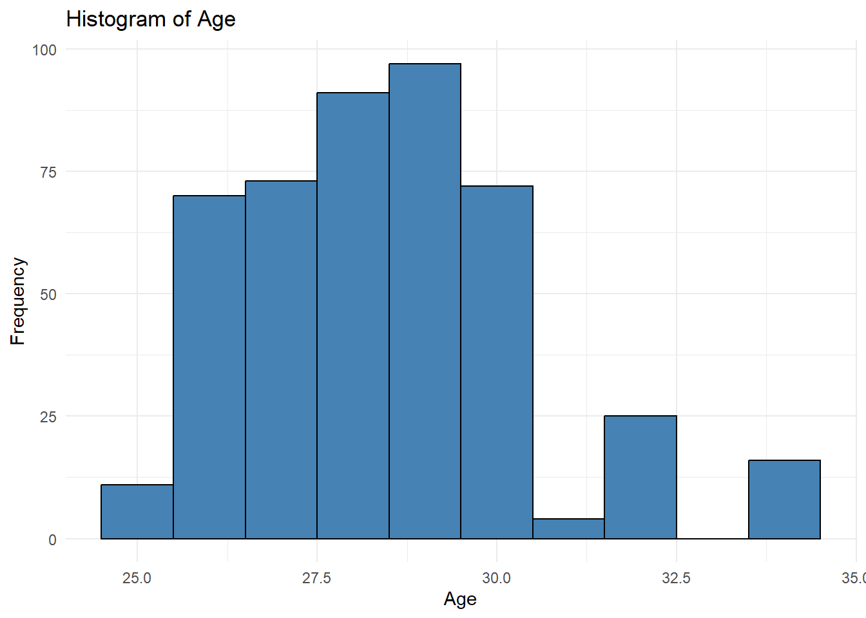
Figure 1
Histogram of Age
The histogram shows that Age values are tightly clustered within a narrow range, with most observations concentrated in the late twenties. This confirms the descriptive statistics, which show that the mean and median were nearly identical. The distribution appears approximately symmetric with a slight right skew, and no extreme age values are evident.
To further assess variability and outliers, a boxplot of Age was generated.
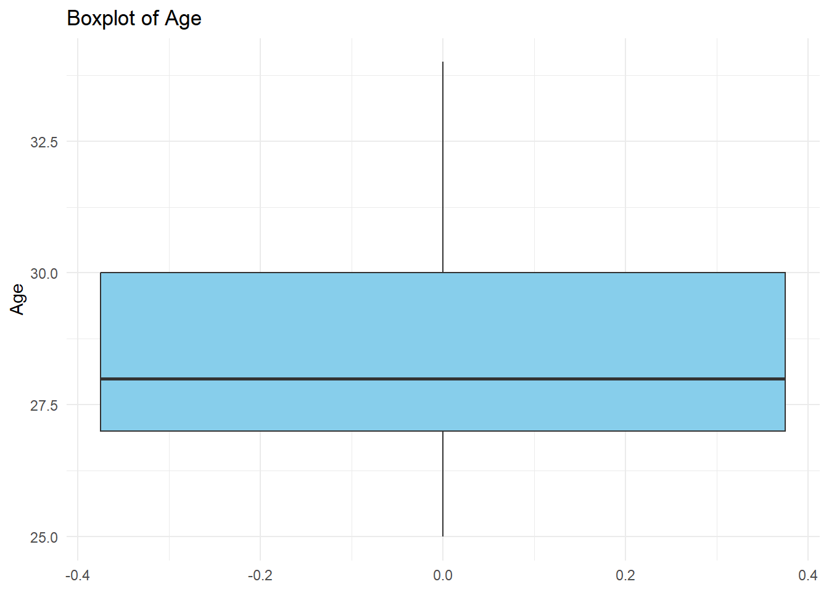
Figure 2
Boxplot of Age
The boxplot shows a small interquartile range (IQR), indicating that the middle 50% of Age values are closely grouped. The median is centrally located within the box, and no significant outliers are present. This reinforces the conclusion that Age exhibits limited variability within the dataset.
Income Distribution
Income was analyzed using a histogram to capture its broader range and higher variability relative to other numerical variables.
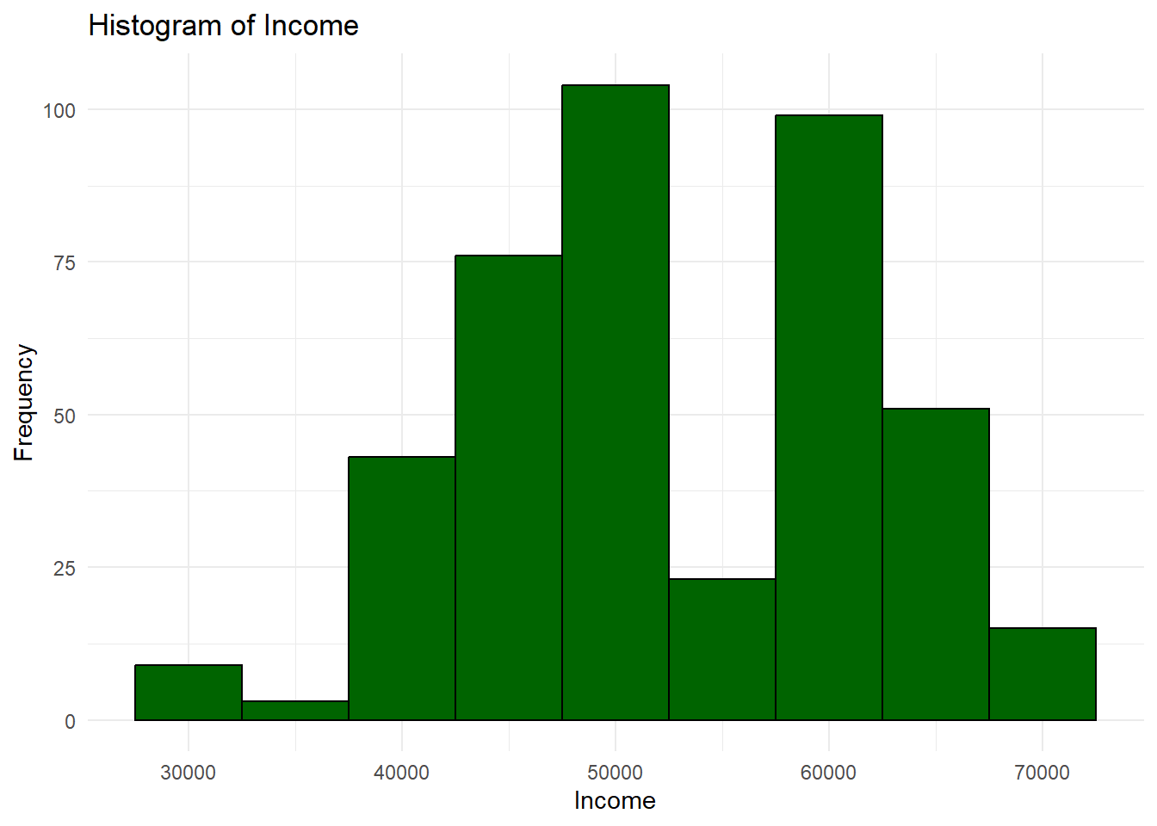
Figure 3
Histogram of Income
The histogram reveals a wider spread of Income values, with observations distributed across multiple income brackets. While the distribution is approximately symmetric, the greater dispersion indicates meaningful differences in economic status among participants. This visual pattern aligns with the high standard deviation observed in the descriptive statistics.
A boxplot was used to evaluate income variability and potential outliers further.
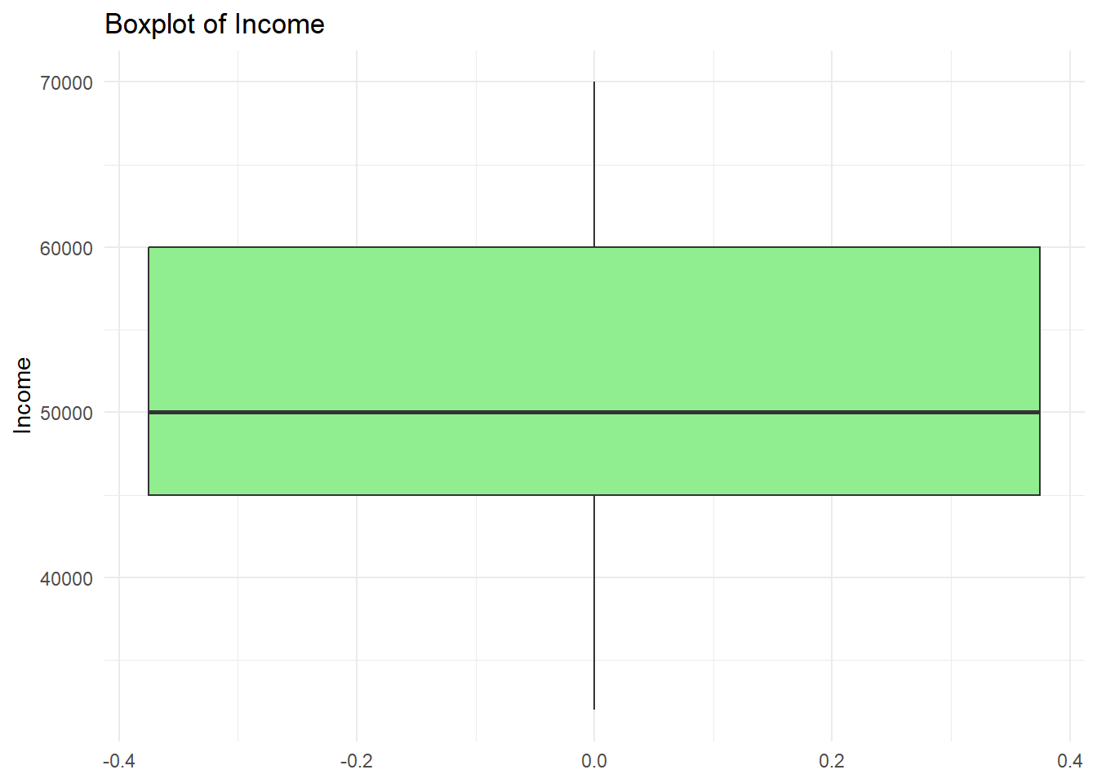
Figure 4
Boxplot of Income
The boxplot confirms that Income has the largest IQR among the numerical variables analyzed. Several values appear at the upper end of the distribution, though no extreme outliers are present. The wide spread suggests that Income may play a more influential role in differentiating outcomes in future analyses.
Happiness Distribution
Happiness scores were visualized to assess overall well-being levels within the dataset.
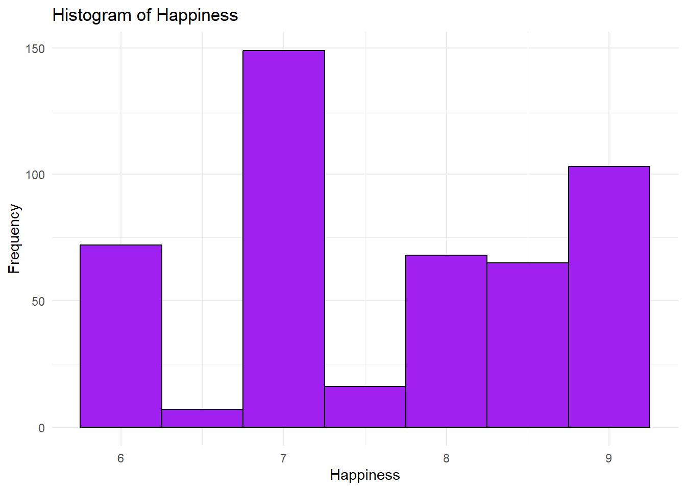
Figure 5
Histogram of Happiness
The histogram shows that Happiness values are moderately concentrated, with most observations falling between scores of 7 and 9. The distribution appears roughly symmetric, indicating that extreme low or high happiness scores are uncommon in the sample.
A boxplot was also generated to evaluate variability and potential outliers.
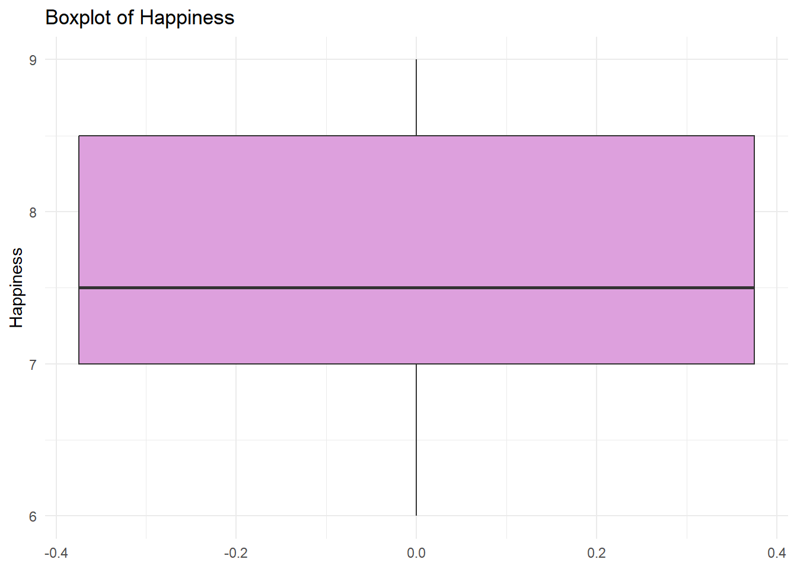
Figure 6
Boxplot of Happiness
The boxplot indicates a relatively small IQR, suggesting limited variability in Happiness scores. The median is positioned near the center of the box, and no substantial outliers are observed. This suggests that self-reported happiness levels are generally consistent across participants.
Categorical Variable Distributions
Bar charts were created for categorical variables to compare the frequency of observations across categories.
Gender Distribution
The distribution of Gender was examined using a bar chart.
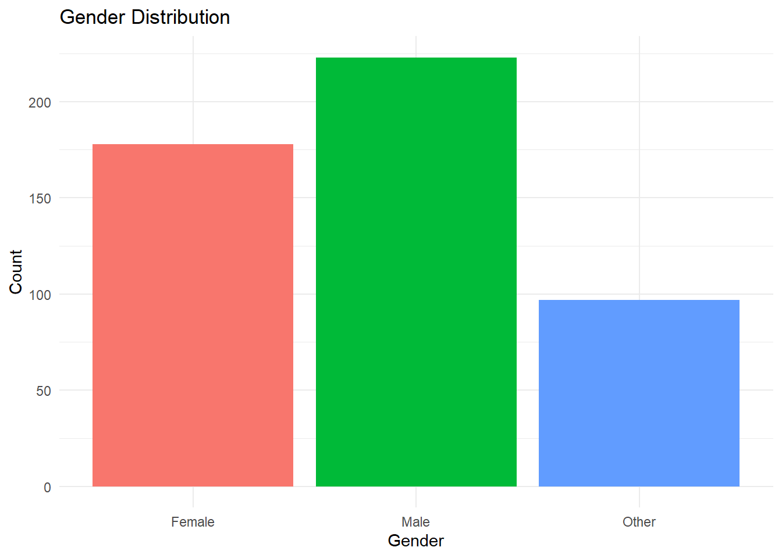
Figure 7
Gender Distribution
The bar chart shows that Male participants represent the largest proportion of the sample, followed by Female participants, with the Other category comprising a smaller share. While all gender categories are represented, the uneven distribution provides important context for interpreting relationships with other variables such as education and income.
Education Level Distribution
Educational attainment was visualized to assess the distribution of educational levels across the sample.
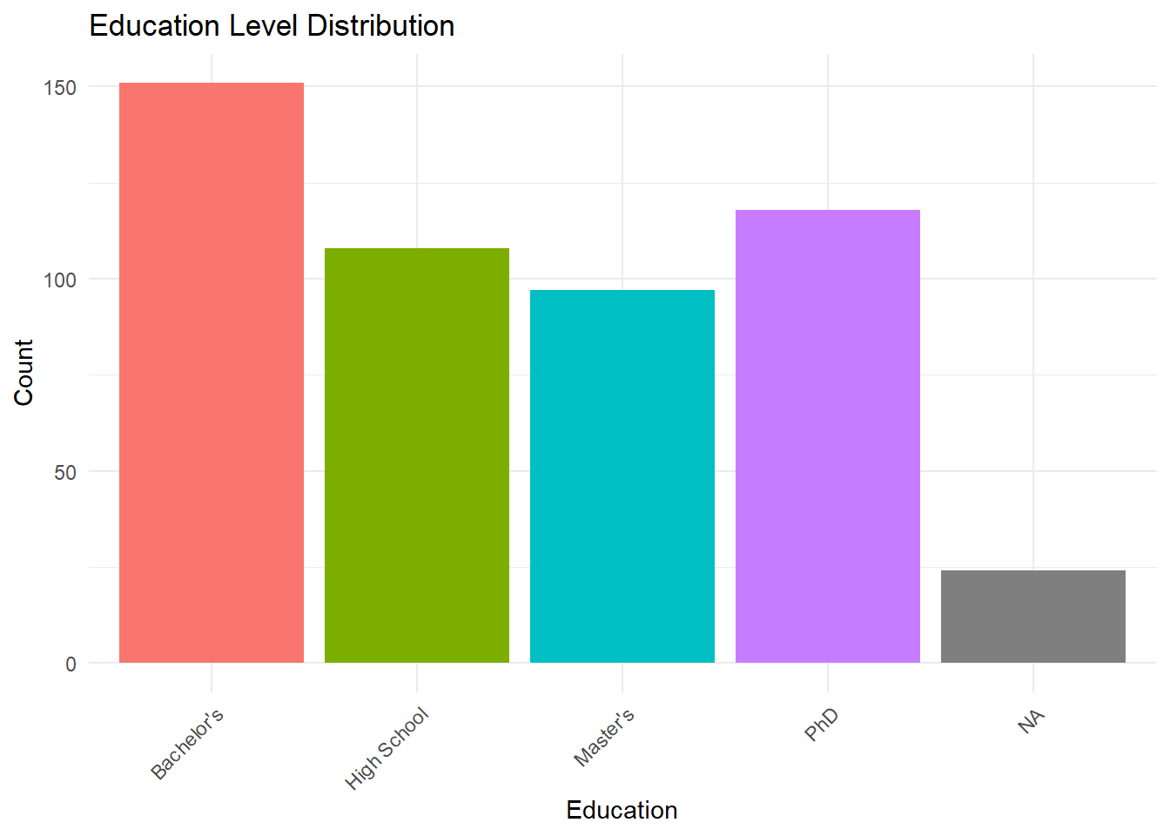
Figure 8
Education Level Distribution
The bar chart indicates that Bachelor’s degrees are the most common level of education in the dataset, followed by High School, Master’s, and PhD levels. This distribution suggests a concentration of participants at the undergraduate level, with fewer individuals represented at advanced degree levels.
Employment Status Distribution
Employment status was examined using a bar chart to summarize labor participation within the dataset.
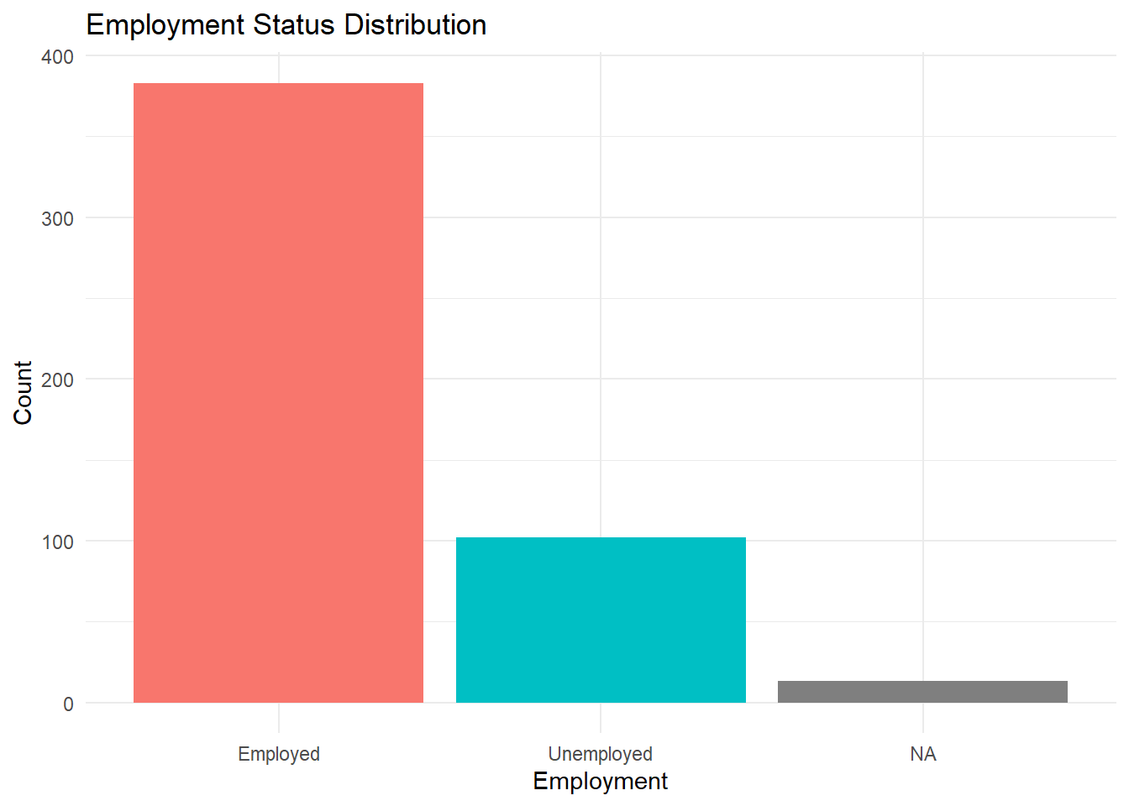
Figure 9
Employment Status Distribution
The bar chart shows that most participants are employed, with a smaller proportion classified as unemployed. This imbalance suggests relatively high labor force participation within the sample and provides important context for interpreting income-related findings.
Relationships Between Categorical Variables
To explore relationships between categorical variables, a contingency table and clustered bar chart were used to examine the association between Gender and Education level.
Table 1
Education Level by Gender
 | Female | Male | Other | Sum
Bachelor's | 138 | 4 | 9 | 151
High School | 10 | 26 | 72 | 108
Master's | 8 | 89 | 0 | 97
Phd | 0 | 103 | 15 | 118
Sum | 156 | 222 | 96 | 474

The contingency table presents the frequency of education levels across gender categories, enabling precise comparisons. The table reveals notable differences in educational attainment between genders, with Female participants primarily concentrated at the Bachelor’s level and Male participants more heavily represented at Master’s and PhD levels.
To complement the tabular summary, a clustered bar chart was generated.
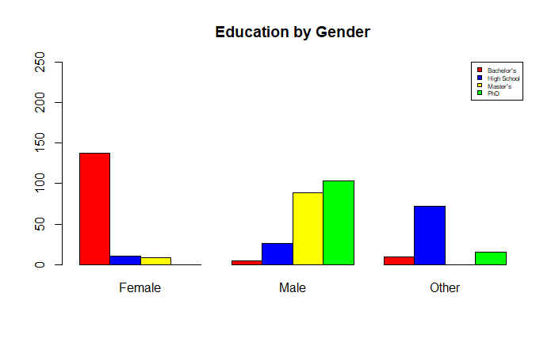
Figure 10
Education Level by Gender (Clustered Bar Chart)
The clustered bar chart visually reinforces the patterns observed in the table. Differences in educational attainment across gender categories are clearly visible, highlighting structural relationships within the dataset. These findings suggest that education may act as an important mediating factor in analyses involving employment and income.
Summary of Visual Findings
Collectively, the visual representations confirm and extend the insights obtained from descriptive statistics. Numerical variables differ substantially in variability, with Income showing the greatest dispersion and Age the least. Categorical analyses reveal meaningful associations, particularly between Gender and Education level. These graphical findings provide a strong descriptive foundation for subsequent inferential or predictive analysis.
Exploration Conclusions
The exploratory data analysis yielded several meaningful insights into the dataset's structure and characteristics. Numerical variables varied substantially in their level of dispersion, with Age showing very limited variability and Income exhibiting the greatest spread. This suggests that Age may be less influential in distinguishing outcomes within this sample, while Income represents a key variable for further analysis.
Visual analysis of categorical variables revealed notable relationships, particularly between Gender and Education level. Female participants were primarily concentrated at the Bachelor’s level, whereas male participants were more heavily represented at the Master’s and PhD levels. These differences highlight structural patterns that may influence related outcomes such as employment status and income.
No extreme anomalies or implausible values were identified after the data cleaning and structural correction process. Missing values were present but preserved intentionally to reflect the true condition of the data during exploratory analysis. Overall, the findings establish a strong descriptive foundation and support the selection of education, employment, and income variables for future inferential or predictive modeling.
Critique
Completing this exploratory analysis in R provided significant advantages over spreadsheet-based tools such as Excel. R offered greater flexibility, reproducibility, and efficiency, particularly when managing data cleaning, statistical computation, and visualization within a single workflow (Databricks, 2020).
While Excel may be sufficient for small datasets and simple analyses, the use of R dramatically reduces manual effort and the risk of human error. If the dataset were expanded from 500 to 50,000 observations, automated code-based analysis would scale efficiently, whereas a manual spreadsheet approach would become impractical.
From an organizational perspective, the ability to automate data processing and reporting using R can substantially increase productivity and support more timely, data-driven decision-making.

References
Databricks. (2020). Big book of data science (2nd ed.). Databricks.
https://www.databricks.com/resources/big-book-of-data-science
Kaliyadan, F., & Kulkarni, V. (2019). Types of variables, descriptive statistics, and sample size. Indian Dermatology Online Journal, 10(1), 82–86.
https://doi.org/10.4103/idoj.IDOJ_468_18
Knaflic, S. N. (2020). *Storytelling with data: A data visualization guide for business professionals* (2nd ed.). Wiley.
Wickham, H., Cook, D., & Hofmann, H. (2010). Graphical inference for exploratory data analysis. IEEE Transactions on Visualization and Computer Graphics, 16(6), 973–979. https://doi.org/10.1109/TVCG.2010.161

Writing example 14 phd essay 2

Predictive Data

Juan Maldonado Franco
Department of Technology, National University
DDS-8500: Principles of Data Science
Dr. Javier E. León
1/13/2026

Predictive Data
This report presents an exploratory data analysis (EDA) of a structured dataset containing demographic, socioeconomic, and behavioral variables, including age, gender, education level, employment status, income, and self-reported happiness. The purpose of this analysis is to summarize and explore the key characteristics of the data using descriptive statistics and visual representations prior to conducting any inferential or predictive modeling.
Exploratory data analysis plays a central role in modern data science by supporting an iterative process of data transformation, visualization, and interpretation that enables analysts to understand distributions, identify patterns, detect anomalies, and assess data quality (Wickham et al., 2010). In this study, the dataset was first cleaned and structurally corrected to address missing values, schema misalignment, and data type inconsistencies. Following this preparation, descriptive statistics and graphical techniques were applied to examine both numerical and categorical variables.
The primary goal of this report is to extract meaningful descriptive insights regarding the distribution of key variables, the variability within the data, and the relationships between selected categorical attributes. These findings provide a foundational understanding of the dataset and inform future analytical steps, including hypothesis testing and predictive analysis.
Data Presentation
The dataset used in this analysis consists of 500 observations, each representing an individual record. The data include both numerical and categorical variables spanning demographic characteristics, educational attainment, employment status, income, and subjective well-being. After the data cleaning and structural correction phase, the dataset contained 16 variables, excluding identifiers used solely for indexing.
Numerical variables include Age, Height, Weight, Income, Score, and Happiness. These variables are measured on either ratio or interval scales and allow computation of measures such as the mean, median, standard deviation, and range (Kaliyadan & Kulkarni, 2019). Categorical variables include Gender, Education, Marital Status, Employment, Rating, Category, Color, Hobby, and Location, which are measured on nominal or ordinal scales.
The sample size of 500 observations is appropriate for descriptive analysis, as it provides sufficient representation across categories while allowing stable estimation of summary statistics. Although missing values are present, they were intentionally preserved during exploratory analysis to accurately reflect the structure and limitations of the original data.
A structured table summarizing variable types and measurement scales is included to support clarity and transparency in the presentation of the dataset.
Descriptive Statistics
Descriptive statistics were computed for all numerical variables to summarize central tendency, variability, and distributional shape. The variables analyzed included Age, Height, Weight, Income, Score, and Happiness.
Age exhibited a narrow distribution with a mean of 28.44 and a median of 28, indicating minimal variability across the sample. Income demonstrated substantially greater dispersion, with a mean of 52,408.98 and a significant standard deviation of 9,271.09, highlighting meaningful differences in economic status among participants. Happiness scores were moderately concentrated, with a mean of 7.64 and relatively low variability.
Across all numerical variables, skewness and kurtosis values suggested approximately symmetric distributions with no extreme deviations. These results indicate that the data are well-suited for further exploratory and inferential analysis.
Descriptive Questions
Based on the initial data exploration and descriptive statistics, the following descriptive research questions were developed to guide the exploratory analysis:
1. What is the distribution of Age within the dataset, and how much variability exists among participants?
2. How is Income distributed across the sample, and does it exhibit greater dispersion compared to other numerical variables?
3. How does educational attainment vary by Gender within the dataset?
4. How is Employment status distributed across demographic groups?
These questions focus on both single-variable characteristics and relationships between categorical variables. Prior research in data analytics suggests that demographic attributes such as education, employment, and income are closely associated with socioeconomic outcomes and well-being. Exploring these relationships descriptively provides essential context before performing inferential or predictive analysis.
Visual Representations
Visual representations were used to complement descriptive statistics and to provide intuitive insight into the structure, distribution, and relationships within the dataset. Graphical methods allow patterns and differences to be identified more easily than numerical summaries alone, particularly when communicating findings to non-technical audiences (Knaflic, 2020). The following figures and tables present visual summaries of both numerical and categorical variables examined in this exploratory analysis.
Numerical Variable Distributions
Histograms and boxplots were created for numerical variables to examine distributional shape, central tendency, variability, and potential outliers.
Age Distribution
The distribution of Age was examined using a histogram to visualize the frequency of observations across age values.
Figure 1
Histogram of Age
The histogram shows that Age values are tightly clustered within a narrow range, with most observations concentrated in the late twenties. This confirms the descriptive statistics, which show that the mean and median were nearly identical. The distribution appears approximately symmetric with a slight right skew, and no extreme age values are evident.
To further assess variability and outliers, a boxplot of Age was generated.
Figure 2
Boxplot of Age
The boxplot shows a small interquartile range (IQR), indicating that the middle 50% of Age values are closely grouped. The median is centrally located within the box, and no significant outliers are present. This reinforces the conclusion that Age exhibits limited variability within the dataset.
Income Distribution
Income was analyzed using a histogram to capture its broader range and higher variability relative to other numerical variables.
Figure 3
Histogram of Income
The histogram reveals a wider spread of Income values, with observations distributed across multiple income brackets. While the distribution is approximately symmetric, the greater dispersion indicates meaningful differences in economic status among participants. This visual pattern aligns with the high standard deviation observed in the descriptive statistics.
A boxplot was used to evaluate income variability and potential outliers further.
Figure 4
Boxplot of Income
The boxplot confirms that Income has the largest IQR among the numerical variables analyzed. Several values appear at the upper end of the distribution, though no extreme outliers are present. The wide spread suggests that Income may play a more influential role in differentiating outcomes in future analyses.
Happiness Distribution
Happiness scores were visualized to assess overall well-being levels within the dataset.
Figure 5
Histogram of Happiness
The histogram shows that Happiness values are moderately concentrated, with most observations falling between scores of 7 and 9. The distribution appears roughly symmetric, indicating that extreme low or high happiness scores are uncommon in the sample.
A boxplot was also generated to evaluate variability and potential outliers.
Figure 6
Boxplot of Happiness
The boxplot indicates a relatively small IQR, suggesting limited variability in Happiness scores. The median is positioned near the center of the box, and no substantial outliers are observed. This suggests that self-reported happiness levels are generally consistent across participants.
Categorical Variable Distributions
Bar charts were created for categorical variables to compare the frequency of observations across categories.
Gender Distribution
The distribution of Gender was examined using a bar chart.
Figure 7
Gender Distribution
The bar chart shows that Male participants represent the largest proportion of the sample, followed by Female participants, with the Other category comprising a smaller share. While all gender categories are represented, the uneven distribution provides important context for interpreting relationships with other variables such as education and income.
Education Level Distribution
Educational attainment was visualized to assess the distribution of educational levels across the sample.
Figure 8
Education Level Distribution
The bar chart indicates that Bachelor’s degrees are the most common level of education in the dataset, followed by High School, Master’s, and PhD levels. This distribution suggests a concentration of participants at the undergraduate level, with fewer individuals represented at advanced degree levels.
Employment Status Distribution
Employment status was examined using a bar chart to summarize labor participation within the dataset.
Figure 9
Employment Status Distribution
The bar chart shows that most participants are employed, with a smaller proportion classified as unemployed. This imbalance suggests relatively high labor force participation within the sample and provides important context for interpreting income-related findings.
Relationships Between Categorical Variables
To explore relationships between categorical variables, a contingency table and clustered bar chart were used to examine the association between Gender and Education level.
Table 1
Education Level by Gender
 | Female | Male | Other | Sum
Bachelor's | 138 | 4 | 9 | 151
High School | 10 | 26 | 72 | 108
Master's | 8 | 89 | 0 | 97
Phd | 0 | 103 | 15 | 118
Sum | 156 | 222 | 96 | 474

The contingency table presents the frequency of education levels across gender categories, enabling precise comparisons. The table reveals notable differences in educational attainment between genders, with Female participants primarily concentrated at the Bachelor’s level and Male participants more heavily represented at Master’s and PhD levels.
To complement the tabular summary, a clustered bar chart was generated.
Figure 10
Education Level by Gender (Clustered Bar Chart)
The clustered bar chart visually reinforces the patterns observed in the table. Differences in educational attainment across gender categories are clearly visible, highlighting structural relationships within the dataset. These findings suggest that education may act as an important mediating factor in analyses involving employment and income.
Summary of Visual Findings
Collectively, the visual representations confirm and extend the insights obtained from descriptive statistics. Numerical variables differ substantially in variability, with Income showing the greatest dispersion and Age the least. Categorical analyses reveal meaningful associations, particularly between Gender and Education level. These graphical findings provide a strong descriptive foundation for subsequent inferential or predictive analysis.
Exploration Conclusions
The exploratory data analysis yielded several meaningful insights into the dataset's structure and characteristics. Numerical variables varied substantially in their level of dispersion, with Age showing very limited variability and Income exhibiting the greatest spread. This suggests that Age may be less influential in distinguishing outcomes within this sample, while Income represents a key variable for further analysis.
Visual analysis of categorical variables revealed notable relationships, particularly between Gender and Education level. Female participants were primarily concentrated at the Bachelor’s level, whereas male participants were more heavily represented at the Master’s and PhD levels. These differences highlight structural patterns that may influence related outcomes such as employment status and income.
No extreme anomalies or implausible values were identified after the data cleaning and structural correction process. Missing values were present but preserved intentionally to reflect the true condition of the data during exploratory analysis. Overall, the findings establish a strong descriptive foundation and support the selection of education, employment, and income variables for future inferential or predictive modeling.
Predictive Research Questions
Building on the exploratory data analysis presented in the previous sections, this phase of the analysis shifts from descriptive exploration to predictive modeling. The descriptive findings highlighted meaningful variability in Income, as well as notable demographic patterns related to Age, Gender, and Education. These observations suggest that Income is an appropriate outcome variable for predictive analysis and that demographic and socioeconomic characteristics may provide explanatory value.
Predictive analytics aims to estimate future or unknown outcomes by modeling relationships between variables using statistical techniques such as linear regression. In this context, predictive modeling allows for the evaluation of how individual and combined predictors contribute to variation in Income, while also assessing model adequacy and practical significance.
Based on the exploratory findings and the correlation evidence summarized below, the following predictive research questions were developed.
Predictive Research Question 1
RQ1: To what extent does Age predict Income among individuals in the dataset?
This question examines whether Age alone provides meaningful predictive information about Income. Prior research in labor economics and data analytics suggests that income often increases with age due to accumulated work experience, skill development, and career progression. However, the strength of this relationship varies depending on contextual factors such as education and labor market structure.
From a practical perspective, understanding the predictive value of Age can inform baseline expectations in workforce and socioeconomic analyses. This relationship may be relevant to organizations involved in workforce planning, compensation analysis, or demographic forecasting. The single linear regression model associated with this question provides a clear and interpretable foundation for evaluating predictive strength, statistical significance, and model fit.
Predictive Research Question 2
RQ2: How do Age, Gender, and Education jointly predict Income when considered simultaneously?
While Age may be associated with Income, it is unlikely to fully explain income variation on its own. Education level and Gender are well-documented factors in income research and often interact with age-related trends. This second research question extends the analysis by incorporating both numerical and categorical predictors into a multiple linear regression model.
Evaluating these predictors simultaneously allows for the assessment of their independent contributions while controlling for the influence of the others. This approach provides a more realistic and robust predictive framework than a single-variable model. The results of this analysis are particularly relevant for stakeholders interested in understanding structural income differences, such as policymakers, organizational leaders, and analysts examining equity and labor market outcomes.
Together, these two predictive research questions establish a progression from a simple baseline model to a more comprehensive multivariable model. This structure supports both interpretability and analytical rigor and provides a foundation for evaluating predictive performance, model adequacy, and practical implications using the regression results presented below.
Correlation Analysis
Prior to estimating regression models, a correlation analysis was conducted to evaluate the strength and direction of relationships among the numerical variables included in the dataset. Correlation analysis provides an important preliminary assessment of whether linear predictive modeling is appropriate and helps identify which variables may offer meaningful explanatory value.
A correlation matrix was generated to summarize pairwise correlations among the selected numerical variables, including Age, Income, Happiness, Score, Height, and Weight.
Table 2
Correlation Matrix of Numerical Variables
 | Age | Income | Happiness | Score | Height | Weight
Age | 1 | 0.530108 | 0.454177 | 0.639117 | 0.646801 | 0.64231
Income | 0.530108 | 1 | 0.697366 | 0.873922 | 0.55318 | 0.460587
Happiness | 0.454177 | 0.697366 | 1 | 0.813178 | 0.140197 | 0.031301
Score | 0.639117 | 0.873922 | 0.813178 | 1 | 0.336212 | 0.198927
Height | 0.646801 | 0.55318 | 0.140197 | 0.336212 | 1 | 0.986797
Weight | 0.64231 | 0.460587 | 0.031301 | 0.198927 | 0.986797 | 1
The correlation coefficients indicate that Income exhibits a moderate positive association with Age, supporting the selection of Age as a predictor variable in the initial regression model. Stronger associations are observed between Income and Score, as well as between Income and Happiness, suggesting that income in this dataset is closely related to performance-related and subjective well-being measures. In contrast, Height and Weight display an extremely high correlation, indicating redundancy between these variables and reinforcing their exclusion from regression modeling to avoid multicollinearity.
To provide a more intuitive summary of these relationships, a correlation heatmap was used.
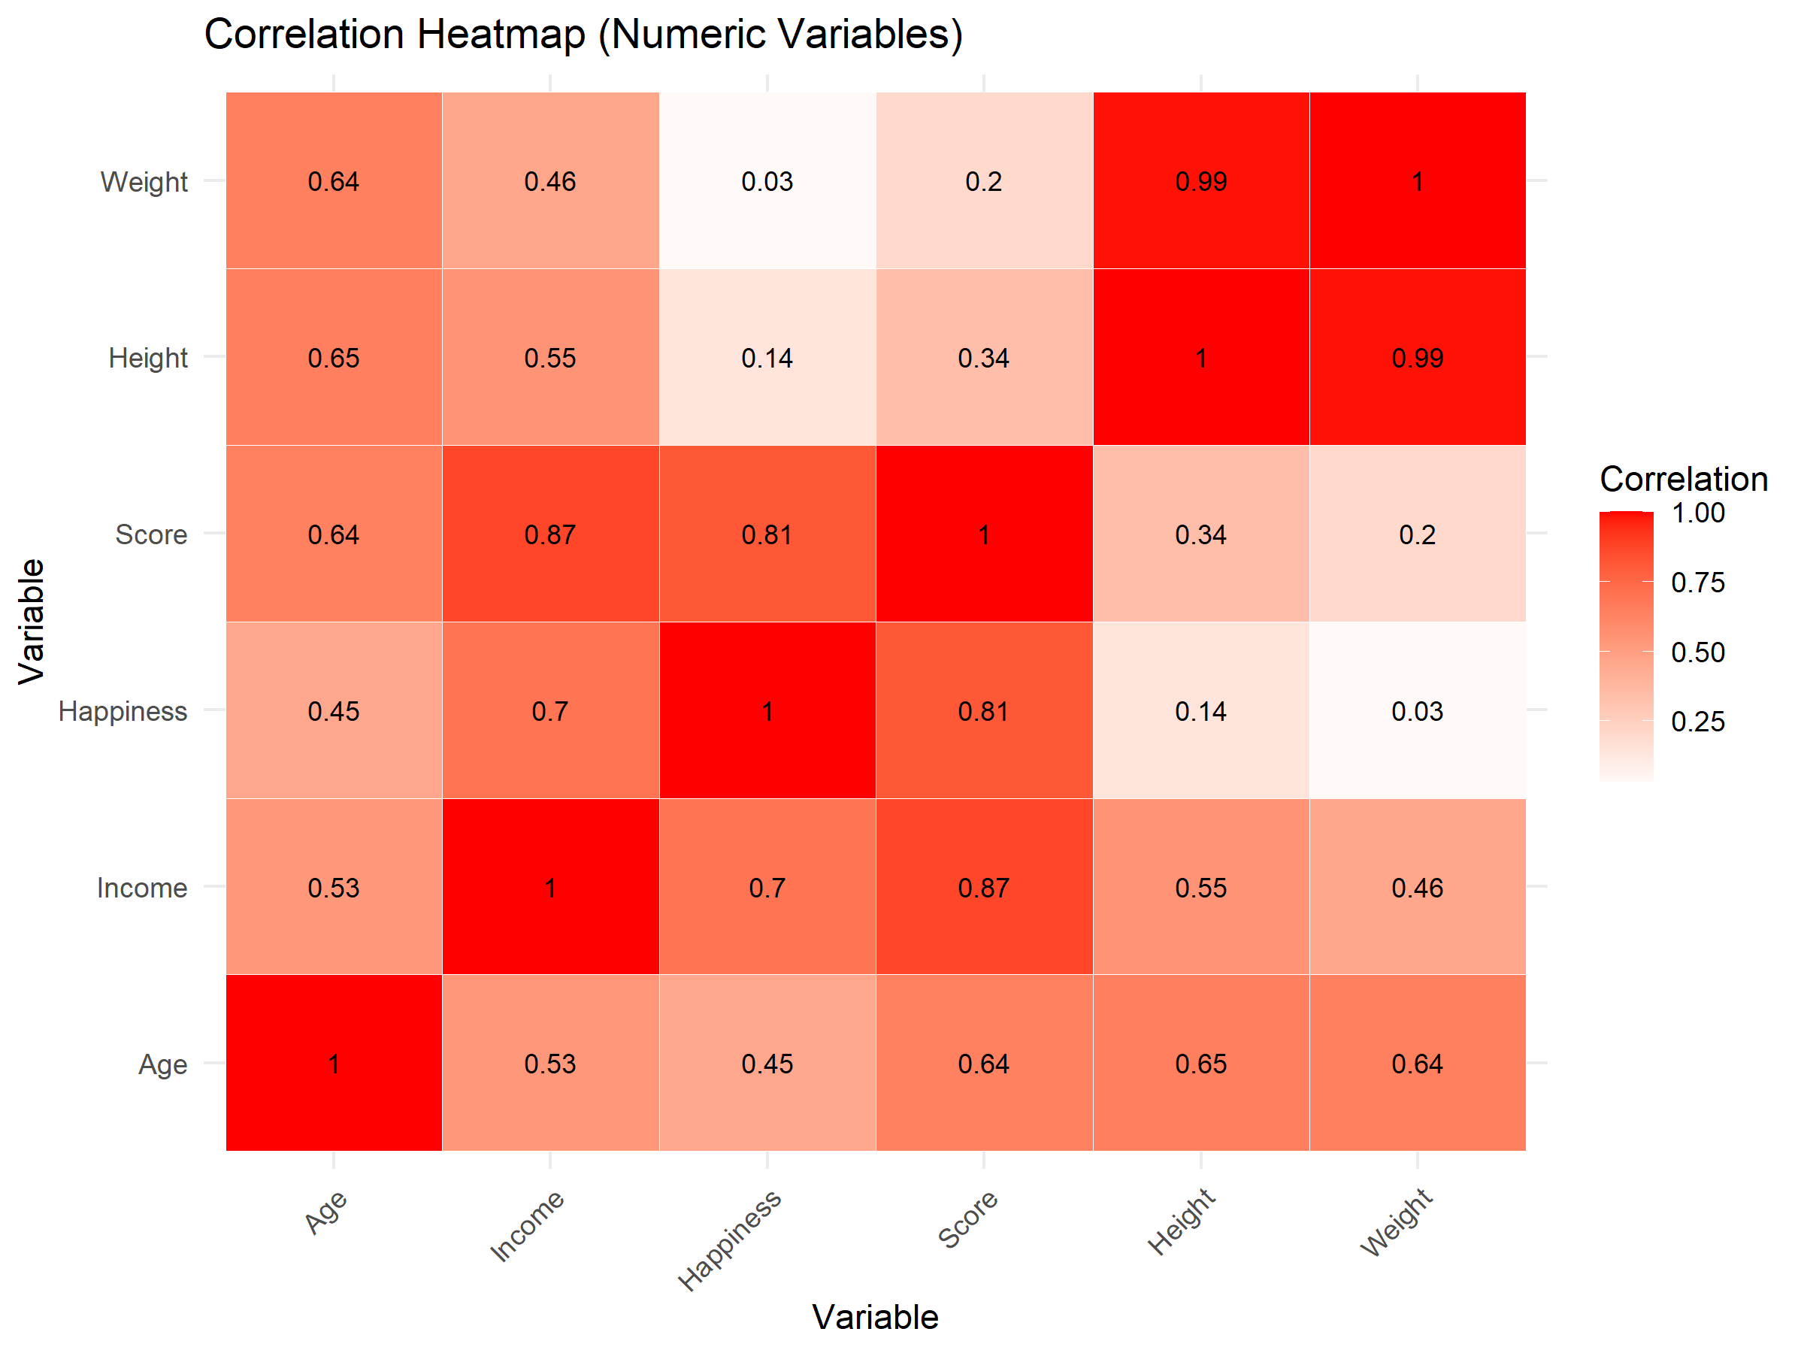
Figure 11
Correlation Heatmap of Numerical Variables
The heatmap visually highlights the relative strength and direction of correlations, making it easier to distinguish strong, moderate, and weak associations. Importantly, the primary predictors used in subsequent regression models (Age, Gender, and Education) do not exhibit extreme correlations with one another, reducing concerns about severe multicollinearity.
It is important to note that correlation analysis identifies association rather than causation. The observed relationships do not imply that changes in one variable directly cause changes in another. Instead, the correlation results serve as an exploratory screening tool that informs model specification and variable selection. This analysis provides evidence of a strong correlation, supporting the use of linear regression as a reasonable predictive approach and motivating the inclusion of additional demographic variables to improve explanatory power.
Overall, the correlation analysis establishes a clear analytical bridge between the exploratory findings and the predictive models that follow.
Linear Regression Models
To address the predictive research questions, linear regression models were estimated to quantify the relationship between Income and selected demographic predictors. Linear regression is an appropriate predictive method when relationships between variables are approximately linear and when model assumptions are reasonably satisfied. The results presented below evaluate both a simple baseline model and a more comprehensive multivariable model.
Model 1: Single Linear Regression (Income ~ Age)
The first model examines whether Age alone provides meaningful predictive information about Income.
Table 3
Single Linear Regression Results for Income ~ Age
Term | Estimate | Std. Error | t value | Pr(>|t|)
(Intercept) | -12949.5 | 5257.291 | -2.46315 | 0.014204
Age | 2273.314 | 184.3659 | 12.33045 | 1.03E-29
The estimated coefficient for Age is positive and statistically significant, indicating that Income tends to increase as Age increases. The associated p-value is well below conventional significance thresholds, providing strong evidence that Age is related to Income in this dataset. This finding aligns with expectations from socioeconomic research, where age is often associated with increased work experience and earning potential.
The coefficient of determination (R²) indicates that Age explains a modest portion of the total variation in Income. While the relationship is statistically significant, the R² value suggests that Age alone does not capture the full complexity of income differences among individuals, highlighting the distinction between statistical significance and predictive strength.
A scatterplot was used to visually examine the relationship between Age and Income.
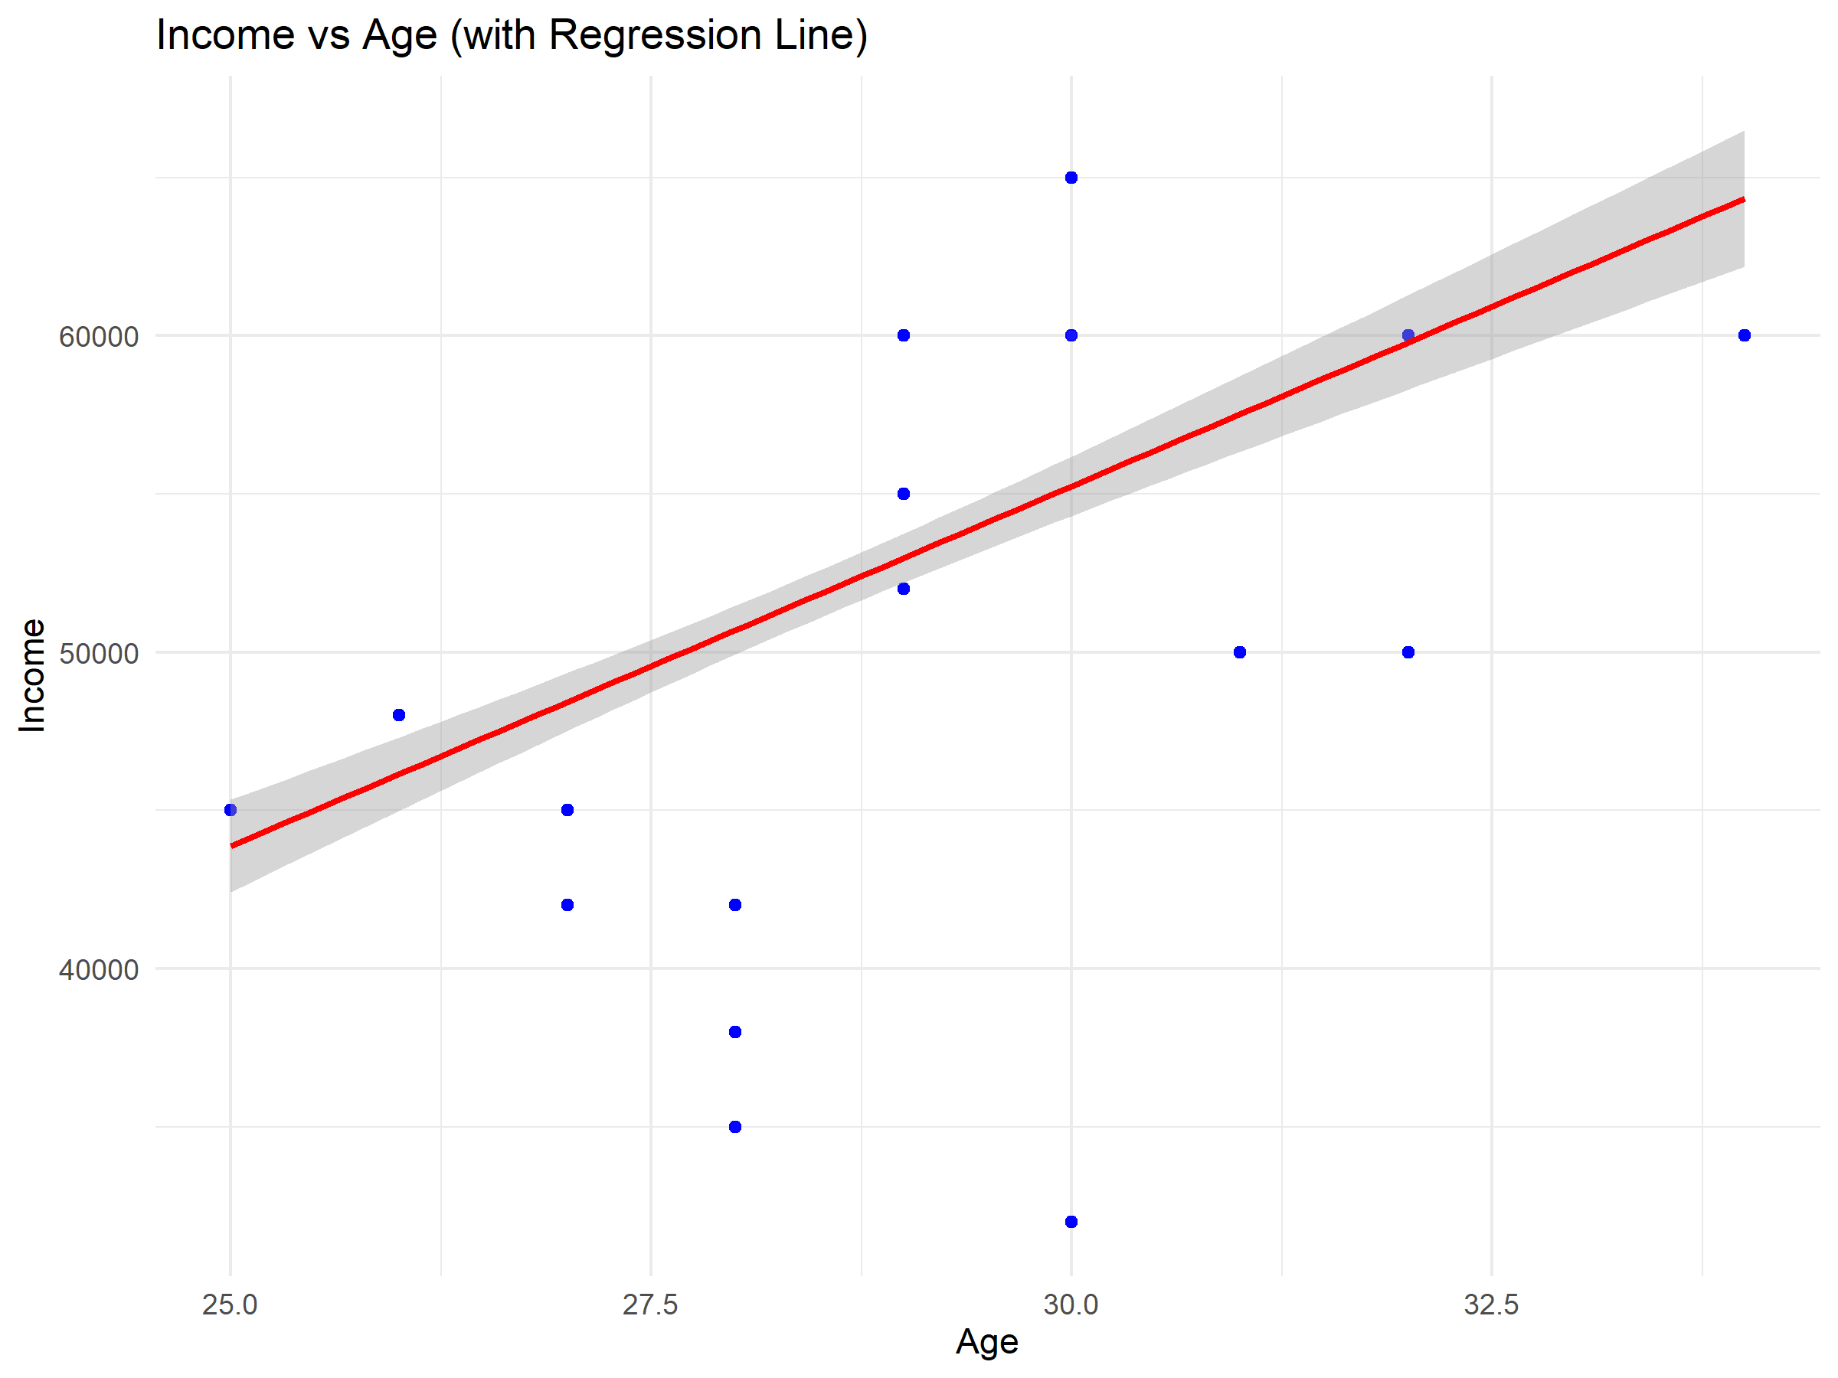
Figure 12
Scatterplot of Income vs. Age with Regression Line
The scatterplot shows a generally upward trend, supporting the assumption of linearity, while also revealing increasing dispersion around the regression line at higher ages. This pattern suggests that income variability grows later in the age range, indicating that while Age contributes to income prediction, it does so with increasing uncertainty. These findings motivate the inclusion of additional predictors in a multivariable model.
Overall, Model 1 serves as a useful baseline, demonstrating that Age is a relevant predictor of Income but is insufficient on its own for strong prediction. The observed relationship between Age and Income is consistent with empirical research showing that earnings tend to increase with age and labor market experience while explaining only a limited portion of overall income variation (Lemieux, 2014).
Model 2: Multiple Linear Regression (Income ~ Age + Gender + Education)
To improve predictive performance and account for additional sources of variation, a multiple linear regression model was estimated using Age, Gender, and Education as predictors.
Table 4
Multiple Linear Regression Results for Income ~ Age + Gender + Education
Term | Estimate | Std. Error | t value | Pr(>|t|)
(Intercept) | 59763.88 | 3898.987 | 15.32805 | 3.37E-41
Age | -483.039 | 145.7803 | -3.31347 | 0.001015
Gender Male | 3093.588 | 758.2523 | 4.079892 | 5.55E-05
Gender Other | -2406.35 | 856.7312 | -2.80876 | 0.005244
Education High School | -9844.5 | 728.3256 | -13.5166 | 5.69E-34
Education Master's | 13021.5 | 874.8264 | 14.88467 | 2.08E-39
Education PhD | 11275.89 | 840.4625 | 13.41629 | 1.41E-33
The multiple regression model exhibits a substantially higher R² and adjusted R² compared to the single-predictor model, indicating that the inclusion of Gender and Education significantly improves the model’s explanatory power. This result demonstrates the value of incorporating both numerical and categorical variables when modeling complex socioeconomic outcomes such as Income.
Interpreting the coefficients relative to their reference categories, Education emerges as a particularly strong predictor of Income. Higher levels of educational attainment are associated with substantially higher predicted Income, while lower levels are associated with lower predicted Income. Gender also shows statistically significant differences in predicted Income across categories, even after controlling for Age and Education. The coefficient for Age changes in magnitude and direction compared to the single-variable model, reflecting the interdependence among predictors and illustrating how controlling for additional variables can alter individual effects.
Regression diagnostics were examined to assess model assumptions.
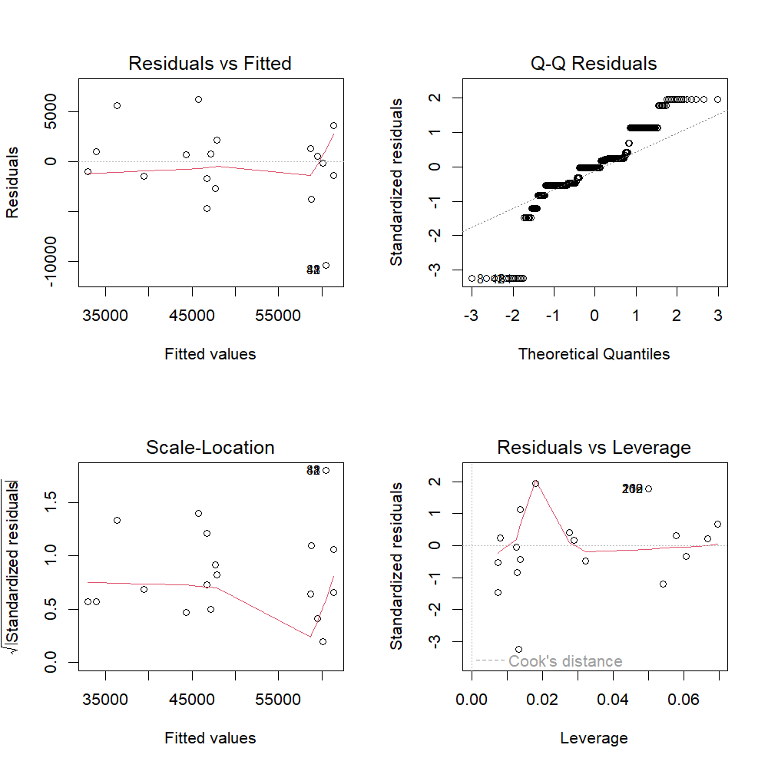
Figure 13
Regression Diagnostics for Multiple Linear Regression Model
The diagnostic plots suggest that linearity and approximate normality of residuals are largely satisfied, although mild deviations are observed at higher fitted income values. These patterns are common in income data and indicate some heteroscedasticity at the upper end of the income distribution, but no extreme violations or highly influential observations were identified that would undermine the model’s suitability for exploratory predictive purposes.
The strong predictive contribution of Education and the persistence of income differences across Gender categories are consistent with extensive empirical research demonstrating that educational attainment and gender remain key determinants of earnings, even after controlling for age and experience (Blau & Kahn, 2017). More recent large-scale evidence further reinforces the presence of gender-related income disparities across diverse labor markets, supporting the inclusion of Gender as a meaningful predictor in income models (Muñoz et al., 2025).
A summary of model sample sizes and missing data was used to evaluate potential limitations.
Table 5
Model Sample Size and Missing Data Summary
Model | Total_Observations | Observations_Used | Observations_Dropped
Single Regression | 498 | 391 | 107
Multiple Regression | 498 | 368 | 130
While some observations were excluded due to missing predictor values, the remaining sample is sufficiently large to support stable estimation and meaningful interpretation of results.
Model Comparison and Interpretation
Comparing the two models highlights the limitations of single-predictor approaches and the advantages of multivariable modeling. While the single regression demonstrates that Age is related to Income, the multiple regression reveals that Education and Gender account for a substantial portion of income variation that Age alone cannot explain.
From a predictive standpoint, the multiple regression model provides a more realistic and informative representation of income dynamics. From an analytical perspective, this progression from a simple to a more complex model illustrates best practices in predictive analysis: begin with an interpretable baseline and then expand the model to improve explanatory and predictive performance while monitoring assumptions and limitations.
Together, these regression analyses address the predictive research questions and demonstrate how linear regression can be used to evaluate both individual and combined predictors of Income in a structured and methodologically sound manner.

References
Blau, F. D., & Kahn, L. M. (2017). The Gender Wage Gap: Extent, Trends, and Explanations. Journal of Economic Literature, 55(3), 789–865. https://doi.org/10.1257/jel.20160995
Databricks. (2020). Big book of data science (2nd ed.). Databricks.
https://www.databricks.com/resources/big-book-of-data-science
Kaliyadan, F., & Kulkarni, V. (2019). Types of variables, descriptive statistics, and sample size. Indian Dermatology Online Journal, 10(1), 82–86.
https://doi.org/10.4103/idoj.IDOJ_468_18
Knaflic, S. N. (2020). *Storytelling with data: A data visualization guide for business professionals* (2nd ed.). Wiley.
Lemieux, T. (2008). The Changing Nature of Wage Inequality. Journal of Population Economics, 21(1), 21–48. https://doi.org/10.1007/s00148-007-0169-0
Muñoz, E., Sansone, D., & Tampellini, J. (2025). Relative Income and Gender Norms: Evidence from Latin America.
Wickham, H., Cook, D., & Hofmann, H. (2010). Graphical inference for exploratory data analysis. IEEE Transactions on Visualization and Computer Graphics, 16(6), 973–979. https://doi.org/10.1109/TVCG.2010.161

Writing example 15 journal 1
Reflective Journal: The Five V’s in Medical Document Digitization
For this journal, I chose an image processing application that supports the digitization of medical documents, particularly for healthcare systems that have not yet fully transitioned from paper-based records. I was drawn to this application because access to historical medical information is essential for patient care, yet many countries still rely on physical records that are difficult to retrieve and analyze. Image processing systems that integrate optical character recognition (OCR) and natural language processing (NLP) make it possible to convert scanned documents into searchable, structured digital data. Recent research shows that combining OCR with NLP significantly improves text accuracy and usability, especially for degraded or handwritten documents (Askarov et al., 2025), making this approach highly relevant for healthcare digitization.
Volume
What stands out to me most regarding volume is the sheer scale of data involved in healthcare recordkeeping. Healthcare systems accumulate large quantities of patient information over time, including clinical notes, diagnostic results, and administrative records. As records span many years or even decades, digitization efforts must handle vast collections of scanned images and extracted text. According to the World Health Organization (2021), health data volumes continue to grow rapidly as healthcare becomes increasingly data-driven. Digitizing historical medical records therefore produces large datasets that require scalable storage and processing solutions consistent with big data applications.
Variety
The variety of data involved in medical document digitization is particularly challenging and is one reason this application is well suited to image processing and NLP techniques. Medical records include handwritten physician notes, scanned PDFs, lab result sheets, demographic information from identification documents, and clinical reports with inconsistent formats. Much of this data is unstructured or semi-structured, making automated extraction difficult. Askarov et al. (2025) highlight how OCR struggles with handwriting variation, faded ink, and document degradation, and how NLP techniques such as contextual correction and entity recognition help address these issues. This diversity of formats demonstrates why healthcare data requires flexible and adaptive data science methods.
Velocity
Velocity in this application is less about high-speed streaming and more about timely availability of information. During initial digitization efforts, healthcare systems may need to process large volumes of historical records in batches. Once systems are operational, new documents such as lab results or clinical notes are generated continuously and must be incorporated quickly so that providers can access up-to-date patient information. I view velocity here as an operational necessity rather than a technical luxury, since delays in processing medical records can negatively affect clinical workflows and patient care (Office of the National Coordinator for Health Information Technology [ONC], 2020).
Veracity
Veracity is the most critical V in this application because inaccuracies in medical data can have serious consequences. OCR systems are prone to errors caused by poor image quality, handwritten text, and aging documents. Askarov et al. (2025) demonstrate that integrating NLP with OCR significantly improves accuracy by using contextual analysis and language modeling to correct recognition errors. Even with these advances, human oversight and validation remain important to ensure reliability. This reinforces the idea that high data quality is essential in healthcare digitization, where trust in the data directly affects patient safety.
Value
The value of digitizing medical documents becomes clear when considering both clinical and analytical benefits. Digitized records allow healthcare providers to access patient histories more efficiently, reduce administrative burden, and make better-informed treatment decisions. From a data science perspective, structured digital records enable large-scale analysis of both structured and unstructured medical data, such as identifying patterns in clinical or radiology notes. In my view, this application demonstrates how transforming paper-based records into digital data creates value not only for individual patients but also for healthcare systems and public health research more broadly (World Health Organization, 2021).

References
Askarov, M., Gafforov, A., Darmonova, A., Dadakhonova, M., Ismailov, T., & Qushnazarova, U. (2025). Preserving historical documents using OCR and natural language processing (NLP). In 2025 International Conference on Computational Innovations and Engineering Sustainability (ICCIES) (pp. 1–6). IEEE. https://doi.org/10.1109/ICCIES63851.2025.11032769
Preserving_Historical_Documents…
Office of the National Coordinator for Health Information Technology. (2020). What is an electronic health record (EHR)? https://www.healthit.gov
World Health Organization. (2021). Global strategy on digital health 2020–2025. https://www.who.int/publications/i/item/9789240020924

Writing example 16 essay 3

Data Repositories in an Integrated Health and Nutrition Companion Application
itle
Juan Maldonado Franco
Department of Technology, National University
DDS-8500: Principles of Data Science
Dr. Javier E. León
1/13/2026

Data Repositories in an Integrated Health and Nutrition Companion Application
Artificial intelligence and data science applications increasingly depend on the ability to integrate, interpret, and personalize information drawn from many data sources. As systems move toward real-time insights and adaptive recommendations, the challenge becomes more than simply storing data. The system must preserve raw data for future learning, maintain trusted facts for safety, and support reasoning over complex relationships. No single repository is optimized for all of these requirements simultaneously. For that reason, modern AI systems typically rely on layered architectures in which different repositories support governance, intelligence, and access in complementary ways (Katakam & Rankin, 2025).
Data repositories are not interchangeable technologies. Relational databases are designed to manage structured data with consistency and strong governance. Data lakes are designed for scale and variety, enabling the storage of raw data in its original form. Graph databases are designed to represent relationships explicitly and support reasoning across interconnected entities. These differences matter because AI systems are shaped by how data can be accessed, validated, and connected. Choosing the wrong repository for the wrong task either limits model performance or undermines trust in the system’s output.
This paper examines three repositories, data lakes, relational databases, and graph databases, through the lens of an Integrated Health and Nutrition Companion Application. The application is intended to unify personal health signals (e.g., CGMs and wearables), clinical information (e.g., labs, medications, and diagnoses), and nutrition planning into a single system. It supports real-time monitoring, proactive risk flags, culturally relevant meal planning, and conversational access to personal health history. Over time, it learns how a user’s body responds to food and lifestyle choices and adapts recommendations accordingly.
Rather than presenting repositories in a traditional instructional order, this paper examines them in the order that reflects how the application would operate in practice. The data lake is discussed first as the ingestion and long-term memory layer. The relational database is discussed next as the trusted core where validated facts and safety constraints live. The graph database follows as the reasoning layer that supports personalization and explainability. Throughout these sections, vector databases are discussed as a semantic access layer that improves retrieval and interaction across repositories without acting as a source of truth. This structure keeps the focus on how a real system is built while still satisfying the assignment’s requirements.
Section 1: Data Lake – Foundation and System Memory
In the proposed application, the data lake serves as the foundation of the architecture and functions as the system’s long-term memory. A data lake stores large volumes of raw data in its original format and applies structure later, when the data is accessed for analysis. This schema-on-read approach is well-suited to environments where data sources are diverse and where future analytical needs are difficult to predict. In healthcare and wellness contexts, data arrives continuously from devices and intermittently from clinical sources, often in non-uniform formats. The lake enables ingestion and retention of this data without delaying usability by up-front modeling constraints.
The application’s inputs naturally fit the data lake model. Continuous glucose monitors generate high-frequency time-series data. Wearables generate streams of heart rate, sleep, and activity data. Blood pressure cuffs provide episodic readings that may vary in frequency by user behavior. Electronic health record data can arrive as structured data extracts, but also as unstructured documents and clinician notes. In addition, users may upload their own medical documents, such as lab PDFs, discharge summaries, or scanned notes, that contain valuable information but require extraction and interpretation. The data lake is the appropriate place to store all of these sources because it preserves the original artifact for reuse and audit.
Preservation matters because the system’s intelligence depends on time and context. The application is designed to identify patterns like “glucose tends to spike after weekday lunch” or “sleep declines after high caffeine intake.” Those patterns may require features that are not obvious when the system is first deployed. Storing raw historical data enables retrospective analysis and supports ongoing model improvement. It also supports evaluation and debugging when the system provides unexpected recommendations. If users question an insight, the system can trace back to the underlying raw signals and documents rather than relying on overly summarized snapshots (The importance of effective data sharing and reuse to funders and others supporting research, 2022).
Vectorization begins at this layer, especially for document upload workflows. When a user uploads a medical PDF, the original file is stored in the data lake. Text is then extracted, segmented into chunks, and transformed into embeddings that support semantic search in the chat interface. This makes the app usable in a natural way, for example, allowing a user to ask, “What were my last lab results?” or “What did my doctor say about my A1C?” The key design principle is that vector embeddings are derived representations, not authoritative records. The data lake remains the source of truth for original documents, and the embeddings exist to improve retrieval speed and relevance.
Although the data lake is central, it is not sufficient on its own for safe decision-making. Raw data may include missing values, device artifacts, inconsistent formatting, or ambiguous context. In regulated or safety-oriented systems, raw data should not directly trigger alerts or clinical guidance without validation. This is why the architecture promotes validated facts into a relational database and expresses personalized reasoning in a graph database. The data lake supports flexibility and future learning, but downstream repositories provide trust, governance, and interpretability.
Section 2: Relational Database – Trusted Core and Safety Layer
Relational databases provide the stable foundation needed for the parts of the application that require accuracy, accountability, and predictable behavior. A relational database organizes data into structured tables with defined schemas and constraints, ensuring that records remain consistent over time. In health-related systems, this matters because certain data elements drive safety-critical logic. The system must be able to rely on verified facts when generating alerts, filtering recommendations, and applying privacy controls. For those tasks, flexibility is less important than correctness.
In this application, the relational database should store information that must remain authoritative and unambiguous. This includes user identity, device registrations, and permission records. It also includes consent settings that determine how health data can be used, stored, or shared. Safety constraints such as allergies, intolerances, and contraindications should be stored relationally so they can be enforced deterministically. For example, if a user has a peanut allergy, the system should never recommend recipes containing peanuts, and this rule should not depend on probabilistic inference. Similarly, medication lists, diagnosed conditions, and validated laboratory values belong in the relational layer because these values are critical for both personalization and risk flagging.
The relational database also supports operational reliability and governance. Access controls and audit trails can be implemented to ensure that sensitive information is handled appropriately. This becomes especially important if the system expands to include clinician-facing features, caregiver accounts, or sharing with family members. The relational layer provides a place to implement clear data ownership and accountability policies. It also supports stable reporting and metrics, such as trend summaries used in the dashboard. While the raw data lake may contain all readings, the relational database can store validated aggregates or clinically relevant summaries that power consistent user-facing indicators (Katakam & Rankin, 2025).
Vectorization can also interact with the relational layer, but in a limited and intentional way. Structured numeric facts (for example, lab values) are not typically vectorized because exactness matters. However, relational systems may store free-text fields such as clinician interpretations, discharge instructions, or medication notes. Those text fields can be embedded and indexed in the semantic layer to support conversational access. The system can retrieve relevant explanations through embeddings while still pulling authoritative numeric values and timestamps from relational tables. This avoids a common failure mode in AI systems: returning a fluent answer that lacks grounding in verified data.
Relational databases are not well-suited for storing all raw telemetry or large numbers of unstructured documents, and attempting to force that fit creates performance and maintenance problems. That limitation is acceptable because it clarifies responsibility. The relational database is not the system’s memory; it is the system’s trusted core. Its value lies in ensuring the most important facts are well-governed, reliable, and safe to use in downstream logic.
Section 3: Graph Database – Reasoning and Personalization Layer
The application’s most distinctive features, adaptive meal planning, substitution logic, and personalized health insights, depend on understanding relationships. Graph databases are designed for this kind of work because they represent entities and their relationships explicitly. Instead of relying on joins across multiple tables, a graph database stores connections as first-class objects that can be traversed efficiently. This supports reasoning across multiple degrees of separation, which is central to personalization in health and nutrition contexts. In practical terms, the system needs to understand not only what a user ate, but what that food contains, how it relates to their condition, and how their biomarkers responded afterward.
In this application, graph nodes can represent users, foods, ingredients, nutrients, recipes, biomarkers, conditions, and contextual factors such as time of day or activity level. Relationships might include “user consumed,” “food contains,” “food spikes glucose,” “recipe substitutes,” or “nutrient contributes to blood pressure risk.” Over time, the application builds a personalized health fingerprint by observing repeated patterns and updating relationship strength. For example, if a user’s CGM consistently shows spikes after eating mashed potatoes, the graph captures the relationship among the user, the food, and the biomarker response. That relationship can then drive recommendations such as “consider taro root instead,” which is more context-aware than generic dietary advice.
Graph databases are also valuable because they support explainability. In health-related domains, a recommendation is more trustworthy when the system can show a traceable reason for it. A graph can support explainable paths, such as: “This meal contains high sodium, sodium contributes to elevated blood pressure, your BP readings have been elevated for three days.” That reasoning is clearer than a model prediction without context. It also supports clinician-aligned thinking, since providers frequently reason through relationships (diagnosis, treatment, expected outcome) rather than through isolated variables (Lee & Stvilia, 2017).
Vectorization can enhance graph-based reasoning without replacing it. Nodes such as recipes or foods can carry embeddings that capture semantic similarity. That helps the system retrieve conceptually similar foods even when naming differs across cultures or when users use different phrasing. For example, a user asking for “Caribbean comfort food” may not map cleanly to a nutrient table without semantic help. Embeddings enable similarity matching, while the graph ensures that constraints and relationships remain explicit. In this way, the vector layer accelerates access to relevant graph entities, but the graph remains responsible for reasoning and constraint-aware personalization.
Like the other repositories, graph databases work best with clear boundaries. They are not ideal for high-frequency raw ingestion (which belongs in the data lake), and they should not be treated as systems of record for safety-critical facts (which belong in the relational database). Instead, the graph database serves as a reasoning layer built on governed facts and historical observations. This design allows the system to evolve relationships over time while preserving trust and correctness.
Section 4: Comparison and Justification – A Unified System Architecture
When compared directly, the three repositories fulfill complementary needs that align with the application’s lifecycle. The data lake is optimized for capturing raw, diverse, and high-volume inputs. The relational database is optimized for governed facts and safety logic. The graph database is optimized for representing relationships and supporting contextual reasoning. Each repository is therefore justified not by general popularity, but by the application’s specific requirements.
The data lake is essential because it preserves raw reality. Without it, the application would either discard valuable data or force early transformation decisions that restrict future machine learning development. However, a lake alone does not provide the controls required for health-related decisions. Raw telemetry and uploaded documents need validation and curation before they can safely drive alerts or recommendations. This limitation justifies the relational database as the system’s authoritative core.
The relational database is essential because it enforces correctness and supports governance. Consent settings, allergies, medication lists, and validated lab results must remain trustworthy and auditable. These elements serve as hard constraints on what the system can recommend. However, relational databases do not naturally support relationship-based reasoning and become cumbersome when modeling complex interconnected systems. This limitation justifies the graph database as the reasoning layer.
The graph database is essential because personalization is relationship-driven. Health outcomes depend on interactions among foods, biomarkers, conditions, and behaviors, and those interactions are not easily expressed as simple tables. Graph structures enable multi-hop reasoning and support explainability. However, graphs depend on upstream repositories for authoritative data and raw history, which justifies their position as a derived layer rather than the system’s record of truth.
Vector databases integrate across all three repositories as a semantic access layer. Embeddings derived from lake documents, relational text fields, and graph nodes enable conversational retrieval and “what-if” planning. This improves usability while preserving clear boundaries around truth. The system still pulls exact lab values from the relational database and grounds explanations in source documents stored in the lake. This approach avoids treating embeddings as facts, which is important because embeddings are model-dependent and can be regenerated. In other words, vectors tie the system together, but they do not redefine which repository owns truth (Katakam & Rankin, 2025).
Taken together, this hybrid architecture supports the app’s full set of requirements: real-time insights grounded in governed facts, long-term learning grounded in raw history, and personalized recommendations grounded in explicit relationships. Removing any repository would reduce capability or increase risk. This is why the proposed structure is more robust than a single-database solution.
Section 5: Architectural Recommendations Informed by Scholarly Research
If implemented in practice, the system should follow a layered architecture with clear ownership boundaries. The data lake should serve as the ingestion backbone, retaining raw telemetry, uploaded documents, and event logs so that models can be retrained and features can be engineered over time. Research on data sharing and reuse emphasizes that preserving original data improves long-term value and supports future analytics, especially as requirements evolve (The importance of effective data sharing and reuse to funders and others supporting research, 2022). In this application, preservation is not only a research concern but also a product concern because the app learns from long-term behavioral and physiological history.
A relational database such as PostgreSQL is appropriate for storing the trusted core of user health facts and governance controls. Recent comparative research on AI-driven mobile health systems shows that relational databases, such as PostgreSQL, offer strong performance, security, and reliability in regulated medical contexts compared to alternative storage solutions (Ed-Daoudi et al., 2025). This supports the recommendation that consent settings, safety constraints, and validated facts reside in a governed relational layer. That design protects both users and the organization by ensuring traceability, transactional integrity, and accountability.
A graph database is recommended for personalization and explainable reasoning. Research on explainable AI using large-scale knowledge graphs demonstrates that graph-based representations enable transparent reasoning paths and improve interpretability in health-related decision-making systems (Abe et al., 2023). In this application, relationship modeling enables adaptive nutrition guidance, substitution logic, and health trend reasoning that align with how users and clinicians interpret recommendations. Graph structures also improve explainability by providing traceable paths that can be communicated clearly in the user interface.
Vector databases should be integrated as a semantic access layer to support conversational functionality and efficient retrieval across repositories. Recent work on graph representation learning in healthcare illustrates how embedding-based representations can be derived from heterogeneous medical records to support semantic retrieval and downstream reasoning without replacing authoritative data sources (Seki et al., 2024). Governance principles still apply at this layer: embeddings should remain linked to their sources, refreshed when models change, and constrained by permissions and safety logic. Used correctly, vectorization improves usability while preserving trust because authoritative values remain in the primary repositories.
Conclusion
This paper examined how data lakes, relational databases, and graph databases can work together to support an integrated health and nutrition companion application. Each repository fulfills a distinct role within the lifecycle: the data lake preserves raw and diverse history, the relational database governs trusted facts and safety constraints, and the graph database enables reasoning and personalization through explicit relationships. Vector databases connect these layers by enabling semantic retrieval and conversational access, but they do not replace the other repositories as sources of truth.
The comparison demonstrates that hybrid architectures are not optional in modern AI applications; they are required to balance scalability, governance, and explainability. A lake-only design lacks trust, a relational-only design lacks flexibility and relational reasoning, and a graph-only design lacks authoritative grounding. The layered architecture proposed here supports real-time insight, adaptive learning, and user-friendly interaction while preserving clear boundaries around data ownership and safety. As AI-driven health applications continue to mature, architectures that combine these repositories thoughtfully will be better positioned to deliver personalized intelligence without sacrificing trust.
References
Abe, S., Tago, S., Yokoyama, K., Ogawa, M., Takei, T., Imoto, S., & Fuji, M. (2023). Explainable AI for estimating pathogenicity of genetic variants using large-scale knowledge graphs. Cancers, 15(4), 1118. https://doi.org/10.3390/cancers15041118
Ed-Daoudi, M., Moumane, K., Mouman, Z., Lakhal, I. A., & Oudaoud, F. (2025). Performance and security in AI-driven mHealth: A comparative evaluation of PostgreSQL, MongoDB, and Firebase for endometriosis management. 2025 12th International Conference on Wireless Networks and Mobile Communications (WINCOM), 1–7. https://doi.org/10.1109/WINCOM65874.2025.11313464
Katakam, R., & Rankin, S. (2025). Designing data governance for the future: Privacy, stewardship, and intelligent control. Journal of Computational Analysis & Applications, 34(12), 590–601. https://doi.org/10.48047/jocaaa.2025.34.12.47
Lee, D. J., & Stvilia, B. (2017). Practices of research data curation in institutional repositories: A qualitative view from repository staff. PLOS ONE, 12(3), e0173987. https://doi.org/10.1371/journal.pone.0173987
Seki, T., Kawazoe, Y., & Ohe, K. (2024). Graph Representation Learning-Based Fixed-Length Clinical Feature Vector Generation from Heterogeneous Medical Records. Studies in Health Technology and Informatics, 310, 715–719. https://doi.org/10.3233/SHTI231058
The importance of effective data sharing and reuse to funders and others supporting research. (2022). Learned Publishing, 35(1), 71–74. https://doi.org/10.1002/leap.1443

Writing example 17 journal 2

Journal 2: Reflections on the Role of Data Governance Then and Now
When I think about data governance in previous decades, I don’t think about formal frameworks or committees. I think about IT departments quietly controlling systems in the background. Governance existed, but it was limited to access permissions, backups, and keeping systems running. Data was mostly used for reporting within individual departments and rarely crossed organizational boundaries. Because of this, there was little need to think about governance beyond basic operational control.
That reality has changed significantly. Today, data is no longer just something organizations store; it is something they actively rely on to make decisions. Analytics, machine learning, and self-service BI have pushed data out of traditional IT silos and into the hands of business users, clinicians, and executives. This shift has made data governance unavoidable. Governance now extends beyond basic control mechanisms to encompass ethical data use, lifecycle stewardship, automated quality checks, and transparent access controls that scale with modern analytics environments (Katakam & Rankin, 2025).
I experienced this shift firsthand while working as a consultant on a data governance initiative at Temple University Health. The organization was beginning to rely on data for informed decision-making and was implementing self-service BI using Power BI. While governance existed within IT, it was outdated and not designed for analytics. As soon as data became more broadly accessible, governance questions emerged: who should have access to financial versus clinical data, how access should be requested and approved, what datasets should be created, and how those datasets should be documented and supported. This experience highlighted that data governance is not only about access control, but about ensuring data can be responsibly shared and reused over time. Without clear governance structures, such as documentation standards, defined ownership, and managed access, data reuse becomes unreliable and difficult to sustain (The importance of effective data sharing and reuse…, 2022).
The importance of governance becomes even clearer when comparing public and private organizations. In the private sector, governance is often driven by efficiency, performance, and risk management, since poor governance can lead to flawed analytics and costly decisions. In public organizations, governance carries additional responsibilities related to transparency, ethical use, privacy, and long-term stewardship of data. Research on institutional repositories shows that governance frameworks are essential for maintaining trust and ensuring data remains accessible and reusable over time, particularly when data serves a broad and diverse set of users (Lee & Stvilia, 2017).
Overall, this week’s readings reinforced my view that data governance has evolved alongside how organizations use data. Once data becomes central to decision-making, governance must extend beyond IT and address the full data lifecycle. Without that structure, analytics initiatives may move quickly, but they are unlikely to be sustainable or trustworthy in the long run.

References
Katakam, R., & Rankin, S. (2025). Designing data governance for the future: Privacy, stewardship, and intelligent control. Journal of Computational Analysis & Applications, 34(12), 590–601. https://doi.org/10.48047/jocaaa.2025.34.12.47
Lee, D. J., & Stvilia, B. (2017). Practices of research data curation in institutional repositories: A qualitative view from repository staff. PLOS ONE, 12(3), e0173987. https://doi.org/10.1371/journal.pone.0173987
The importance of effective data sharing and reuse to funders and others supporting research. (2022). Learned Publishing, 35(1), 71–74. https://doi.org/10.1002/leap.1443

Writing example 18 rmarkdown 3
---
title: "Assignment 1 — Evaluate a New Data Set in the Analytical Environment"
author: "Juan Maldonado Franco"
date: "`r format(Sys.Date(), '%B %d, %Y')`"
output:
html_document:
toc: true
toc_depth: 3
number_sections: true
df_print: paged
pdf_document:
toc: true
number_sections: true
fontsize: 11pt
geometry: margin=1in
---

<div align="center">

**Assignment 1: Evaluate a New Data Set in the Analytical Environment** </br>
</br>
**Juan Maldonado Franco** </br>
**Department of Technology, National University** </br>
**Course: DDS-8501, Exploratory Data Analysis** </br>
**Instructor: Dr Amir Schur** </br>
**Date: `r format(Sys.Date(), "%B %d, %Y")`**

</div>

\newpage

```{r setup, include=FALSE}
knitr::opts_chunk$set(
echo = TRUE,
message = FALSE,
warning = FALSE
)

```

<center><h1>Executive Summary</h1></center>

This report evaluates the structural integrity and measurement properties of the DOHMH New York City Restaurant Inspection Results dataset, a regulatory repository containing approximately 296,854 observations of food service establishment inspections. The primary objective of this analysis was not merely to summarize the data, but to rigorously validate its readiness for advanced statistical modeling. By applying a structured Exploratory Data Analysis (EDA) framework within the R analytical environment, this study transforms the raw, software-inferred dataset into a semantically accurate analytical object.

The evaluation followed a four-stage algorithmic workflow. First, the environment was initialized to conditionally acquire the dataset and its associated data dictionary, ensuring portability and reproducibility. Second, a structural audit was conducted utilizing str() and summary() functions alongside metadata verification to identify discrepancies between the stored data types and their conceptual definitions. Third, a semantic reclassification was performed to manually recode misclassified variables—specifically transforming nominal identifiers stored as integers into factors and encoding the inspection grade as an ordered factor. Finally, each variable was formally mapped to Stevens’ (1946) measurement scales (nominal, ordinal, interval, ratio) to define the boundaries of valid statistical inference.

The structural audit revealed significant misalignment between the raw data import and the dataset’s logical structure. Notably, administrative identifiers such as CAMIS (entity ID) and ZIPCODE were automatically typed as numeric doubles. If left uncorrected, this would permit nonsensical arithmetic operations, such as calculating the “average zip code.” Furthermore, the analysis clarified distinct measurement hierarchies: the SCORE variable was identified as a discrete ratio variable where lower values indicate better compliance, whereas GRADE was identified as an ordinal variable with unequal intervals between ranks. This means that the dataset, in its transformed state, is now a reliable foundation for public health surveillance and compliance modeling (Wong et al., 2015).

<center><h1>Introduction</h1></center>

Exploratory Data Analysis (EDA) is an iterative and conceptually disciplined approach to understanding a dataset prior to formal statistical modeling or inference. In contrast to confirmatory analysis, which evaluates predefined hypotheses, EDA emphasizes structural discovery: identifying variable characteristics, detecting anomalies and irregularities, and clarifying which analytical operations are valid given the dataset’s measurement properties. A central requirement of rigorous EDA is semantic alignment between a variable’s conceptual meaning and its computational representation. When variables are imported with incorrect data types—for example, categorical codes treated as numeric measurements—subsequent summaries, visualizations, and models may become invalid or misleading.

This report evaluates a public-health dataset within the R analytical environment using a structured EDA workflow aligned with foundational steps emphasized in the course. Specifically, the analysis focuses on importing and interpreting dataset documentation, assessing the structure of the available variables, and classifying variables according to (a) qualitative versus quantitative status, (b) Stevens’ measurement typologies (nominal, ordinal, interval, ratio), and (c) discrete versus continuous granularity. The intended outcome is an analytically coherent representation of the dataset that supports defensible descriptive analysis and establishes a reliable foundation for subsequent modeling.

<center><h1>Analytical Environment and Dataset Acquisition</h1></center>

All analyses are conducted using the R statistical computing language within the RStudio integrated development environment. R is widely used for exploratory and statistical workflows due to its robust support for structured data manipulation, missing-data handling, and reproducible reporting through R Markdown (Wickham, 2014). R Markdown integrates narrative text, executable code, and analytical output in a single document, supporting transparency, reproducibility, and auditability of analytic decisions.

The goal of this section is to establish a fully configured analytical environment by acquiring, validating, and loading both the inspection results dataset and its associated documentation. Although the present assignment focuses primarily on dataset structure and variable typologies, loading both resources at this stage ensures continuity across subsequent analyses.

<h2>2.1 Dataset Selection</h2>
The dataset evaluated in this assignment is the DOHMH New York City Restaurant Inspection Results dataset, hosted on the NYC Open Data platform. This dataset captures regulatory inspection outcomes for food service establishments in New York City and is commonly used in public-health surveillance and compliance analytics. It supports typical EDA objectives such as evaluating inspection outcomes, identifying temporal inspection patterns, and examining the structure and measurement properties of administrative and observational variables.

<h2>2.2 Files Used for This Assignment</h2>

Two files are used in this analysis:

- DOHMH_New_York_City_Restaurant_Inspection_Results_20260127.csv: This file contains the inspection results data and constitutes the primary dataset to be evaluated during the EDA process.

- RestaurantInspectionDataDictionary_09242018.xlsx: This Excel-based data dictionary provides detailed documentation of the dataset’s variables, including column names, definitions, and expected value encodings. The data dictionary is used to establish variable semantics prior to classification and recoding. At the PhD level, this step is critical, as variable type decisions must be justified by documented meaning rather than software-assigned defaults.

<h2>2.3 Library Setup</h2>

The following libraries are used for data acquisition, documentation parsing, and table presentation. Package installation commands are included but commented out to avoid unnecessary reinstallation.

```{r}
# Install only if needed:
# install.packages(c("readr","readxl","dplyr","janitor","knitr","kableExtra","stringr"))

library(readr)
library(readxl)
library(dplyr)
library(janitor)
library(knitr)
library(kableExtra)
library(stringr)

```

<h2>2.4 Conditional File Acquisition</h2>

To support reproducibility and portability of the analysis, both files are conditionally downloaded only if they are not already present in the working directory. If local copies exist, they are used directly.

```{r}
# File names (local)
data_file <- "DOHMH_New_York_City_Restaurant_Inspection_Results_20260127.csv"
dict_file <- "RestaurantInspectionDataDictionary_09242018.xlsx"

# Source URLs (NYC Open Data)
# Note: Raw URL strings used to ensure reliable download
data_url <- "https://data.cityofnewyork.us/api/views/43nn-pn8j/rows.csv?accessType=DOWNLOAD"
dict_url <- "https://data.cityofnewyork.us/api/views/43nn-pn8j/files/RestaurantInspectionDataDictionary_09242018.xlsx"

# Conditional download: inspection results
if (!file.exists(data_file)) {
message("Inspection results file not found. Downloading...")
download.file(url = data_url, destfile = data_file, mode = "wb")
} else {
message("Inspection results file found locally.")
}

# Conditional download: data dictionary
if (!file.exists(dict_file)) {
message("Data dictionary file not found. Downloading...")
download.file(url = dict_url, destfile = dict_file, mode = "wb")
} else {
message("Data dictionary file found locally.")
}

```

<h2>2.5 Loading the Data Dictionary</h2>

The data dictionary is loaded from the “Column Info” tab of the Excel file. This tab contains the variable-level metadata required to interpret column meanings and guide classification decisions.

```{r}
dict_raw <- read_excel(dict_file, sheet = "Column Info", col_names = FALSE)

# Extract the second row as column names
new_colnames <- dict_raw %>%
slice(2) %>%
unlist(use.names = FALSE) %>%
as.character()

# Apply column names and remove first two rows to retain definitions
dict_clean <- dict_raw %>%
slice(-c(1, 2)) %>%
setNames(new_colnames) %>%
clean_names()

# Standardize dictionary into a minimal joinable form
dict <- dict_clean %>%
transmute(
column_name_raw = column_name,
column_description = column_description,
column_name = janitor::make_clean_names(column_name_raw)
) %>%
filter(!is.na(column_name_raw))

# Preview
head(dict, 20)

```

At this stage, no transformations, re-coding, or filtering are applied. The dataset is loaded in its raw form to preserve the integrity of subsequent exploratory steps.

<h2>2.6 Loading the Inspection Results Dataset</h2>

The inspection results dataset is read into R and assigned to a working data frame. Column names are standardized using clean_names() to facilitate consistent referencing throughout the analysis.

```{r}
df_raw <- read_csv(file = data_file, show_col_types = FALSE, progress = FALSE) %>%
clean_names()

df <- df_raw

# Basic verification
nrow(df)
ncol(df)

```

At the conclusion of this section, both the inspection results dataset and its accompanying documentation are available within the analytical environment. Subsequent sections build on this foundation to assess dataset structure, identify misclassified variables, and assign formal measurement typologies.

<center><h1>Dataset Structure and Initial Inspection</h1></center>

The first analytical step after data acquisition is a systematic inspection of the dataset’s structure. This step serves two purposes. First, it establishes a baseline understanding of the dataset as it has been imported into the analytical environment, including the number of observations, number of variables, and software-assigned data types. Second, it provides early signals of potential issues—such as misclassified variables, unexpected missingness, or anomalous value patterns—that must be addressed before formal variable classification and recoding.

<h2>3.1 Dimensionality of the Dataset</h2>

The inspection results dataset was loaded in its raw form without any filtering, transformation, or recoding. The dimensionality of the dataset was assessed by examining the number of rows (observations) and columns (variables).

```{r}
dim(df)

```

These values establish the overall scale of the dataset and inform later decisions regarding visualization, summarization, and computational feasibility.

<h2>3.2 Software-Assigned Structure and Data Types</h2>

The internal structure of the dataset was examined using R’s str() function, which reports each variable’s name, assigned data type, and a preview of its values. This step reflects how the data are currently represented in memory, not how they should be represented conceptually.

```{r}
str(df)

```

At this stage, the dataset typically contains a mixture of character, numeric, integer, and date-like variables. Because R infers types based on observed values during import, these assignments may not align with the documented meaning of each variable. Consequently, the output of str() is treated as a diagnostic artifact rather than a definitive classification.

<h2>3.3 Summary Statistics and Initial Distributions</h2>

To complement the structural overview, summary statistics were generated for all variables using the summary() function. For numeric variables, this includes measures of central tendency and dispersion; for categorical variables, it includes frequency counts and missing-value indicators.

```{r}
summary(df)

```

This output provides an initial view of value ranges, category distributions, and the presence of missing values. Importantly, summary statistics at this stage are interpreted cautiously, as misclassified variables may produce misleading summaries (e.g., numeric summaries for coded categorical variables).

<h2>3.4 Alignment with Data Dictionary Metadata</h2>

To support principled variable classification, the dataset structure was aligned with the official data dictionary. The “Column Info” tab of the data dictionary provides variable definitions and contextual information that are essential for interpreting the meaning and intended measurement level of each column.

A structural audit table was constructed that combines software-assigned information from the dataset with documented metadata from the data dictionary.

```{r}
# Structural audit of dataset variables
dataset_structure <- data.frame(
column_name = names(df),
r_class = sapply(df, function(x) paste(class(x), collapse = ", ")),
n_unique = sapply(df, dplyr::n_distinct),
n_missing = sapply(df, function(x) sum(is.na(x))),
stringsAsFactors = FALSE
)

# Align dataset structure with dictionary metadata
structure_with_dict <- dataset_structure %>%
left_join(dict, by = c("column_name" = "column_name"))

kable(
structure_with_dict %>% select(column_name, r_class, n_unique, column_description),
caption = "Dataset structure aligned with DOHMH data dictionary metadata."
) %>%
kable_styling(full_width = FALSE)

```

This table provides a consolidated view of each variable’s name and software-assigned type, number of distinct values, extent of missingness, and documented definition. Identifying the true nature of the variables requires this juxtaposition of computational status and semantic definition.

<h2>3.5 Initial Observations and Implications for Variable Classification</h2>

The combined inspection of str(df), summary(df), and the data dictionary highlights the need for careful variable classification in subsequent steps. In particular, variables with low cardinality but numeric storage, variables representing administrative identifiers, and variables encoding outcomes or categories using text or codes are flagged for closer evaluation. Similarly, variables with substantial missingness or unexpected value ranges warrant further scrutiny before inclusion in descriptive analysis or modeling. At this stage, no variables are recoded or reclassified. Instead, this section establishes the empirical and documentary basis for the variable classification and measurement typology decisions that follow.

<center><h1>Variable Classification and Typologies</h1></center>

The alignment of R-native data types with the conceptual intent of the DOHMH dataset requires manual intervention. Based on the structural audit performed in Section 3, several variables were identified as being stored in formats that contradict their measurement level—specifically administrative identifiers stored as numeric doubles and categorical flags stored as character strings. This misalignment can lead to erroneous statistical assumptions if not corrected.

<h2>4.1 Data Transformation and Recoding</h2>

In this step, the variables were reclassified to ensure that subsequent statistical operations are mathematically and logically sound. This includes converting nominal identifiers to character strings (or factors) to prevent accidental arithmetic operations and transforming qualitative attributes into factors.

```{r}
# Reclassify variables based on documented semantics
df_clean <- df %>%
mutate(
# Reclassify IDs and codes as Factors (Categorical)
camis = as.factor(camis),
zipcode = as.factor(zipcode),
phone = as.factor(phone),
bin = as.factor(bin),
bbl = as.factor(bbl),
community_board = as.factor(community_board),
council_district = as.factor(council_district),
census_tract = as.factor(census_tract),

# Transform qualitative attributes into factors for categorical analysis
boro = as.factor(boro),
critical_flag = as.factor(critical_flag),
action = as.factor(action),
violation_code = as.factor(violation_code),
violation_description = as.factor(violation_description),
cuisine_description = as.factor(cuisine_description),
inspection_type = as.factor(inspection_type),
nta = as.factor(nta),

# Establish ordinality for Grade
grade = factor(grade, levels = c("A", "B", "C", "P", "Z"), ordered = TRUE),

# Standardize temporal data
inspection_date = as.Date(inspection_date, format="%m/%d/%Y"),
grade_date = as.Date(grade_date, format="%m/%d/%Y"),
record_date = as.Date(record_date, format="%m/%d/%Y")
)

# Verify the final R classes for key variables
str(df_clean[c("camis", "boro", "score", "grade", "inspection_date")])

```

The transformation of grade into an ordered factor is particularly important. Since grade implies a hierarchy (A is better than B), treating it as a standard nominal character string would lose this inherent information during analysis.

<h2>4.2 Measurement Scale and Typology Assignment</h2>

The following table summarizes the formal classification of all 27 variables within the DOHMH dataset. Each assignment is based on Stevens' (1946) typologies, ensuring that the chosen statistical methods align with the underlying properties of the data.

```{r}
# Comprehensive Typology for All Variables
typology_all <- structure_with_dict %>%
select(column_name, column_description) %>%
mutate(
`Quant/Qual` = case_when(
column_name %in% c("score", "latitude", "longitude") ~ "Quantitative",
column_name %in% c("inspection_date", "grade_date", "record_date") ~ "Quantitative (Interval)",
TRUE ~ "Qualitative"
),
`Stevens Typology` = case_when(
column_name %in% c("score") ~ "Ratio",
column_name %in% c("latitude", "longitude") ~ "Interval", # Coordinates
column_name %in% c("inspection_date", "grade_date", "record_date") ~ "Interval",
column_name == "grade" ~ "Ordinal",
TRUE ~ "Nominal"
),
`Granularity` = case_when(
column_name %in% c("latitude", "longitude") ~ "Continuous",
TRUE ~ "Discrete"
),
`Rationale` = case_when(
column_name == "score" ~ "Point total; lower values indicate better compliance. Zero is the lower bound of the scoring scale.",
column_name == "grade" ~ "Ranked categories (A > B > C).",
column_name %in% c("latitude", "longitude") ~ "Geospatial coordinates.",
column_name %in% c("inspection_date", "grade_date", "record_date") ~ "Dates; differences are meaningful.",
TRUE ~ "Identifier, label, or unordered category."
)
)

kable(typology_all, caption = "Complete Variable Classification and Measurement Typologies") %>%
kable_styling(latex_options = "hold_position", full_width = FALSE, font_size = 10)

```

This classification framework serves as the blueprint for all future analysis. This means that any future attempt to calculate the mean of grade or the sum of camis identifiers will be flagged as analytically invalid, preserving the integrity of the research.

<center><h1>Importance of Variable Types in EDA</h1></center>

A fundamental pillar of Exploratory Data Analysis (EDA) is the recognition that variable type dictates the boundaries of valid inference. EDA is widely defined as an approach for maximizing insight into a dataset by uncovering structure, detecting anomalies, testing assumptions, and guiding subsequent modeling decisions (NIST, 2012). While the conceptual foundations of EDA were introduced by Princeton Univ NJ Dept Of Statistics and Tukey (1993), later treatments emphasize that exploratory analysis is not merely descriptive but methodologically consequential: incorrect assumptions about measurement levels can systematically distort statistical conclusions, visual interpretation, and model behavior.

In contemporary data science workflows, the importance of correctly identifying variable types spans three interrelated domains: statistical validity, visualization and automated discovery, and feature engineering for predictive modeling.

Statistical and Analytical Validity

The application of measurement typologies, first formalized by Stevens (1946), remains a requirement for mathematical coherence in statistical analysis. Measurement scales determine which operations are permissible and which inferential procedures are valid. For example, calculating the mean of a Zip Code or a categorical identifier produces a numerically defined quantity that lacks any real-world interpretation. Similarly, treating an ordinal variable as if it were measured on a ratio or interval scale implicitly assumes equal spacing between categories—an assumption that is rarely justified.

Violations of these assumptions can lead to biased estimates, invalid hypothesis tests, and misleading measures of association. As emphasized in modern statistical guidance, exploratory analysis must explicitly evaluate whether the underlying scale of measurement supports the intended analytical operation before applying parametric methods (NIST, 2012; Tukey, 1977).

Constraints on Visualization and Automated Discovery

Variable types also act as a primary constraint on effective visualization and heuristic-driven discovery. Appropriate graphical representations depend directly on measurement level: nominal variables are meaningfully summarized using frequency-based charts, while quantitative variables require distributional displays such as histograms, boxplots, or density plots. When these constraints are ignored, visualizations may obscure patterns, exaggerate differences, or create the illusion of structure where none exists.

Recent work on automated exploratory data analysis (AutoEDA) systems highlights that correct identification of variable types is essential for algorithmic selection of visual encodings and summary statistics (Staniak & Biecek, 2019). These systems build on data-structuring principles articulated by Wickham (2014), where variables correspond to columns and observations to rows. Misclassification at the variable-typing stage therefore propagates directly into automated visualization pipelines, increasing the risk of misleading or uninterpretable outputs.

Implications for Feature Engineering and Predictive Modeling

In the transition from EDA to predictive modeling, variable types define the semantic contract of the data and determine appropriate encoding strategies. Nominal variables require representation through one-hot encoding or embeddings, ordinal variables must preserve rank information, and quantitative variables may require scaling or transformation depending on model assumptions. Errors introduced during variable classification can cascade through the modeling pipeline, affecting both performance and interpretability.

Sambasivan et al. (2021) describe such upstream errors as “data cascades,” showing that seemingly minor data preparation decisions often become a dominant source of technical debt and model failure in high-stakes systems. From this perspective, the typology decisions made during EDA are not ancillary but foundational: they constrain which models can be applied, how features are encoded, and how results can be interpreted with confidence.

<center><h1>Conclusion</h1></center>

The transition from raw data to actionable intelligence requires a disciplined focus on structural discovery. This evaluation demonstrates that the DOHMH New York City Restaurant Inspection Results dataset, while rich in observational detail, required significant semantic intervention to be rendered “analysis-ready.”

Through the systematic application of EDA principles, this report identified and corrected critical type mismatches that would have otherwise compromised the validity of downstream statistical operations. By aligning the computational representation of variables like CAMIS, SCORE, and GRADE with their conceptual definitions, we have established a robust data foundation. This process confirms the central thesis of the assignment: that the validity of any statistical model is predetermined by the rigorous classification of its constituent variables. The dataset is now formally structured, semantically aligned, and prepared for advanced descriptive and predictive analysis.

<center><h1>References</h1></center>

NIST. (2012). NIST/SEMATECH e-Handbook of statistical methods: Exploratory data analysis (EDA). National Institute of Standards and Technology. https://www.itl.nist.gov/div898/handbook/eda/section1/eda11.htm

NYC Open Data. (2026). DOHMH New York City restaurant inspection results [Data set]. https://data.cityofnewyork.us/Health/DOHMH-New-York-City-Restaurant-Inspection-Results/43nn-pn8j

Princeton Univ Nj Dept Of Statistics, & Tukey, J. W. (1993). Exploratory Data Analysis: Past, Present and Future. DTIC AND NTIS.

Sambasivan, N., Kapania, S., Highfill, H., Akrong, D., Paritosh, P., & Aroyo, L. M. (2021). “Everyone wants to do the model work, not the data work”: Data cascades in high-stakes AI. Proceedings of the 2021 CHI Conference on Human Factors in Computing Systems, 1–15. https://doi.org/10.1145/3411764.3445518

Staniak, M., & Biecek, P. (2019). The Landscape of R Packages for Automated Exploratory Data Analysis. https://doi.org/10.32614/RJ-2019-033

Stevens, S. S. (1946). On the Theory of Scales of Measurement. Science, 103(2684), 677–680.

Wickham, H. (2014). Tidy data. Journal of Statistical Software, 59(10), 1–23. https://doi.org/10.18637/jss.v059.i10

Wong, M. R., McKelvey, W., Ito, K., Schiff, C., Jacobson, J. B., & Kass, D. (2015). Impact of a letter-grade program on restaurant sanitary conditions and diner behavior in New York City. American Journal of Public Health, 105(3), e81–e87. https://doi.org/10.2105/AJPH.2014.302404

